Accounts Payable Documents and Reports

INVEX Release 2.0a

Release Date, 2023

© Copyright 2020Invera Inc. All Rights Reserved.

Invera Inc. (hereinafter referred to as Invera) has prepared this document for use by its personnel, licensees and customers. The information contained herein is the property of Invera and shall not be reproduced in whole or in part without prior written approval from Invera.

Invera reserves the right to make changes in specifications and other information contained in this document without prior notice, and the reader should in all cases consult Invera to determine whether any such changes have been made.

The terms and conditions governing the licensing of Invera software consist solely of those set forth in the written contracts between Invera and its customers. No representation or other affirmation of fact contained in this document, including but not limited to statements regarding capacity, response-time performance, suitability for use, or performance of products described herein shall be deemed to be a warranty by Invera for any purpose or give rise to any liability of Invera whatsoever.

INVEX is a Trademark of Invera Inc.

Web: www.invera.com  Email: info@invera.com  Phone: (514) 935-3535 | Invera Corp.  6125 Luther Lane, #425  Dallas, TX 75225  U.S.A. | Invera Inc.  4333 St. Catherine Street West,  Westmount, Quebec H3Z 1P9  Canada

ACCOUNTS PAYABLE DOCUMENTS AND REPORTS
Table of Contents
1. ACCOUNTS PAYABLE OPEN ITEM LIST 11
1.1 Overview 11
1.1.1 Target Audience 11
1.1.2 Frequency of Use 11
1.2 Selection Options 12
1.3 General Rules 14
1.3.1 Values 14
1.3.2 Transaction Eligibility - Accounts Payable Invoices Included/Excluded 14
1.4 Data 14
1.4.1 Primary Source of Data 14
1.4.2 Grouped By 14
1.4.3 Detail Line Sequenced By 14
1.4.4 Page Breaks By 14
1.4.5 Data Totaled By 14
1.4.6 Report Summary Recap (New Page) 14
1.5 Accounts Payable Open Item List (Excluding Payment History) 16
1.5.1 Report Layout 16
1.5.2 Summary Recap Page – Sample 16
1.6 Accounts Payable Open Item List (Including Payment History) 18
1.6.1 Report Layout 18
1.7 Report Structure 20
1.7.1 Report Field Description 20
1.8 Accounting Period Selection Window 25
1.8.2 Report Execution – Business Rules 27
2. AGED ACCOUNTS PAYABLE REPORT 29
2.1 Overview 29
2.1.1 Target Audience 29
2.1.2 Frequency of Use 29
2.2 Selection Options 29
2.3 General Rules 32
2.3.1 Values 32
2.3.2 Transaction Eligibility - Accounts Payable Invoices Included/Excluded 32
2.4 Data 32
2.4.1 Primary Source of Data 32
2.4.2 Grouped By 32
2.4.3 Detail Line Sequenced By 32
2.4.4 Page Breaks By 32
2.4.5 Data Totaled By 32
2.5 Aged Accounts Payable Report 33
2.5.1 Report Layout 33
2.6 Report Structure 35
2.6.1 Report Field Description 35
2.7 Accounting Period Selection Window 38
2.7.2 Report Execution – Business Rules 40
3. CASH FORECAST REPORT 43
3.1 Overview 43
3.1.1 Target Audience 43
3.1.2 Frequency of Use 43
3.2 Selection Options 43
3.2.1 Due Date/Discount Date Business Rules 44
3.3 General Rules 46
3.3.1 Values 46
3.3.2 Accounts Payable Invoices Excluded 46
3.4 Data 46
3.4.1 Primary Source of Data 46
3.4.2 Grouped By 46
3.4.3 Detail Line Sequenced By 46
3.4.4 Page Breaks By 46
3.4.5 Data Totaled By 46
3.5 Cash Forecast Report 47
3.5.1 Report Layout 47
3.6 Report Structure 49
3.6.1 Report Field Description 49
4. PAYMENT SCHEDULE REPORT 51
4.1 Overview 51
4.1.1 Target Audience 51
4.1.2 Frequency of Use 51
4.2 Selection Options 51
4.3 General Rules 54
4.3.1 Values 54
4.4 Data 54
4.4.1 Primary source of Data 54
4.4.2 Grouped By 54
4.4.3 Detail Line Sequenced By 54
4.4.4 Page Breaks By 54
4.4.5 Data Totaled By 54
4.5 Payment Schedule Report 55
4.5.1 Report Layout 55
4.6 Report Structure 57
4.6.1 Report Field Description 57
5. CASH DISBURSEMENT EDIT REPORT 59
5.1 Overview 59
5.1.1 Target Audience 59
5.1.2 Frequency of Use 59
5.2 General Rules 59
5.2.1 Values 59
5.3 Data 59
5.3.1 Primary Source of Data 59
5.3.2 Grouped By 59
5.3.3 Detail Line Sequenced By 59
5.3.4 Page Breaks By 59
5.3.5 Data Totaled by 60
5.3.6 Journal Summary 60
5.4 Cash Disbursement Edit Report 61
5.4.1 Report Layout 61
5.4.2 Example (Sequenced by Vendor ID) 62
5.5 Report Structure 64
5.5.1 Report Field Description 64
6. CASH DISBURSEMENT JOURNAL 67
6.1 Overview 67
6.1.1 Target Audience 67
6.1.2 Frequency of Use 67
6.2 Selection Options 67
6.3 General Rules 68
6.3.1 Values 68
6.4 Data 68
6.4.1 Primary Source of Data 68
6.4.2 Grouped By 68
6.4.3 Detail Line Sequenced By 68
6.4.4 Data Totaled By 69
6.4.5 Journal Summary Recap (New Page) 69
6.5 Cash Disbursement Journal 70
6.5.1 Report Layout 70
6.6 Report Structure 73
6.6.1 Report Field Description 73
7. PURCHASE JOURNAL 77
7.1 Overview 77
7.1.1 Target Audience 77
7.1.2 Frequency of Use 77
7.2 Selection Options 77
7.3 General Values 78
7.3.1 Values 78
7.4 Data 78
7.4.1 Primary source of Data 78
7.4.2 Detail Line Sequenced By 78
7.4.3 Page Breaks By 78
7.4.4 Journal Summary Recap (New Page) 78
7.5 Report Layout 80
7.6 Report Structure 83
7.6.1 Report Field Description 83
8. OUTSTANDING CHECKS LIST 87
8.1 Overview 87
8.1.1 Target Audience 87
8.1.2 Frequency of Use 87
8.2 Report Selections 88
8.2.1 Selection Fields 88
8.3 General Rules 89
8.3.1 Values 89
8.4 Data 89
8.4.1 Primary Source of Data 89
8.4.2 Grouped By 89
8.4.3 Detail Line Sequenced By 89
8.4.4 Page Breaks By 89
8.4.5 Data Totaled By 89
8.5 Report Sample (with no data) 90
8.6 Report Sample (with data) 91
8.7 Report Structure 93
8.7.1 Report Field Description 93
8.8 Technical Notes 94
8.8.1 Accessing Fiscal Calendar Information (Accounting Period Lookup Feature) 94
9. PURCHASE TAX REPORT 95
9.1 Overview 95
9.1.2 Target Audience 95
9.1.3 Frequency of Use 95
9.2 Report Selections 96
9.2.1 Selection Fields 96
9.3 Data 97
9.3.1 Primary Source of Data 97
9.3.2 Grouped By 97
9.3.1 Detail Line Sequenced By 97
9.3.2 Control Breaks 97
9.3.3 Page Breaks By 97
9.3.4 Data Totaled By 97
9.3.5 Display 97
9.4 Report Sample 98
9.4.1 Report Layout 99
9.5 Report Structure 100
9.5.1 Report Field Description 100
10. VOUCHER EDIT REPORT 101
10.1 Overview 101
10.1.1 Target Audience 101
10.1.2 Frequency of Use 101
10.2 Report Selections 102
10.2.1 Selection Fields 102
10.3 General Business Rules 102
10.4 Data 103
10.4.1 Primary source of Data 103
10.4.2 Secondary Related Data 103
10.4.3 Grouped By 103
10.4.4 Detail Line Sequenced By 103
10.4.5 Page Breaks By 103
10.4.6 Session ID Summary Recap (New Page) 103
10.4.7 Report Summary Recap (New Page) 104
10.5 Report Layout 105
10.6 Report Sample 107
10.7 Report Structure 110
10.7.1 Report Field Description 110
11. PRIOR PERIODS TRANSACTION POSTING REPORT 116
11.1 Overview 116
11.1.1 Target Audience 116
11.1.2 Frequency of Use 117
11.1.3 Type of Report 117
11.1.4 Prerequisites 117
11.2 Report Selections 118
11.2.1 Selection Fields 118
11.3 General Rules 119
11.4 Data 120
11.4.1 Primary Source of Data 120
11.4.2 Grouped By 120
11.4.3 Detail Line Sequenced By 120
11.4.4 Page Breaks By 120
11.4.5 Data Totaled By 120
11.4.6 Report Summary Recap (New Page) 120
11.5 Example 122
11.6 Report Structure 123
11.6.1 Report Field Description 123
11.7 Technical Notes 124
11.7.1 Accessing Fiscal Calendar Information (Report Requester Screen) 124
12. 1099 REPORT 125
12.1 Overview 125
12.1.1 Target Audience 125
12.1.2 Frequency of Use 125
12.1.3 General Rules 125
12.2 Report Selections 126
12.2.1 Selection Fields 126
12.3 General Rules 127
12.3.1 Vendors Excluded 127
12.3.2 Zero Check Amounts Excluded 127
12.4 Data 127
12.4.1 Primary Source 127
12.4.2 Grouped By 127
12.4.3 Records Sequenced By 127
12.4.4 Control Breaks 127
12.4.5 Page Breaks By 127
12.4.6 Data Totaled By 127
12.5 Example 128
12.6 Report Structure 130
12.6.1 Detail Page(s) 130
13. REMITTANCE ADVICE DOCUMENT 131
13.1 Introduction 131
13.2 Remittance Advice Templates 131
13.2.1 North America Template 131
13.2.2 Europe-1 Template 131
13.2.3 Europe-2 Template 131
13.3 Initiating Document Generation/Printing 131
13.4 Number of Copies 132
13.5 Document Printing - General Rules and Restrictions 132
13.6 Document Formatting 132
13.7 Postal Address Printing Format 133
13.8 Sample Data – Remittance Advice 133
13.8.1 Remittance Advice – Example 134
13.9 Remittance Advice Document Template 135
13.9.1 North American Template 136
13.9.2 Europe-1 Template 137
13.9.3 Europe-2 Template 138
13.10 Remittance Advice Document – Fields Descriptions Table 139
13.11 Data Extraction – General Rules 141
13.12 Remittance Advice Document – Fields Descriptions Table 141
13.13 Remittance Advice – Summary of Execution Options 144
14. RECONCILIATION POSITION REPORT BY PO 145
14.1 Overview 145
14.1.1 Target Audience 145
14.1.2 Prerequisites 145
14.2 Report Selections 147
14.3 General Rules 150
14.3.2 Transaction Eligibility – Cost Reconciliation Transactions Included/Excluded 150
14.4 Data 150
14.4.1 Primary Source of Data 150
14.4.2 Grouped By 150
14.4.3 Detail Line Sequenced By 150
14.4.4 Control Breaks By 150
14.4.5 Page Break By 151
14.4.6 Data Totaled By 151
14.5 Sample Report: Transactions in Base Currency 152
14.6 Sample Report: Transactions in Foreign Currency 154
14.7 Report Layout 155
14.8 Report Structure 156
14.8.1 Report Field Description 156
14.9 Accounting Period Selection Window 159
14.9.2 Report Execution – Business Rules 161
15. RECONCILIATION POSITION BY VENDOR 163
15.1 Overview 163
15.1.1 Target Audience 163
15.1.2 Prerequisites 163
15.2 Report Selections 165
15.3 General Rules 167
15.3.2 Transaction Eligibility – Cost Reconciliation Transactions Included/Excluded 168
15.4 Data 168
15.4.1 Primary Source of Data 168
15.4.2 Grouped By 168
15.4.3 Detail Line Sequenced By 168
15.4.4 Control Breaks By 168
15.4.5 Page Break By 169
15.4.6 Data Totaled By 169
15.5 Sample Report: Transactions in Base currency 170
15.6 Sample Report: Transactions in Foreign Currency 172
15.7 Report Layout 174
15.8 Report Structure 175
15.8.1 Report Field Description 175
15.9 Accounting Period Selection Window 179
15.9.2 Report Execution – Business Rules 181
16. COST RECONCILIATION ACTIVITY JOURNAL 183
16.1 Overview 183
16.1.1 Target Audience 183
16.1.2 Prerequisites 183
16.2 Report Selections 186
16.2.1 Accounting Period Business Rules 189
16.3 General Rules 190
16.4 Data 190
16.4.1 Primary Source of Data 190
16.4.2 Grouped By 190
16.4.3 Detail Line Sequenced By 190
16.4.4 Control Breaks By 190
16.4.5 Page Break By 191
16.4.6 Data Totaled By 191
16.4.7 Total Summary Recap (New Page) 191
16.4.8 Sample Report 193
16.4.9 Report Layout 195
16.5 Report Structure 197
16.5.1 Report Field Description 197
16.6 Technical Notes 200
16.6.1 Accessing Fiscal Calendar Information (Accounting Period Look-Up Feature) 200
16.6.2 Current Period Radio Button Selection 200
16.6.3 Previous Period Radio Button Selection 200

ACCOUNTS PAYABLE OPEN ITEM LIST

Overview
The Accounts Payable Open Item List provides information about open payables. As the primary Accounts Payable report, the Open Item List shows the most detail regarding individual Vouchers and Debit/Credit Memos.

Selection options are available which determine the type of information displayed on the report.

Target Audience
Accounting staff can use this report to quickly identify those items requiring immediate payment.

The Accounts Payable Open Item List is also used as a verification report for the Period-End Balancing procedures. Please refer to the ‘INVEX Interface to General Ledger’ document for further details.

Frequency of Use
Monthly or on-demand

Selection Options
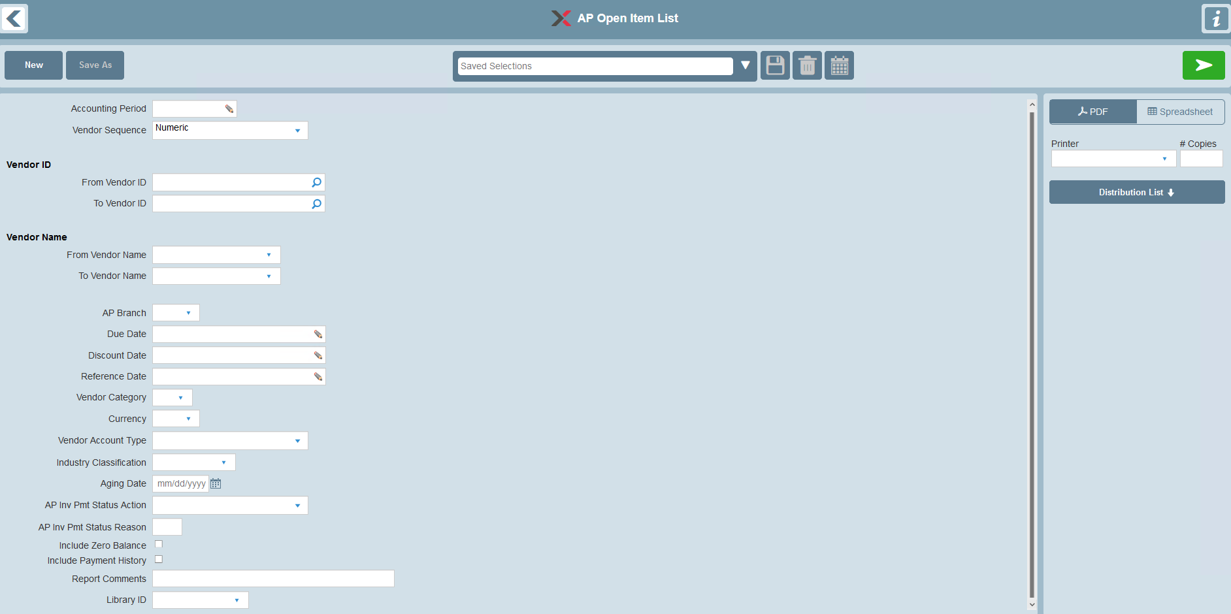

The report selections are listed below along with specific notes on their use in this report.

Selection | Valid Values | Default | Notes
Accounting Period | If selected, must be a specific Accounting Period. |  | Optional selection.  Look-up provided.  Please refer to the ‘Accounting Period Business Rules’ section for details on how this selection filter is used.
Vendor Sequence | A – Alphabetic (Report is sequenced by Vendor Long Name)  N – Numeric (Report is sequenced by Vendor ID) | N – Numeric Sequence
Vendor ID | All or range | All
Vendor Name | All or range | All
AP Branch | All or specific value | All
Due Date | All or range | All
Discount Date | All or range | All
Entry Date | All or range | All
Vendor Category | All or specific value | All
Currency | All or specific value | All | Selects AP Invoices based on the currency of the Invoice
Vendor Account Type | All or specific value | All | Options are:  - M – Miscellaneous  - R – Regular
SIC Number | All or specific value | All | Selects AP Invoices based on the Standard Industrial Classification code
Aging Date | If provided, must be a specific date | System Date (at the time of Report generation)
AP Invoice Payment Status Action | All or specific value | All | Selects AP Invoices based on their Payment Status Action
AP Invoice Payment Status Reason | All or specific value | All | Selects Payment Held AP Invoices based their Hold Reason
Include Zero Balance | Unchecked - excluded  Checked - included | Unchecked | If checked, includes printing of transactions where there is no calculated Accounts Payable Open Item balance remaining.
Include Payment History | Unchecked - excluded  Checked - included | Unchecked | If checked, also prints the payment history associated to each Accounts Payable Open Item transaction.
Report Comments |  | None | Provides an option to print report comments on the Selection page of the report
Library ID | None or a specific Library ID | None | Provides an option to select a Library ID for generic remarks to be printed on the Selection page of the report

Accounting Period Business Rules
- If an Accounting Period selection is provided, transaction eligibility is determined based on the Accounting Period selection and the ‘Period Ending Date’ in the Fiscal Calendar enterprise parameter.
- Accounts Payable Open Item Header transactions are eligible for possible inclusion on the report if the Entry Reference (APTPYH-ENT-DT) Date is less than or equal to the corresponding Accounting Period’s Period Ending Date.
- Accounts Payable Payment History transactions are eligible for possible inclusion on the report if the Payment Activity (APTPYD-ACTVY-DT) Date is less than or equal to the corresponding Accounting Period’s Period Ending Date.

Refer to the following sections for further details:
- 'Transaction Eligibility - Accounts Payable Invoices Included/Excluded'
- 'Report Field Descriptions'

General Rules

Values
Accounts Payable Invoice amounts and corresponding Accounts Payable Payment History amounts are printed in the currency of the Invoice.

For all report totaling levels, the amounts are printed in the equivalent Base Currency.

Transaction Eligibility - Accounts Payable Invoices Included/Excluded
Transactions are printed/not printed based on the resulting "calculated" balance. Refer to the 'Report Field Descriptions' section for further details.

Data

Primary Source of Data
- APTPYH – Accounts Payable Invoice
- APTPYD – Accounts Payable Payment History

Grouped By
- Vendor ID

Detail Line Sequenced By
Accounts Payable Invoices:
- Due Date
- Reference Prefix and Number

Accounts Payable Payment History:
- Reference Date

Page Breaks By
- Report summary recap

Data Totaled By
- Vendor ID
- Report

Report Summary Recap (New Page)
A separate report summary recap is provided for the following information:

- A recap of the total Accounts Payable for each AP branch that is listed in the report details. The branch recap is based on the following:
- the AP Branch
- the printed ‘Base Currency Balance’ that was calculated

- The recap is sequenced by AP Branch.

- A grand total for all the AP branches is included.

Accounts Payable Open Item List (Excluding Payment History)

Report Layout
AP Open Item List
Base Currency: QQQ
Vendor ID Name Contact Tel No Terms AR Balance
Due Dt Disc Dt Disc Amt Ref No Brh Entry Dt Inv No Inv Date PO No Description Orig Amt Cry Bal ExRt Base Cry Bal Odue P
Pmts
ZZZZZZZZ QQQQQQQQQQQQQQQQQQQQQQQQQQQQQQQQQQQ QQQQQQQQQQQQQQQQQQQQQQQQQQQQQQ QQQQQQQQQQQQQQQ QQQQQQQQQQQQQQQQQQQQQQQQQQQQQQQQQQQQQQQQQQQQQ
Z,ZZZ,ZZZ,ZZZ.ZZ-

MM/DD/YY MM/DD/YY ZZ,ZZZ.ZZ QQ99999999 QQQ MM/DD/YY QQQQQQQQQQQQQQQQQQQQQQ MM/DD/YY 99999999 QQQQQQQQQQQQQQQQQQQQQQQ ZZZZ,ZZ9.99- QQQ ZZZZ,ZZZ.ZZ- ZZZZ,ZZ9.99- ZZ.999999 ZZZZ,ZZ9.99- ZZZZ Q
MM/DD/YY MM/DD/YY ZZ,ZZZ.ZZ QQ99999999 QQQ MM/DD/YY QQQQQQQQQQQQQQQQQQQQQQ MM/DD/YY 99999999 QQQQQQQQQQQQQQQQQQQQQQQ ZZZZ,ZZ9.99- QQQ ZZZZ,ZZZ.ZZ- ZZZZ,ZZ9.99- ZZ.999999 ZZZZ,ZZ9.99- ZZZZ Q
MM/DD/YY MM/DD/YY ZZ,ZZZ.ZZ QQ99999999 QQQ MM/DD/YY QQQQQQQQQQQQQQQQQQQQQQ MM/DD/YY 99999999 QQQQQQQQQQQQQQQQQQQQQQQ ZZZZ,ZZ9.99- QQQ ZZZZ,ZZZ.ZZ- ZZZZ,ZZ9.99- ZZ.999999 ZZZZ,ZZ9.99- ZZZZ Q

Vendor Total Z,ZZZ,ZZZ,ZZZ.ZZ- QQQ Z,ZZZ,ZZZ,ZZ9.99-

ZZZZZZZZ QQQQQQQQQQQQQQQQQQQQQQQQQQQQQQQQQQQ QQQQQQQQQQQQQQQQQQQQQQQQQQQQQQ QQQQQQQQQQQQQQQ QQQQQQQQQQQQQQQQQQQQQQQQQQQQQQQQQQQQQQQQQQQQQ
Z,ZZZ,ZZZ.ZZZ.ZZ-

MM/DD/YY MM/DD/YY ZZ,ZZZ.ZZ QQ99999999 QQQ MM/DD/YY QQQQQQQQQQQQQQQQQQQQQQ MM/DD/YY 99999999 QQQQQQQQQQQQQQQQQQQQQQQQ ZZZZ,ZZ9.99- QQQ ZZZZ,ZZZ.ZZ-ZZZZ,ZZ9.99- ZZ.999999 ZZZZ,ZZ9.99- ZZZZ Q
MM/DD/YY MM/DD/YY ZZ,ZZZ.ZZ QQ99999999 QQQ MM/DD/YY QQQQQQQQQQQQQQQQQQQQQQ MM/DD/YY 99999999 QQQQQQQQQQQQQQQQQQQQQQQQ ZZZZ,ZZ9.99- QQQ ZZZZ,ZZZ.ZZ ZZZZ,ZZ9.99- ZZ.999999 ZZZZ,ZZ9.99- ZZZZ Q
MM/DD/YY MM/DD/YY ZZ,ZZZ,ZZ QQ99999999 QQQ MM/DD/YY QQQQQQQQQQQQQQQQQQQQQQ MM/DD/YY 99999999 QQQQQQQQQQQQQQQQQQQQQQQQ ZZZZ,ZZ9.99- QQQ ZZZZ,ZZZ.ZZ-ZZZZ,ZZ9.99- ZZ.999999 ZZZZ,ZZ9.99- ZZZZ Q

Vendor Total Z,ZZZ,ZZZ,ZZZ.ZZ- QQQ Z,ZZZ,ZZZ,ZZ9.99-

Report Total Z,ZZZ,ZZZ,ZZZ.ZZ- QQQ Z,ZZZ,ZZZ,ZZ9.99-

Summary Recap Page – Sample
2/15/06 16:50 PAGE: 4
AP Open Item List
AP Branch Base Cry Bal
QQQ QQQQQQQQQQQQQQQ ZZZZ,ZZZ,ZZ9.99-

CHI Chicago 10,000.00
DET Detroit 7,500.00

Total 17,500.00

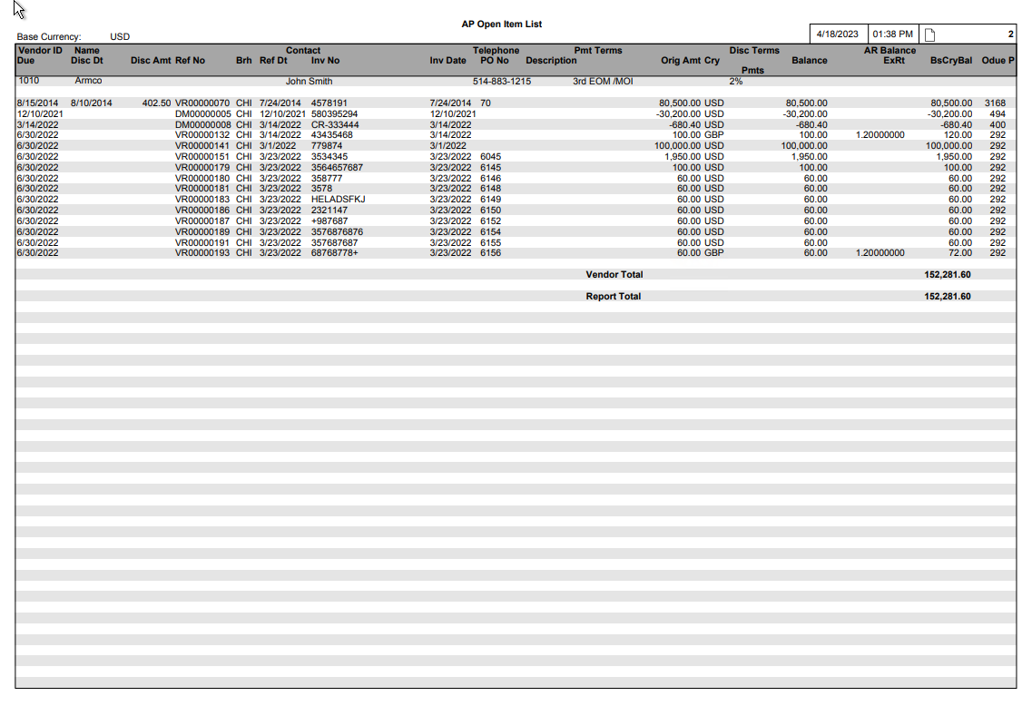

Accounts Payable Open Item List (Including Payment History)

Report Layout
AP Open Item List
Base Currency: QQQ
Vendor ID Name Contact Tel No Terms AR Balance
Due Dt Disc Dt Disc Amt Ref No Brh Entry Dt Inv No Inv Date PO No Description Orig Amt Cry Bal ExRt Base Cry Bal Odue P
Pmts
ZZZZZZZZ QQQQQQQQQQQQQQQQQQQQQQQQQQQQQQQQQQQ QQQQQQQQQQQQQQQQQQQQQQQQQQQQQQ QQQQQQQQQQQQQQQ QQQQQQQQQQQQQQQQQQQQQQQQQQQQQQQQQQQQQQQQQQQQQ
Z,ZZZ,ZZZ,ZZZ.ZZ-

MM/DD/YY MM/DD/YY ZZ,ZZZ.ZZ QQ99999999 QQQ MM/DD/YY QQQQQQQQQQQQQQQQQQQQQQ MM/DD/YY 99999999 QQQQQQQQQQQQQQQQQQQQQQQ ZZZZ,ZZ9.99- QQQ
MM/DD/YY ZZZZ,ZZZ.ZZ-
MM/DD/YY ZZZZ,ZZZ.ZZ- ZZZZ,ZZ9.99- ZZ.999999 ZZZZ,ZZ9.99- ZZZZ Q
MM/DD/YY MM/DD/YY ZZ,ZZZ.ZZ QQ99999999 QQQ MM/DD/YY QQQQQQQQQQQQQQQQQQQQQQ MM/DD/YY 99999999 QQQQQQQQQQQQQQQQQQQQQQQ ZZZZ,ZZ9.99- QQQ ZZZZ,ZZ9.99- ZZ.999999 ZZZZ,ZZ9.99- ZZZZ Q
MM/DD/YY MM/DD/YY ZZ,ZZZ.ZZ QQ99999999 QQQ MM/DD/YY QQQQQQQQQQQQQQQQQQQQQQ MM/DD/YY 99999999 QQQQQQQQQQQQQQQQQQQQQQQ ZZZZ,ZZ9.99- QQQ ZZZZ,ZZ9.99- ZZ.999999 ZZZZ,ZZ9.99- ZZZZ Q

Vendor Total Z,ZZZ,ZZZ,ZZZ.ZZ- QQQ Z,ZZZ,ZZZ,ZZ9.99-

ZZZZZZZZ QQQQQQQQQQQQQQQQQQQQQQQQQQQQQQQQQQQ QQQQQQQQQQQQQQQQQQQQQQQQQQQQQQ QQQQQQQQQQQQQQQ QQQQQQQQQQQQQQQQQQQQQQQQQQQQQQQQQQQQQQQQQQQQQ
Z,ZZZ,ZZZ,ZZZ.ZZ-

MM/DD/YY MM/DD/YY ZZ,ZZZ.ZZ QQ99999999 QQQ MM/DD/YY QQQQQQQQQQQQQQQQQQQQQQ MM/DD/YY 99999999 QQQQQQQQQQQQQQQQQQQQQQQ ZZZZ,ZZ9.99- QQQ ZZZZ,ZZ9.99- ZZ.999999 ZZZZ,ZZ9.99- ZZZZ Q
MM/DD/YY MM/DD/YY ZZ,ZZZ.ZZ QQ99999999 QQQ MM/DD/YY QQQQQQQQQQQQQQQQQQQQQQ MM/DD/YY 99999999 QQQQQQQQQQQQQQQQQQQQQQQ ZZZZ,ZZ9.99- QQQ ZZZZ,ZZ9.99- ZZ.999999 ZZZZ,ZZ9.99- ZZZZ Q
MM/DD/YY MM/DD/YY ZZ,ZZZ,ZZ QQ99999999 QQQ MM/DD/YY QQQQQQQQQQQQQQQQQQQQQQ MM/DD/YY 99999999 QQQQQQQQQQQQQQQQQQQQQQQ ZZZZ,ZZ9.99- QQQ ZZZZ,ZZ9.99- ZZ.999999 ZZZZ,ZZ9.99- ZZZZ Q

Vendor Total Z,ZZZ,ZZZ,ZZZ.ZZ- QQQ Z,ZZZ,ZZZ,ZZ9.99-

Report Total Z,ZZZ,ZZZ,ZZZ.ZZ- QQQ Z,ZZZ,ZZZ,ZZ9.99-

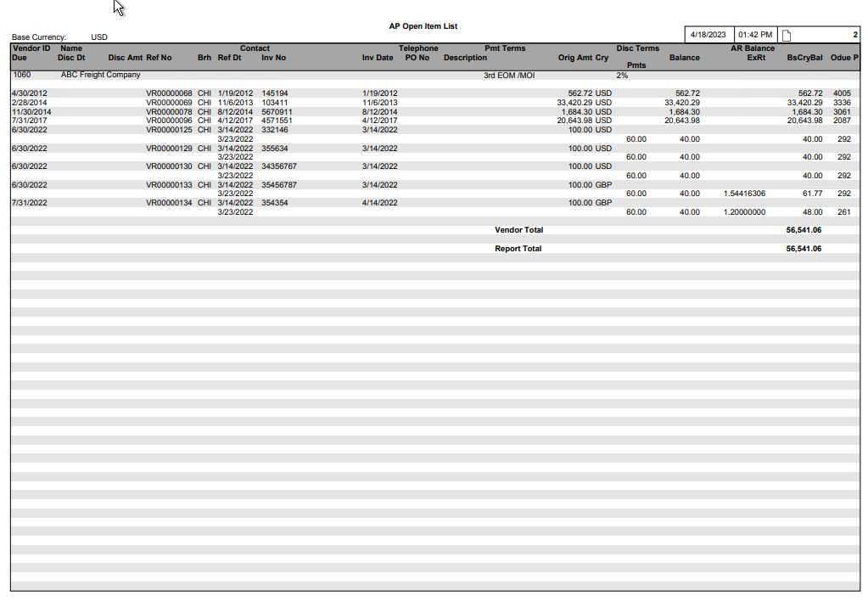

Report Structure

Report Field Description
Group | Report Field | Field Name | Business Rules | Formatting
Header Line 1
 | Vendor ID | PYH-VEN-ID
 | Vendor Long Name | VEN-VEN-LONG-NM
 | Contact |  | Represents the AR Contact of the Vendor’s Pay-to Address  Field is left blank if there is no AR Contact for the Vendor’s Pay-To Address
 | Telephone Number |  | Based on the AR Contact of the Vendor’s Pay-to Address  Field is left blank if there is no AR Contact for the Vendor’s Pay-To Address
 | Payment Terms
 | Discount Terms
Header Line 2 |  |  |  | Accounts Receivable Balance  - Line is only printed by exception if the Vendor has a Customer ID defined in the Accounts Receivable system (APRVEN-RLTD-CUS-ID) with a non-zero A/R Balance.  - Vendor’s Customer ID must be entered in the Vendor Account (in the Related Customer ID field)  Denoted in Base Currency
 | AR Balance | COC-AR-BAL
Detail Line 1
(Open Item)
 | Due Date | PYH-DUE-DT
 | Discount Date | PYH-DISC-DT
 | Discount Amount | PYH-DISC-AMT
 | Reference Number | PYH-OPA-PFX,  PYH-OPA-NO |  | Reference Prefix and Number
 | AP Branch | PYH-AP-BRH
 | Entry Date | PYH-ENT-DT
 | Invoice Number | PYH-VEN-INV-NO
 | PO Number | PYH-PO-NO
 | Invoice Date | PYH_VEN_INV_DT
 | Description | PYH-DESC30 |  | Maximum 20 characters are eligible to be printed.
 | Original Amount | PYH-ORIG-AMT
 | Currency | PYH-CRY
 | Balance | Calculated | - Only printed on this line if no Accounts Payable Payment History transactions are printed for this AP Open Item.  Case A  - Accounting Period selected, and  - AP Open Item Header is eligible, and  - AP Payments are eligible  (APTPYH_ORIG_AMT)  + (∑ APTPYD Payments included/excluded, subject to Accounting Period filtering)  Transaction excluded from report if the 'Include Zero Balance' selection is off and the resulting Calculated Balance is zero.  Case B  - Accounting Period selected, and  - AP Open Item Header is not eligible, and  - AP Payments are eligible  (APTPYH_ORIG_AMT calculated as zero)  + (∑ APTPYD Payments included/excluded, subject to Accounting Period filtering)  Transaction excluded from report if the 'Include Zero Balance' selection is off and the resulting Calculated Balance is zero.  Case C  - Accounting Period selected, and  - AP Open Item Header is not eligible, and  - AP Payments are not eligible  Transaction excluded from report.  Case D  - Accounting Period not selected  (APTPYH_ORIG_AMT)  + (∑ All APTPYD Payments)  Transaction excluded from report if the 'Include Zero Balance' selection is off and the resulting Calculated Balance is zero.
 | Exchange Rate | PYH-EX-RT | - Only printed on this line if no Accounts Payable Payment History transactions are printed for this AP Open Item.
 | Base Currency Balance | Calculated | (Calculated ‘Balance’) * (PYH-EX-RT)  - Only printed on this line if no Accounts Payable Payment History transactions are printed for this AP Open Item.
 | Overdue Days | Calculated | Represents the number of days in which the Aging Date exceeds the Due Date | The number of Overdue Days is printed only on the same line as the Balance.
 | Payment Status |  | Only printed if the Payment Status Action is H (Hold) | The Payment Status is printed only on the same line as the Balance.
Detail Line 2  (Payment History) |  |  | This Detail Line is only printed if the ‘Include Payment History’ selection option is checked.
 | Reference Date | PYD-ACTVY-DT |  | No separate heading
 | Payments | PYD-APLD-AMT
 | Balance | Calculated | (PYH-ORIG-AMT)  + All previously printed Payments for this AP Open Item (if any)  + current Payment | If more than one payment is printed, then the Balance is printed only on the same line as the most recent payment.
 | Exchange Rate | PYH-EX-RT | Only printed if the Base Currency differs from the Open Item Currency | The Exchange Rate is printed only on the same line as the Balance.
 | Base Currency Balance | Calculated | (Calculated ‘Balance’) *  (PYH-EX-RT) | The Base Currency Balance is printed only on the same line as the Balance.
Vendor Sub-Totals | Balance |  | Only printed when all the following conditions are true:  - All AP Open Item transactions printed for the Vendor are denominated in the same currency  - That currency is foreign
 | Currency |  | Only printed if the related Balance is printed
 | Base Currency Balance
Report Grand Totals | Balance |  | Only printed when all the following conditions are true:  - All AP Open Item transactions printed on the entire report are denominated in the same currency  - That currency is foreign
 | Currency |  | Only printed if the related Balance is printed
 | Base Currency Balance
Report Summary Recap
 | AP Branch
 | Branch Name
 | Base Currency Balance

Accounting Period Selection Window
If the Accounting Period selection is accessed via the Report Requester screen, the following window is provided:
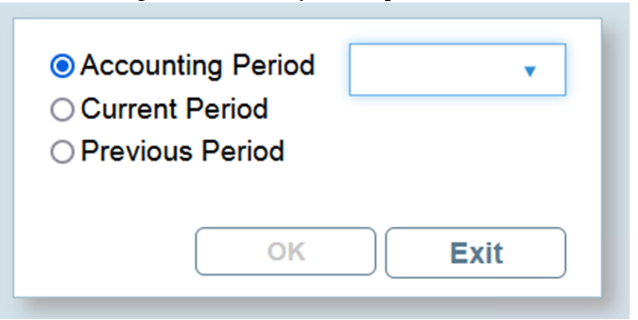

Radio Button Selections

Radio Button Selection Label | Valid Values | Default | Notes
Accounting Period | Specific value | checked | A valid Accounting Period must be provided if this radio button is selected.  Drop-down look-up is provided via Fiscal Calendar EP (glrfis table)  Example:  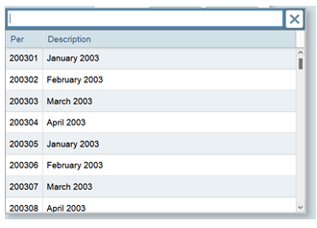
Current Period |  | unchecked | Allows user to select transactions for the entire 'current' Accounting Period.  Note that this is a variable context report selection that is determined dynamically relative to the date of report execution.  This uses the System Date at time of report execution, and the Fiscal Calendar enterprise parameter, to determine whether transactions are selected for reporting purposes.
Previous Period |  | unchecked | Allows user to select transactions for the entire 'previous' Accounting Period.  Note that this is a variable context report selection that is determined dynamically relative to the date of report execution.  This uses the System Date at time of report execution, and the Fiscal Calendar enterprise parameter, to determine whether transactions are selected for reporting purposes.

Business Rules
If the user navigates back from the Accounting Period Selection window via the OK or EXIT buttons, and has selected the “Accounting Period” radio button but has not provided a specific Accounting Period value, then this is equivalent to not having requested an Accounting Period selection filter for the report.

Navigating Back to the Report Requester Screen
Depending on the business case, one of the following values is returned from the Accounting Period Selection window and displayed directly on the main Report Requester screen:

- A specific Accounting Period value eg. “202203”
- The label “Cur Period”
- The label “Prev Period”
- blank (ie. indicates no filtering was requested via the window)

Business Case 1 - Example:


Business Case 2 - Example:
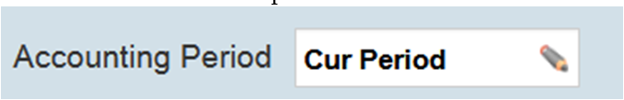

Business Case 3 - Example:
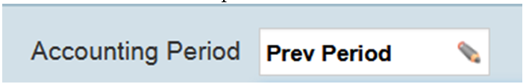

Business Case 4 - Example:
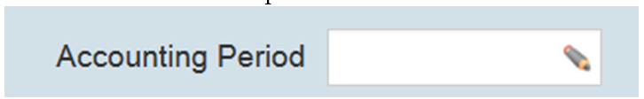

Report Execution – Business Rules

Accounting Period Radio Button
- If the “Accounting Period” radio button was selected, then the specific Accounting Period value that was provided directly is used at report execution time.

Current Period Radio Button
- If the “Current Period” radio button was selected, then the Accounting Period to be used at report execution time is determined as follows:
- Determine System Date dynamically at report execution time
- Access Fiscal Calendar enterprise parameter (glrfis table) and access the Accounting Period whose Period Beginning Date/Ending Date range corresponds to the System Date
- For user clarity, the front selection page of the generated report output indicates the actual equivalent Accounting Period, not the words “Current Period”
- If there is no corresponding Fiscal Calendar enterprise parameter record available, the report cannot be generated correctly and an error is issued via the View Log button in the Document Manager:
“Current Accounting Period unavailable – please review Fiscal Calendar ep”

Previous Period Radio Button
- If the “Previous Period” radio button was selected, then the Accounting Period to be used at report execution time is determined as follows:
- Determine System Date dynamically at report execution time
- Access Fiscal Calendar enterprise parameter (glrfis table) and access the Accounting Period whose Period Beginning Date/Ending Date range corresponds to the System Date
- Access the immediately preceding Accounting Period. If the immediately preceding Accounting Period is determined to be period 13, then period 12 is used instead for reporting purposes
- For user clarity, the front selection page of the generated report output indicates the actual equivalent Accounting Period, not the words “Previous Period”
- If there is no immediately preceding Fiscal Calendar enterprise parameter record available, the report cannot be generated correctly and an error is issued via the View Log button in the Document Manager:
“Previous Accounting Period unavailable – please review Fiscal Calendar ep“

AGED ACCOUNTS PAYABLE REPORT

Overview
The Aged Accounts Payable Report shows the status of each Open Item in relation to its Due Date. Users have the added flexibility of defining the Aging periods for which they want information.

Target Audience
Accounting personnel use this report to quickly identify those items requiring immediate payment.

Frequency of Use
Monthly, initiated by Accounting staff at end of month.

Selection Options
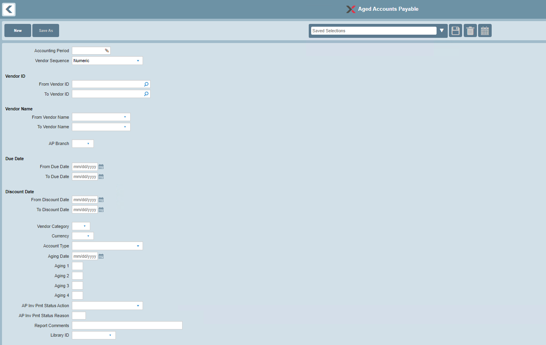

The report selections are listed below along with specific notes on their use in this report:

Selection | Valid Values | Default | Notes
Accounting Period | If selected, must be a specific Accounting Period. |  | Optional selection.  Look-up provided.  Please refer to the ‘Accounting Period Business Rules’ section for details on how this selection filter is used.
Vendor Sequence | A – Alphabetic (Report is sequenced by Vendor Long Name)  N – Numeric (Report is sequenced by Vendor ID) | N – Numeric Sequence
Vendor ID | All or range | All
Vendor Name | All or range | All
AP Branch | All or specific value | All
Due Date | All or range | All
Discount Date | All or range | All
Vendor Category | All or specific value | All
Currency | All or specific value | All | Selects AP Invoices based on the currency of the Invoice
Vendor Account Type | All or specific value | All | Options are:  - M – Miscellaneous  - R – Regular
Aging Date | If provided, must be a specific date | System Date (at the time of Report generation) | Ages the AP Invoice transactions into the appropriate aging bracket based on the Aging Date selection entry.  The Aging Date has no bearing on whether transactions are included on the report.
Aging 1 | User-defined |  | Represents the number of days for the first Aging Period
Aging 2 | User-defined |  | Represents the number of days for the second Aging Period  Aging period cannot be less than previous Aging Period
Aging 3 | User-defined |  | Represents the number of days for the third Aging Period  Aging period cannot be less than previous Aging Period
Aging 4 | User-defined |  | Represents the number of days for the fourth Aging Period  Aging period cannot be less than previous Aging Period
AP Invoice Payment Status Action | All or specific value | All | Selects AP Invoices based on their Payment Status Action
AP Invoice Payment Status Reason | All or specific value | All | Selects Payment Held AP Invoices based on their Hold Reason
Report Comments |  | None | Provides an option to print Report comments on the Selection page of the Report
Library ID | None or specific Library ID | None | Provides an option to select a Library ID for generic remarks to be printed on the Selection page of the Report

Accounting Period Business Rules
- If an Accounting Period selection is provided, transaction eligibility is determined based on the Accounting Period selection and the ‘Period Ending Date’ in the Fiscal Calendar enterprise parameter.
- Accounts Payable Open Item Header transactions are eligible for possible inclusion on the report if the Entry Reference (APTPYH-ENT-DT) Date is less than or equal to the corresponding Accounting Period’s Period Ending Date.
- Accounts Payable Payment History transactions are eligible for possible inclusion on the report if the Payment Activity (APTPYD-ACTVY-DT) Date is less than or equal to the corresponding Accounting Period’s Period Ending Date.

Refer to the following sections for further details:
- 'Transaction Eligibility - Accounts Payable Invoices Included/Excluded'
- 'Report Field Descriptions'

General Rules

Values
Accounts Payable Invoices are printed in the currency of the Invoice.

For all reporting totaling levels, the amounts are printed in the equivalent Base Currency.

Transaction Eligibility - Accounts Payable Invoices Included/Excluded

When Accounting Period Selection is Not Provided
- Archived Transactions (APTPYH-ARCH-TRS) are not printed on the report.
- Transactions are printed/not printed based on the resulting "calculated" balance. Refer to the 'Report Field Descriptions' section for further details.

When Accounting Period Selection is Provided
Transactions are printed/not printed based on the resulting "calculated" balance. Refer to the 'Report Field Descriptions' section for further details.

The following criteria are not relevant when determining inclusion/exclusion of Accounts Payable Invoices:
- The state of the Archived Transaction flag (APTPYH-ARCH-TRS)
- The state of the Transaction Status (TCTTSA-STS-TYP = T) record

Data

Primary Source of Data
- APTPYH – Accounts Payable Open Item
- APTPYD – Accounts Payable Payment History

Grouped By
- Vendor ID

Detail Line Sequenced By
- Due Date
- Reference Prefix and Number

Page Breaks By
- No page breaks provided

Data Totaled By
- Vendor
- Report

Aged Accounts Payable Report

Report Layout
Aged Accounts Payable Report
Base Currency: QQQ
Vendor ID Name Past Due Past Due Past Due Past Due Past Due P
Due Dt Ref No Brh Inv No PO No Odue Bal Cry ExRt Base Cry Bal Current Due 1-15 16-30 31-45 46-60 61-
Description
ZZZZZZZZ QQQQQQQQQQQQQQQQQQQQQQQQQQQQQQQQQQQ

MM/DD/YY QQ99999999 QQQ QQQQQQQQQQQQQQQQQQQQQQ 99999999 ZZZZ ZZZZ,ZZ9.99- QQQ ZZ.999999 ZZZZ,ZZ9.99- ZZZZ,ZZ9.99- Q
QQQQQQQQQQQQQQQQQQQQQQQQQQQQQQ

MM/DD/YY QQ99999999 QQQ QQQQQQQQQQQQQQQQQQQQQQ 99999999 ZZZZ ZZZZ,ZZ9.99- QQQ ZZ.999999 ZZZZ,ZZ9.99- ZZZZ,ZZ9.99- Q
QQQQQQQQQQQQQQQQQQQQQQQQQQQQQQ

MM/DD/YY QQ99999999 QQQ QQQQQQQQQQQQQQQQQQQQQQ 99999999 ZZZZ ZZZZ,ZZ9.99- QQQ ZZ.999999 ZZZZ,ZZ9.99- ZZZZ,ZZ9.99- Q
QQQQQQQQQQQQQQQQQQQQQQQQQQQQQQ

MM/DD/YY QQ99999999 QQQ QQQQQQQQQQQQQQQQQQQQQQ 99999999 ZZZZ ZZZZ,ZZ9.99- QQQ ZZ.999999 ZZZZ,ZZ9.99- ZZZZ,ZZ9.99- ZZZZ,ZZ9.99- Q
QQQQQQQQQQQQQQQQQQQQQQQQQQQQQQ

Vendor Total Z,ZZZ,ZZZ,ZZ9.99- Z,ZZZ,ZZZ,ZZ9.99- Z,ZZZ,ZZZ,ZZ9.99- Z,ZZZ,ZZZ,ZZ9.99- Z,ZZZ,ZZZ,ZZ9.99-

ZZZZZZZZ QQQQQQQQQQQQQQQQQQQQQQQQQQQQQQQQQQQ

MM/DD/YY QQ99999999 QQQ QQQQQQQQQQQQQQQQQQQQQQ 99999999 ZZZZ ZZZZ,ZZ9.99- QQQ ZZ.999999 ZZZZ,ZZ9.99- ZZZZ,ZZ9.99- Q
QQQQQQQQQQQQQQQQQQQQQQQQQQQQQQ

MM/DD/YY QQ99999999 QQQ QQQQQQQQQQQQQQQQQQQQQQ 99999999 ZZZZ ZZZZ,ZZ9.99- QQQ ZZ.999999 ZZZZ,ZZ9.99- ZZZZ,ZZ9.99- Q
QQQQQQQQQQQQQQQQQQQQQQQQQQQQQQ

Vendor Total Z,ZZZ,ZZZ,ZZ9.99- Z,ZZZ,ZZZ,ZZ9.99-

Report Total Z,ZZZ,ZZZ,ZZ9.99- Z,ZZZ,ZZZ,ZZ9.99- Z,ZZZ,ZZZ,ZZ9.99- Z,ZZZ,ZZZ,ZZ9.99- Z,ZZZ,ZZZ,ZZ9.99-

Percentage ZZ9.99% ZZ9.99% ZZ9.99% ZZ9.99% Z9.99%

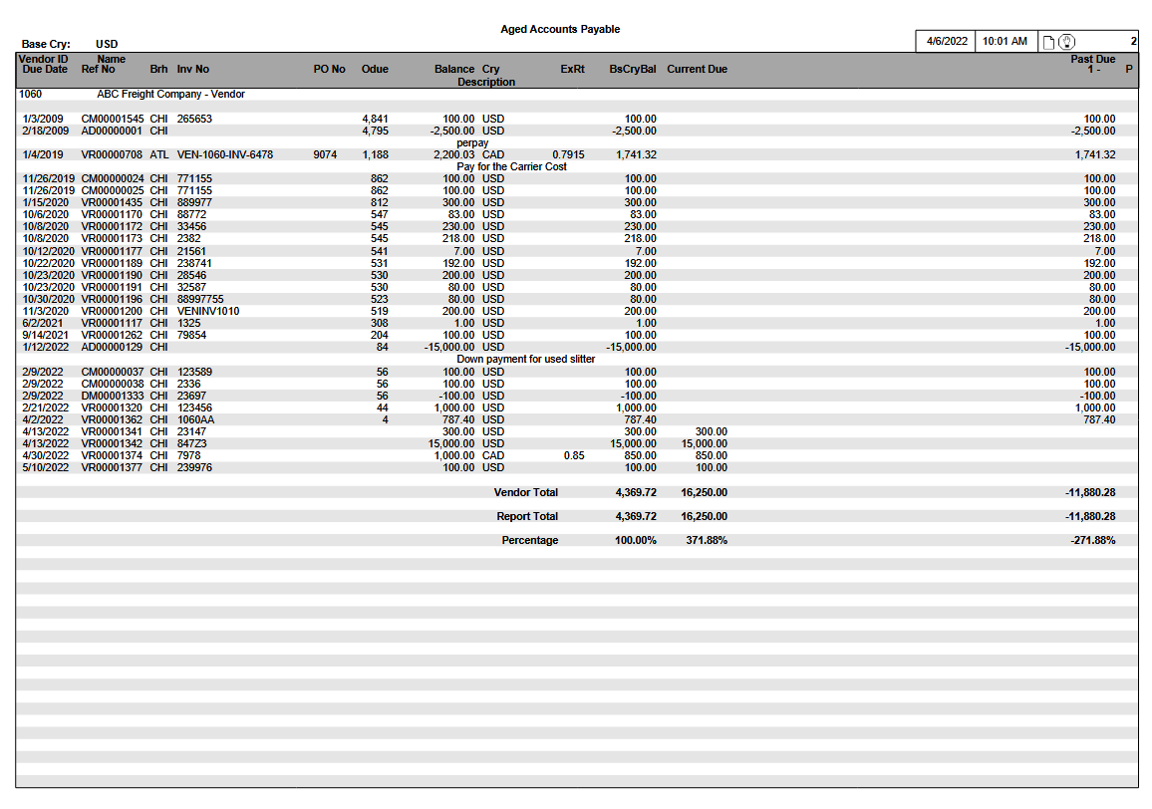

Report Structure

Report Field Description
Group | Report Field | Field Name | Business Rules | Formatting
Header Line 1 | Vendor ID
 | Vendor Long Name
Detail Line 1 | Due Date
 | Reference Number |  |  | Reference Prefix and Number
 | AP Branch
 | Invoice Number
 | PO Number
 | Overdue Days | Calculated | Represents the number of days in which the Report Date exceeds the Due Date
 | Balance | Calculated | Case A  - Accounting Period selected, and  - AP Open Item Header is eligible, and  - AP Payments are eligible  (APTPYH_ORIG_AMT)  + (∑ APTPYD Payments included/excluded, subject to Accounting Period filtering)  Transaction excluded from report if the resulting Calculated Balance is zero.  Case B  - Accounting Period selected, and  - AP Open Item Header is not eligible, and  - AP Payments are eligible  (APTPYH_ORIG_AMT calculated as zero)  + (∑ APTPYD Payments included/excluded, subject to Accounting Period filtering)  Transaction excluded from report if the resulting Calculated Balance is zero.  Case C  - Accounting Period selected, and  - AP Open Item Header is not eligible, and  - AP Payments are not eligible  Transaction excluded from report.  Case D  - Accounting Period not selected  (APTPYH_ORIG_AMT)  + (∑ All APTPYD Payments)  Transaction excluded from report if the resulting Calculated Balance is zero.
 | Currency
 | Exchange Rate |  | Only printed if the Base Currency differs from the Open Item Currency
 | Base Currency Balance | Calculated | (Calculated 'Balance') * APTPYH Exchange Rate
 | Current Due
 | Aging 1 |  |  | Column label varies according to Aging Period specified.  Denominated in Base Currency.
 | Aging 2 |  |  | Column label varies according to Aging Period specified.  Denominated in Base Currency.
 | Aging 3 |  |  | Column label varies according to Aging Period specified.  Denominated in Base Currency.
 | Aging 4 |  |  | Column label varies according to Aging Period specified.  Denominated in Base Currency.
 | Aging 5 |  |  | Column label varies according to Aging Period specified.  Denominated in Base Currency.
 | Payment Status |  | Only printed if the Payment Status Action is H (Hold)
Detail Line 2 | Description |  | Only printed if Description information exists
Totals | Base Currency Balance
 | Current Due
 | Aging Periods
 | Percentage | Calculated | Aging Period/ Σ (Aging Periods) | Printed below the corresponding Aging Period.

Accounting Period Selection Window
If the Accounting Period selection is accessed via the Report Requester screen, the following window is provided:


Radio Button Selections

Radio Button Selection Label | Valid Values | Default | Notes
Accounting Period | Specific value | checked | A valid Accounting Period must be provided if this radio button is selected.  Drop-down look-up is provided via Fiscal Calendar EP (glrfis table)  Example:  
Current Period |  | unchecked | Allows user to select transactions for the entire 'current' Accounting Period.  Note that this is a variable context report selection that is determined dynamically relative to the date of report execution.  This uses the System Date at time of report execution, and the Fiscal Calendar enterprise parameter, to determine whether transactions are selected for reporting purposes.
Previous Period |  | unchecked | Allows user to select transactions for the entire 'previous' Accounting Period.  Note that this is a variable context report selection that is determined dynamically relative to the date of report execution.  This uses the System Date at time of report execution, and the Fiscal Calendar enterprise parameter, to determine whether transactions are selected for reporting purposes.

Business Rules
If the user navigates back from the Accounting Period Selection window via the OK or EXIT buttons, and has selected the “Accounting Period” radio button but has not provided a specific Accounting Period value, then this is equivalent to not having requested an Accounting Period selection filter for the report.

Navigating Back to the Report Requester Screen
Depending on the business case, one of the following values is returned from the Accounting Period Selection window and displayed directly on the main Report Requester screen:

- A specific Accounting Period value eg. “202203”
- The label “Cur Period”
- The label “Prev Period”
- blank (ie. indicates no filtering was requested via the window)

Business Case 1 - Example:


Business Case 2 - Example:


Business Case 3 - Example:


Business Case 4 - Example:


Report Execution – Business Rules

Accounting Period Radio Button
- If the “Accounting Period” radio button was selected, then the specific Accounting Period value that was provided directly is used at report execution time.

Current Period Radio Button
- If the “Current Period” radio button was selected, then the Accounting Period to be used at report execution time is determined as follows:
- Determine System Date dynamically at report execution time
- Access Fiscal Calendar enterprise parameter (glrfis table) and access the Accounting Period whose Period Beginning Date/Ending Date range corresponds to the System Date
- For user clarity, the front selection page of the generated report output indicates the actual equivalent Accounting Period, not the words “Current Period”
- If there is no corresponding Fiscal Calendar enterprise parameter record available, the report cannot be generated correctly and an error is issued via the View Log button in the Document Manager:
“Current Accounting Period unavailable – please review Fiscal Calendar ep”

Previous Period Radio Button
- If the “Previous Period” radio button was selected, then the Accounting Period to be used at report execution time is determined as follows:
- Determine System Date dynamically at report execution time
- Access Fiscal Calendar enterprise parameter (glrfis table) and access the Accounting Period whose Period Beginning Date/Ending Date range corresponds to the System Date
- Access the immediately preceding Accounting Period. If the immediately preceding Accounting Period is determined to be period 13, then period 12 is used instead for reporting purposes
- For user clarity, the front selection page of the generated report output indicates the actual equivalent Accounting Period, not the words “Previous Period”
- If there is no immediately preceding Fiscal Calendar enterprise parameter record available, the report cannot be generated correctly and an error is issued via the View Log button in the Document Manager:
“Previous Accounting Period unavailable – please review Fiscal Calendar ep“

CASH FORECAST REPORT

Overview
The Cash Forecast Report is essentially a short-term cash budgeting tool. The report provides information about Open Items, which are due today, next week, next month, or during some other future period. Users have the added flexibility of defining the Aging periods for which they want information.

Target Audience
Accounting personnel use this report to determine whether sufficient funds exist to make payments against Vendor invoices.

Frequency of Use
On demand

Selection Options
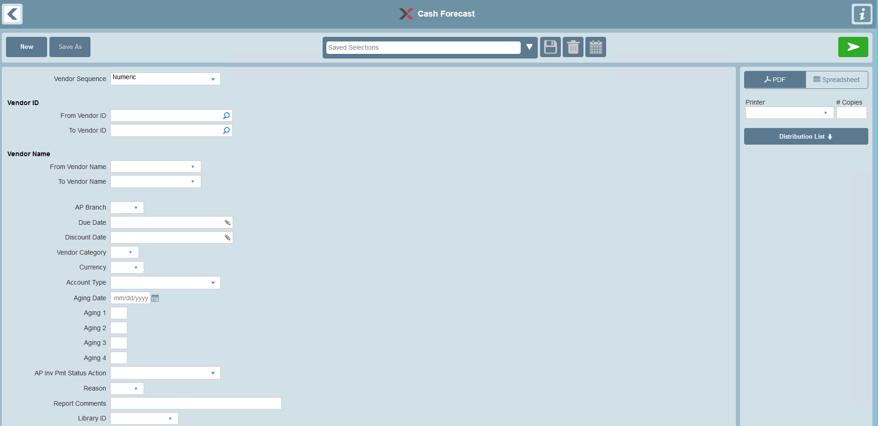

The report selections are listed below along with specific notes on their use in this report:

Selection | Valid Values | Default | Notes
Vendor Sequence | A – Alphabetic (Report is sequenced by Vendor Long Name)  N – Numeric (Report is sequenced by Vendor ID) | N – Numeric Sequence
Vendor ID | All or range | All
Vendor Name | All or range | All
AP Branch | All or specific value | All
Due Date | All or range | All | Please refer to the ‘Due Date/Discount Date Business Rules’ section for details on how this selection filter is used.
Discount Date | All or range | All | Please refer to the ‘Due Date/Discount Date Business Rules’ section for details on how this selection filter is used.
Vendor Category | All or specific value | All
Currency | All or specific value | All | Selects AP Invoices based on the currency of the Invoice
Vendor Account Type | All or specific value | All | Options are:  - M – Miscellaneous  - R – Regular
Aging Date | If provided, must be a specific date | System Date (at the time of Report generation) | Ages the AP Invoices based on the Aging Date selection entry
Aging 1 | User-defined |  | Represents the number of days for the first Aging Period
Aging 2 | User-defined |  | Represents the number of days for the second Aging Period  Aging period cannot be less than previous Aging Period
Aging 3 | User-defined |  | Represents the number of days for the third Aging Period  Aging period cannot be less than previous Aging Period
Aging 4 | User-defined |  | Represents the number of days for the fourth Aging Period  Aging period cannot be less than previous Aging Period
AP Invoice Payment Status Action | All or specific value | All | Selects AP Invoices based on their Payment Status Action
AP Invoice Payment Status Reason | All or specific value | All | Selects Payment Held AP Invoices based on their Hold Reason
Report Comments |  | None | Provides an option to print Report comments on the Selection page of the Report
Library ID | None or specific Library ID | None | Provides an option to select a Library ID for generic remarks to be printed on the Selection page of the Report

Due Date/Discount Date Business Rules
The ‘Due Date’ and ‘Discount Date’ selection options work in conjunction with each other using special business rules to determine whether an Open Item should be included on the report (subject to other selection criteria).

The following table outlines the business rules for these selection options:

Due Date Selection | Discount Date Selection | Notes
Not selected | Not selected | AP Open Item is included
Selected | Not selected | AP Open Item is included if it is within Due Date range selection.
Not selected | Selected | AP Open Item is included if both of the following conditions occur:  - [it is within Discount Date range selection] and  - [a Discount is offered]
Selected | Selected | AP Open Item is included if either of the following conditions occur:  - [it is within Due Date range selection] or,  - [it is within Discount Date range selection and a Discount is offered]

Example
AP Open Item has the following information:
- Discount Offered: 75.00
- Discount Date: June 17
- Due Date: June 26

Business Case | Due Date Selection | Discount Date Selection | AP Open Item Included
1 | Not selected | Not selected | Yes
2 | June 11 – June 24 | Not selected | No
3 | June 26 – July 9 | Not selected | Yes
4 | Not selected | June 11 – June 16 | No
5 | Not selected | June 11 – June 24 | Yes
6 | June 11 – June 25 | June 11 – June 17 | Yes
7 | June 11 – June 26 | June 11 – June 16 | Yes
8 | June 11 – June 25 | June 11 – June 16 | No

General Rules

Values
Accounts Payable Invoices are printed in the currency of the Invoice

For all reporting totaling levels, the amounts are printed in the equivalent Base Currency.

Accounts Payable Invoices Excluded
- Archived Transactions are not printed on this report
- Zero balance transactions are not printed on this report

Data

Primary Source of Data
- APTPYH – Accounts Payable Invoice

Grouped By
- Vendor ID

Detail Line Sequenced By
- Due Date
- Reference Prefix and Number

Page Breaks By
- No page breaks provided

Data Totaled By
- Vendor
- Report

Cash Forecast Report

Report Layout
Cash Forecast Report
Base Currency: QQQ
Vendor ID Name Due in Due in Due in Due in Due in P
Due Dt Ref No Brh Ref Dt Description Odue Bal Cry ExRt Base Cry Bal Past Due 1-15 16-30 31-45 45-60 61-

ZZZZZZZZ QQQQQQQQQQQQQQQQQQQQQQQQQQQQQQQQQQQ

MM/DD/YY QQ999999 QQQ MM/DD QQQQQQQQQQQQQQQQQQQQQQQQQQQQQ ZZZZ ZZZZ,ZZ9.99- QQQ ZZ.999999 ZZZZ,ZZ9.99- ZZZZ,ZZ9.99- Q
MM/DD/YY QQ999999 QQQ MM/DD QQQQQQQQQQQQQQQQQQQQQQQQQQQQQ ZZZZ ZZZZ,ZZ9.99- QQQ ZZ.999999 ZZZZ,ZZ9.99- ZZZZ,ZZ9.99- Q
MM/DD/YY QQ999999 QQQ MM/DD QQQQQQQQQQQQQQQQQQQQQQQQQQQQQ ZZZZ ZZZZ,ZZ9.99- QQQ ZZ.999999 ZZZZ,ZZ9.99- ZZZZ,ZZ9.99- Q

Vendor Total Z,ZZZ,ZZZ,ZZ9.99- Z,ZZZ,ZZZ,ZZ9.99-

ZZZZZZZZ QQQQQQQQQQQQQQQQQQQQQQQQQQQQQQQQQQQ

MM/DD/YY QQ999999 QQQ MM/DD QQQQQQQQQQQQQQQQQQQQQQQQQQQQQ ZZZZ ZZZZ,ZZ9.99- QQQ ZZ.999999 ZZZZ,ZZ9.99- ZZZZ,ZZ9.99- Q
MM/DD/YY QQ999999 QQQ MM/DD QQQQQQQQQQQQQQQQQQQQQQQQQQQQQ ZZZZ ZZZZ,ZZ9.99- QQQ ZZ.999999 ZZZZ,ZZ9.99- ZZZZ,ZZ9.99- Q

Vendor Total Z,ZZZ,ZZZ,ZZ9.99- Z,ZZZ,ZZZ,ZZ9.99- ZZZZ,ZZ9.99-

Report Total Z,ZZZ,ZZZ,ZZ9.99- Z,ZZZ,ZZZ,ZZ9.99- Z,ZZZ,ZZZ,ZZ9.99- Z,ZZZ,ZZZ,ZZ9.99-

Percentage ZZ9.99% ZZ9.99% ZZ9.99% ZZ9.99%

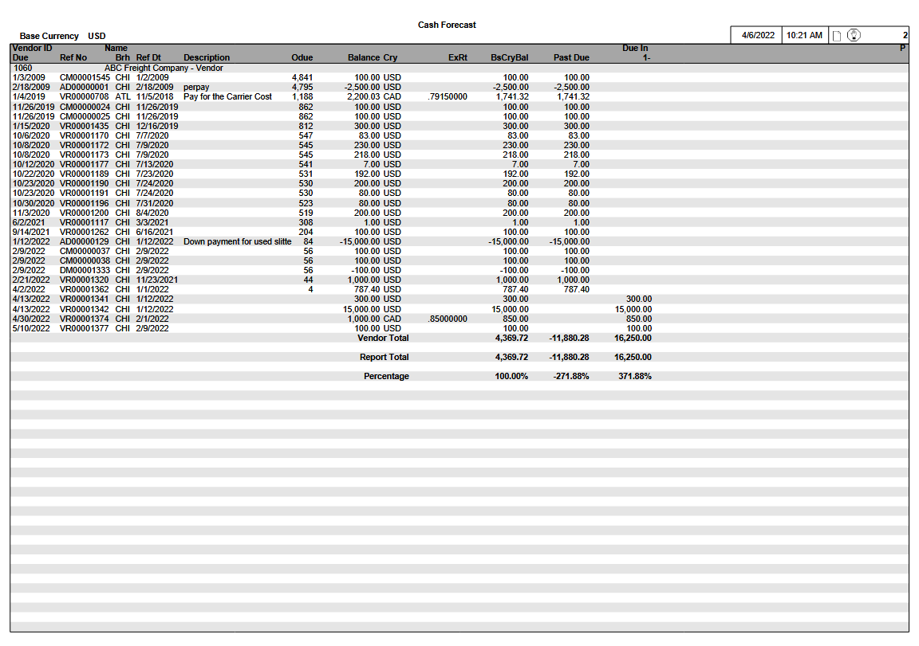

Report Structure

Report Field Description
Group | Report Field | Field Name | Business Rules | Formatting
Header Line 1 | Vendor ID
 | Vendor Long Name
Detail Line 1 | Due Date
 | Reference Number |  |  | Reference Prefix and Number
 | AP Branch
 | Reference Date
 | Description
 | Overdue Days | Calculated | Represents the number of days in which the Report Date exceeds the Due Date
 | Balance
 | Currency
 | Exchange Rate |  | Only printed if the Base Currency differs from the Open Item Currency
 | Base Currency Balance | Calculated | Balance * Exchange Rate
 | Past Due
 | Aging 1 |  |  | Column label varies according to Aging Period specified  Denominated in Base Currency
 | Aging 2 |  |  | Column label varies according to Aging Period specified  Denominated in Base Currency
 | Aging 3 |  |  | Column label varies according to Aging Period specified.  Denominated in Base Currency
 | Aging 4 |  |  | Column label varies according to Aging Period specified.  Denominated in Base Currency
 | Aging 5 |  |  | Column label varies according to Aging Period specified.  Denominated in Base Currency
 | Payment Status |  | Only printed if the Payment Status Action is H (Hold)
Totals | Base Currency Balance
 | Past Due
 | Aging Periods
 | Percentage | Calculated | Aging Period/Σ(Aging Periods) | Printed below the corresponding Aging Period

PAYMENT SCHEDULE REPORT

Overview
The Payment Schedule Report is launched indirectly via the Payment Scheduling feature in the Cash Disbursements business application. As a result, there is no stand-alone Payment Schedule Report selection on the INVEX menu.

The report output includes the list of Open Items which have been scheduled for payment, as well as the initial Payment Scheduling criteria, based on various user-defined filters.

Target Audience
Accounting staff use the Payment Scheduling function when high volumes of Cash Disbursements that can be selected for payment by specific criteria exist.

Frequency of Use
On demand

Selection Options
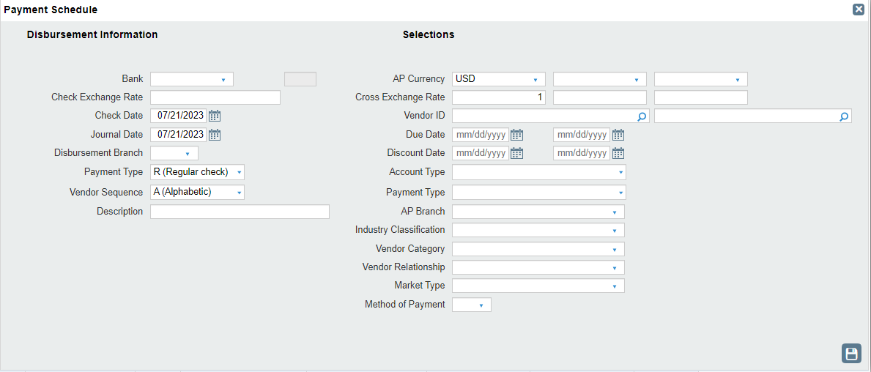

Selections Section
Information in the 'Selections' section of the screen are used as payment filtering criteria. The report selections are listed below along with specific notes on their use in this report:

Selection Option Label | Valid Values | Default | Notes
AP Currency | Must be a minimum of 1 specific AP Currency provided  (Message ref 1500) | AP Currency 1 is defaulted from the Base Currency. | Filtering is based on the currency of each AP Open Item transaction.  Multiple Currencies can be mixed within the same Payment Scheduling cycle.  A minimum of 1 AP Currency and Exchange Rate must be provided.  Up to 3 different AP Currencies and Rates can be selected in the same Payment Scheduling cycle.  The same AP Currency selection cannot be duplicated.  (Message ref 1561).
Cross Exchange Rate | Must be a minimum of 1 specific Cross Exchange Rate provided | Based on the corresponding AP Currency that was selected | The Cross Exchange Rate represents the rate in effect between the AP Currency and the Check Currency.  - Cross Exchange Rate cannot be zero if corresponding AP Currency is selected.  - Cross Exchange Rate must be 1 and cannot be edited where the AP Currency and Check currency are the same.
Vendor ID | All or range.  Lookup provided. | All
Due Date | All or range.  Date control lookup provided. | All
Discount Date | All or range.  Date control lookup provided. | All
Account Type | All or specific value.  Lookup provided. | All | Filtering is based on the Account Type of the Vendor's Account.  Options are:  - R-Regular  - M-Miscellaneous
Payment Type | All or specific value.  Lookup provided. | All | Filtering is based on the Payment Type linked to each corresponding AP Open Item transaction.
AP Branch | All or multi-select up to 5 eligible branches.  Lookup provided. | ⁽¹⁾All | Filtering is based on the Branch of each AP Open Item transaction.  ⁽¹⁾Business Rules - User's Branch Access  The ability to schedule AP Open Item transactions by branch is subject to the User's Branch Access security settings.
Industrial Classification | All or specific value.  Lookup provided. | All | Filtering is based on the Standard Industrial Classification Code of the Vendor's Account.
Vendor Category | All or specific value.  Lookup provided. | All | Filtering is based on the Vendor Category of the Vendor's Account.
Vendor Relationship | All or specific value.  Lookup provided. | All | Filtering is based on the Vendor Relationship of the Vendor's Account.
Market Type | All or specific value.  Lookup provided. | All | Filtering is based on the Market Type of the Vendor's Account.
Method of Payment | All or specific value.  Lookup provided. | All | Filtering is based on the Method of Payment of the Vendor's Account Ship-From zero.

General Rules
The front page that is printed along with the Payment Schedule Report lists the "Disbursement Information" properties that were assigned by the user, as well as the selection filters that were initially requested via the Payment Scheduling feature.

Values
Accounts Payable Open Item amounts are printed in the currency of the Invoice.

Data

Primary source of Data
- APTDSD – Accounts Payable Distribution
- APTDSH – Cash Disbursements
- APTDSS – Cash Disbursements Session
- APTPYH – Accounts Payable Open Item

Grouped By
- Vendor ID

Detail Line Sequenced By
- Disbursement Entry Number
- Due Date

Page Breaks By
- No page breaks provided

Data Totaled By
- Vendor
- Cash Disbursement Session Grand Total

Payment Schedule Report

Report Layout
Payment Schedule Report
Ssn ID: 999999
Ven ID Vendor Name
Dsb Ent No Due Disc Odue Brh Ref No Inv No AP Amt Cry Disc Amt
ZZZZZZZZ QQQQQQQQQQQQQQQQQQQQQQQQQQQQQQQQQQQ

99999999 MM/DD/YY MM/DD/YY ZZZZ QQQ QQ99999999 QQQQQQQQQQQQQQQQQQQQQQ ZZZZ,ZZ9.99- QQQ ZZZZ,ZZZ.ZZ
MM/DD/YY MM/DD/YY ZZZZ QQQ QQ99999999 QQQQQQQQQQQQQQQQQQQQQQ ZZZZ,ZZ9.99- QQQ ZZZZ,ZZZ.ZZ
MM/DD/YY MM/DD/YY ZZZZ QQQ QQ99999999 QQQQQQQQQQQQQQQQQQQQQQ ZZZZ,ZZ9.99- QQQ ZZZZ,ZZZ.ZZ

CHECK TOTAL Z,ZZZ,ZZZ,ZZ9.99- QQQ

ZZZZZZZZ QQQQQQQQQQQQQQQQQQQQQQQQQQQQQQQQQQQ

99999999 MM/DD/YY MM/DD/YY ZZZZ QQQ QQ99999999 QQQQQQQQQQQQQQQQQQQQQQ ZZZZ,ZZ9.99- QQQ ZZZZ,ZZZ.ZZ
MM/DD/YY MM/DD/YY ZZZZ QQQ QQ99999999 QQQQQQQQQQQQQQQQQQQQQQ ZZZZ,ZZ9.99- QQQ ZZZZ,ZZZ.ZZ

CHECK TOTAL Z,ZZZ,ZZZ,ZZ9.99- QQQ

SCHEDULED TOTAL Z,ZZZ,ZZZ,ZZ9.99- QQQ

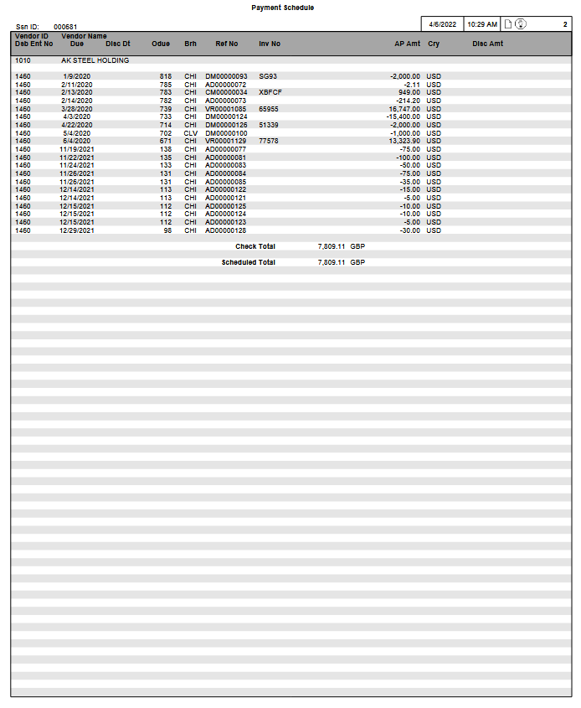

Report Structure

Report Field Description
Group | Report Field | Business Rules | Formatting
Header Line 1 | Vendor ID
 | Vendor Long Name
Detail Line 1 | Disbursement Entry Number
 | Due Date
 | Discount Date | If a Discount is offered but no Discount Amount has been applied, then the Discount Date does not appear on the report
 | Overdue Days | Represents the number of days in which the Report Date exceeds the Due Date
 | Branch
 | Reference Number |  | Reference Prefix and Number
 | Invoice Number
 | AP Amount
 | Currency
 | Discount Amount | If a Discount is offered but no Discount Amount has been applied, then the Discount Amount does not appear on the report
Totals | Check Total

CASH DISBURSEMENT EDIT REPORT

Overview
The Cash Disbursement Edit Report provides a list of payments for an Open Cash Disbursement Session that is in progress, as well as the corresponding AP Open Items.

The Report can be launched for a specific session via the Cash Disbursement Session Browse. Once the Session has been selected, the Print button is accessed in order to initiate the generation of the Report. At this point, the option exists to sequence the report by either Vendor ID or Vendor Name.

Target Audience
This Report is used to verify the Open Items scheduled for payment and the required cash amount. Disbursement entries can be modified prior to the Disbursement Update.

Frequency of Use
On demand

General Rules

Values
Accounts Payable Invoices are printed in the currency of the Invoice.

Data

Primary Source of Data
- APTDSH – Cash Disbursements

Grouped By
- Vendor ID or Vendor Name

Detail Line Sequenced By
Accounts Payable Invoice
- Due Date
- Reference Prefix and Number

Advance Payments
- Transactions are displayed in the order in which they were applied

GL Accounting Distributions
- Basic GL Account
- Subaccount

Page Breaks By
- No page breaks provided

Data Totaled by
- Check
- Report

Journal Summary
System-assigned Distributions
- Bank
- Accounts Payable
- Exchange Variance
- Exchange Gain/Loss
- Discounts

Miscellaneous Accounting Distributions (manually entered)
- Basic GL Account
- Subaccount

Accounting Distributions are sequenced according to the Basic GL Account and Subaccount.

Cash Disbursement Edit Report

Report Layout
Cash Disbursement Edit Report

Ssn ID: 999999 Brh: QQQ Jrnl Dt: MM/DD/YY Bank: QQQQQQQQQQQQQQQQQQQQQQQQQQQQQQQQQQQ Cry: QQQ Chk ExRt: ZZ.999999
Ven ID Vendor Name Dsb No Chk Dt Chk No T Bnk Pmt Ref Dsb Ent Rmks AR Balance Chk Amt
Due Dt Disc Dt Odue Brh Ref No/Pf Inv No/Description Amt Cry Disc Amt
GL Acct Subaccount Dr Amt Cr Amt

ZZZZZZZZ QQQQQQQQQQQQQQQQQQQQQQQQQQQQQQQQQQQ 99999999 MM/DD/YY ZZZZZZZZ Q QQQQQQQQQQQQQQQQQQQQQQ QQQQQQQQQQQQQQQQQQQQQQQQQQQQQQQQQQQQQQQQQQQQQ ZZZ,ZZZ,ZZ9.99
Z,ZZZ,ZZZ,ZZZ.ZZ-
MM/DD/YY MM/DD/YY ZZZZ QQQ QQ99999999 QQQQQQQQQQQQQQQQQQQQQQQQQQQQQQ ZZZZ,ZZ9.99- QQQ ZZZZ,ZZZ.ZZ
MM/DD/YY MM/DD/YY ZZZZ QQQ QQ99999999 QQQQQQQQQQQQQQQQQQQQQQQQQQQQQQ ZZZZ,ZZ9.99- QQQ ZZZZ,ZZZ.ZZ
MM/DD/YY MM/DD/YY ZZZZ QQQ QQ99999999 QQQQQQQQQQQQQQQQQQQQQQQQQQQQQQ ZZZZ,ZZ9.99- QQQ ZZZZ,ZZZ.ZZ

ZZZZZZZZ QQQQQQQQQQQQQQQQQQQQQQQQQQQQQQQQQQQ 99999999 MM/DD/YY ZZZZZZZZ Q QQQQQQQQQQQQQQQQQQQQQQ QQQQQQQQQQQQQQQQQQQQQQQQQQQQQQQQQQQQQQQQQQQQQ ZZZ,ZZZ,ZZ9.99
Z,ZZZ,ZZZ,ZZZ.ZZ-
MM/DD/YY MM/DD/YY ZZZZ QQQ QQ99999999 QQQQQQQQQQQQQQQQQQQQQQQQQQQQQQ ZZZZ,ZZ9.99- QQQ ZZZZ,ZZZ.ZZ
MM/DD/YY MM/DD/YY ZZZZ QQQ QQ99999999 QQQQQQQQQQQQQQQQQQQQQQQQQQQQQQ ZZZZ,ZZ9.99- QQQ ZZZZ,ZZZ.ZZ
QQQQQQQQ QQQQQQQQQQQQQQQQQQQQQQQQQQQQQQ ZZZZ,ZZZ.ZZ- QQQ ZZZZ,ZZZ.ZZ- QQQ

DISBURSED TOTAL ZZZ,ZZZ,ZZ9.99-

-----------------------------------------------------------------------------------------------------------------------------JOURNAL SUMMARY-----------------------------------------------------------------------------------------------------------------------------
--------------------------------------------------------------------------------------------------------------------------------------------------------------------------------------------------------------------------------------------------------------------------------------
Base Cry: QQQ

GL Acct Description Subaccount Dr Amt Cr Amt
QQQQQQQQ QQQQQQQQQQQQQQQQQQQQQQQQQQQQQQ QQQQQQQQQQQQQQQQQQQQQQQQQQQQQQ ZZZZ,ZZZ.ZZ ZZZZ,ZZZ.ZZ
QQQQQQQQ QQQQQQQQQQQQQQQQQQQQQQQQQQQQQQ QQQQQQQQQQQQQQQQQQQQQQQQQQQQQQ ZZZZ,ZZZ.ZZ ZZZZ,ZZZ.ZZ
QQQQQQQQ QQQQQQQQQQQQQQQQQQQQQQQQQQQQQQ QQQQQQQQQQQQQQQQQQQQQQQQQQQQQQ ZZZZ,ZZZ.ZZ ZZZZ,ZZZ.ZZ
QQQQQQQQ QQQQQQQQQQQQQQQQQQQQQQQQQQQQQQ QQQQQQQQQQQQQQQQQQQQQQQQQQQQQQ ZZZZ,ZZZ.ZZ ZZZZ,ZZZ.ZZ
QQQQQQQQ QQQQQQQQQQQQQQQQQQQQQQQQQQQQQQ QQQQQQQQQQQQQQQQQQQQQQQQQQQQQQ ZZZZ,ZZZ.ZZ ZZZZ,ZZZ.ZZ

QQQQQQQQ QQQQQQQQQQQQQQQQQQQQQQQQQQQQQQ QQQQQQQQQQQQQQQQQQQQQQQQQQQQQQ ZZZZ,ZZZ.ZZ ZZZZ,ZZZ.ZZ

Total ZZZ,ZZZ,ZZ9.99 ZZZ,ZZZ,ZZ9.99

Example (Sequenced by Vendor ID)
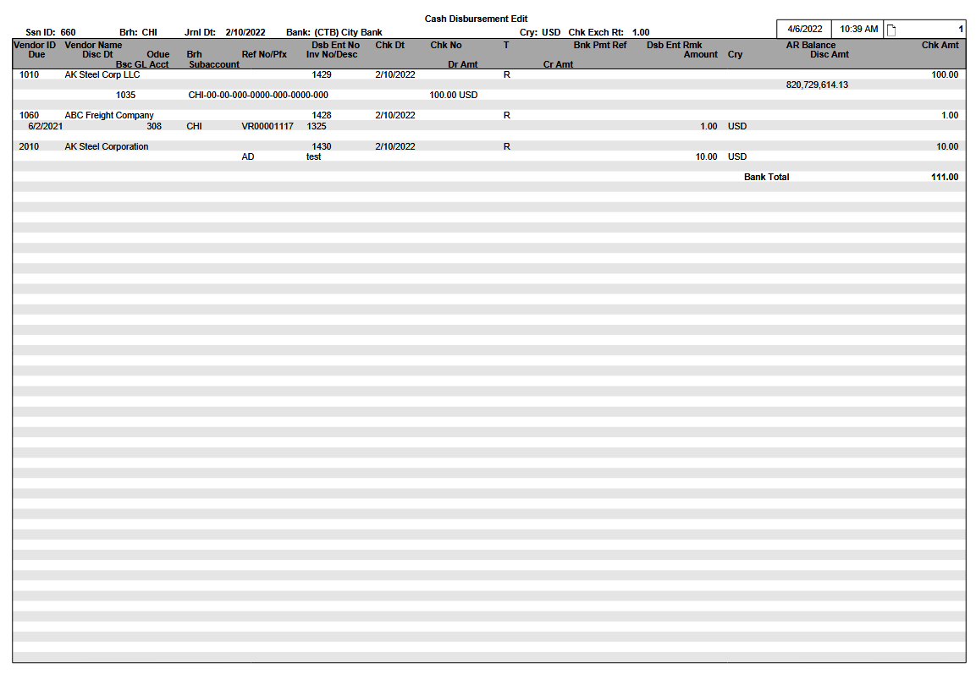
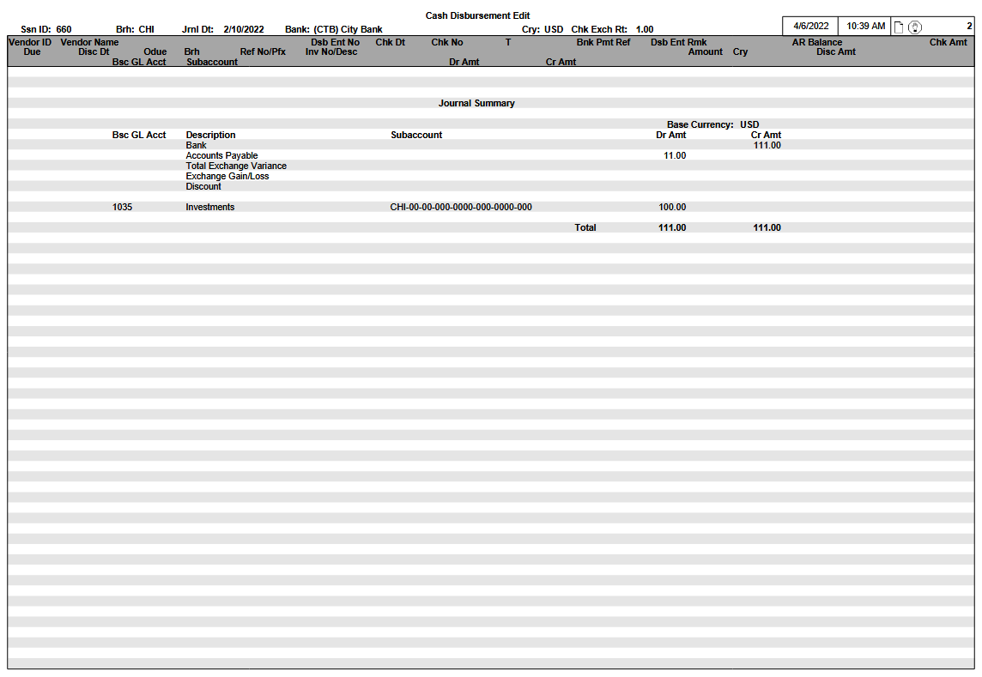

Report Structure

Report Field Description
Group | Report Field | Field Name | Business Rules | Formatting
 | Session ID
 | Disbursing Branch
 | Journal Date
 | Bank Name
 | Check Currency
 | Check Exchange Rate |  | Only shown if the Check Currency differs from the Base Currency
Header Line 1 | Vendor ID
 | Vendor Name | For Regular Vendors, the Vendor Name comes from the Name1 field in TCTNAD  For Miscellaneous Vendors, the Vendor Name comes from either the Vendor Long Name (if one exists) or the Vendor Name on the Vendor Account
 | Disbursement Entry Number
 | Check Date
 | Check Number
 | Payment Type
 | Bank Payment Reference
 | Disbursement Entry Remarks
 | Check Amount
Header Line 2 |  |  |  | Accounts Receivable Balance  - Line is only printed by exception if the Vendor has a Customer ID defined in the Accounts Receivable system (APRVEN-RLTD-CUS-ID) with a non-zero A/R Balance.  - Vendor’s Customer ID must be entered in the Vendor Account (in the Related Customer ID field)  Denoted in Base Currency
 | AR Balance | COC-AR-BAL
Detail Line 1 | Due Date
 | Discount Date
 | Overdue Days |  | Represents the number of days that the System Date exceeds the Due Date
 | AP Branch
 | Reference Number/Advance Prefix |  |  | If any Advance Payments have been applied, then the Advance Prefix is printed in the same space that is occupied by the Reference Prefix and Number
 | Vendor Invoice Number/Description |  |  | If any Advance Payments have been applied, then the Description is printed in the same space that is occupied by the Vendor Invoice Number
 | AP Amount/Advance Amount |  |  | If any Advance Payments have been applied, then the Advance Payment is printed in the same space that is occupied by the AP Amount
 | Currency |  |  | Advance Amount denoted in Check Currency
 | Discount Amount
Detail Line 2 | Basic GL Account
 | Subaccount |  |  | Subaccount components use hyphen separators
 | Debit Amount |  |  | Denoted in Base Currency
 | Credit Amount |  |  | Denoted in Base Currency
Totals | Check Total
Journal Summary  (System-assigned Distributions) | Bank |  | Total of Check Amounts  Bank Amount is always printed in the Credit Amount field
 | Accounts Payable | For Regular Checks, Manual Checks, and Transfers:  Total Distributed Amount (from the AP Distribution Totals table) + Total Advance Distributed Amount (from the AP Distribution Totals table)  For Adjustments:  Distributed Amount (from the AP Distribution table) + Total Advance Distributed Amount (from the AP Distribution Totals table)  Please note that the Distributed Amount from APTDSD must be converted to Base Currency (Distributed Amount * Open Item Exchange Rate) | If the value is positive, then it is printed in the Debit Amount field.  If the value is negative, then it is printed in the Credit Amount field. | If the value is negative, then it is printed without the negative sign
 | Exchange Variance | Total Exchange Variance Amount (from the AP Distribution Totals table) | Only printed if the Bank Account is not in Base Currency  If the Total Exchange Variance is positive, then it is printed in the Debit Amount field  If the Total Exchange Variance is negative, then it is printed in the Credit Amount field. | If the Total Exchange Variance is negative, then it is printed without the negative sign
 | Exchange Gain/Loss | Total Exchange Gain/Loss (from the AP Distribution Totals table) | If the value is a gain, then the amount is positive and it is printed in the Credit Amount field  If the value is a loss, then the amount is negative and it is printed in the Debit Amount field | If the value is a loss, then it is printed without the negative sign
 | Discounts | Total Discount Taken Amount (from the AP Distribution Totals table) | Discounts are always printed in the Credit Amount field
Manually entered Accounting Distributions | Basic GL Account |  |  | Accounting Distributions are to be sub-totaled if they belong to the same GL Account/Subaccount combination
 | Subaccount |  |  | Subaccount components use hyphen separators
 | Debit Amount
 | Credit Amount

CASH DISBURSEMENT JOURNAL

Overview
The Cash Disbursement Journal displays a listing of issued checks, sequenced by Bank.

Target Audience
Accounting staff compares the Cash Disbursement Journal with the Cash Disbursement Edit Report to ensure that every Cash Disbursement appears properly on each document.

The Cash Disbursement Journal is also used as a verification report for the Period-End Balancing procedures. Please refer to the ‘INVEX Interface to General Ledger’ document for further details.

Frequency of Use
Monthly

Selection Options
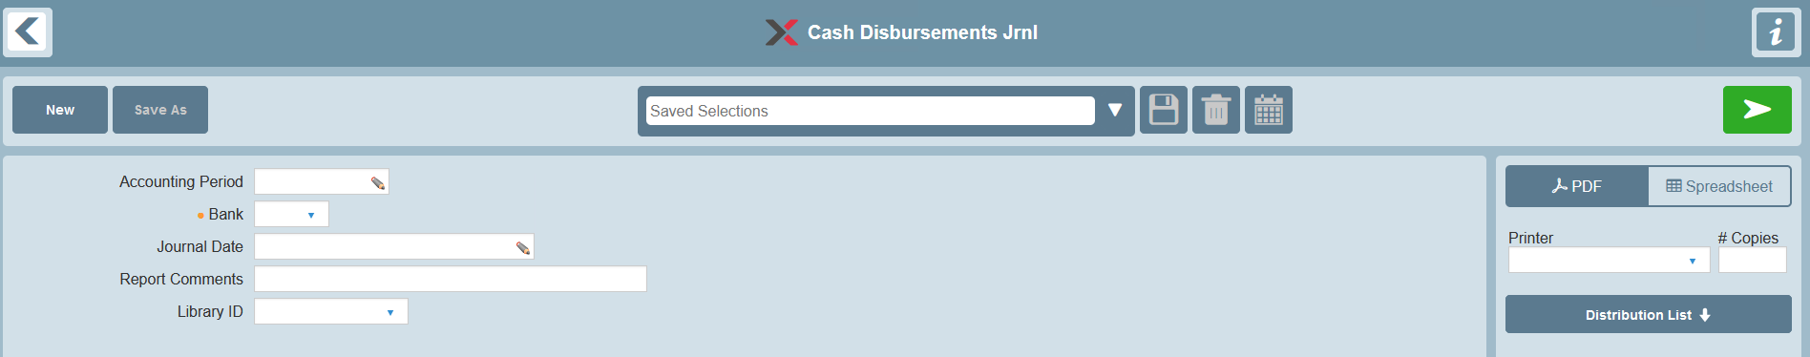

The report selections are listed below along with specific notes on their use in this report:

Selection | Valid Values | Default | Notes
Accounting Period | If selected, must be a specific Accounting Period. |  | Optional selection.  Look-up provided.  Please refer to the ‘Accounting Period Business Rules’ section for details on how this selection filter is used.
Bank | Specific bank code |  | Mandatory selection  Voided Checks  The Bank Code of the Voided Check is used as the selection filter.
Journal Date | Specific date range |  | Optional selection.  Voided Checks  The Update Date of the Voided Check is used as the selection filter.
Report Comments |  | None | Provides an option to print Report comments on the Selection page of the Report
Library ID | None or specific Library ID | None | Provides an option to select a Library ID for generic remarks to be printed on the Selection page of the Report

Accounting Period Business Rules
- When the Accounting Period selection is used, transaction filtering is determined based on the Accounting Period selection and the ‘Period Beginning Date’ and ‘Period Ending Date’ range in the Fiscal Calendar enterprise parameter.
- Cash Disbursements Journal transactions are included on the report if the Journal Date (or the Update Date for Voided Checks) is:
- greater than or equal to the corresponding Accounting Period’s Period Beginning Date, and
- less than or equal to the corresponding Accounting Period’s Period Ending Date

General Rules

Values
- Accounts Payable Invoices are printed in the currency of the Invoice

Data

Primary Source of Data
- APJDBJ – Cash Disbursements Journal
- APJDJV – Cash Disbursements Journal Void Checks
- APJDDJ – Cash Disbursements Journal Detail
- APJDUJ – Cash Disbursements Journal Advance Payment Distribution
- APJAGJ – Cash Disbursements Journal GL Distribution
- APJDNJ – Cash Disbursements Journal Name/Address

Grouped By
- Bank

Detail Line Sequenced By
- Check Number
- Disbursement Reference Number

Please note that Voided Checks are also included in the regular sort sequence.

Accounts Payable Invoices
- Reference Prefix and Number

Advance Payments
- Transactions are displayed in the order in which they were applied

Miscellaneous Accounting Distributions (manually entered)
- Basic GL Account
- Subaccount
- Page Breaks By
- Journal Summary Recap

Data Totaled By
- Check
- Report

Journal Summary Recap (New Page)

System-assigned Accounting Distributions
- Bank
- Accounts Payable (by branch)
- There is one summary distribution line recap for Accounts Payable for each branch that has transactions. The branch recap is based on the following business cases:
- Business Case 1 – Applications of existing AP Open Items. The branch recap is based on the AP Branch.
- Business Case 2 – Creation of new Advance Payments. The branch recap is based on the Cash Disbursement Branch.
- Exchange Variance
- Exchange Gain/Loss
- Discounts

Miscellaneous Accounting Distributions (Manually Entered)
- Basic GL Account
- Subaccount

Miscellaneous Accounting Distributions are sequenced according to the Basic GL Account and Subaccount.

A single grand totaling is provided for both the ‘INVEX Accounting Distributions’ and ‘Manual Accounting Distributions’ sections together.

Cash Disbursement Journal

Report Layout
Cash Disbursement Journal
Bank Name: (QQQ) QQQQQQQQQQQQQQQQQQQQQQQQQQQQQQQQQQQ Cry: QQQ
Chk No Dsb Ref Chk Dt Chk ExRt Jrnl Dt Brh T Ven ID Vendor Name Bnk Pmt Ref Chk Amt
Brh Ref No AP Amt Cry Disc Amt
Pf Description Adv Amt
GL Acct Subaccount Dr Amt Cr Amt
ZZZZZZZZ 99999999 MM/DD/YY ZZ.999999 MM/DD/YY QQQ Q ZZZZZZZZ QQQQQQQQQQQQQQQQQQQQQQQQQQQQQQQQQQQ QQQQQQQQQQQQQQQQQQQQQQ ZZZ,ZZZ,ZZ9.99-
QQQ QQ99999999 ZZZZ,ZZ9.99- QQQ ZZZZ,ZZZ.ZZ
QQQ QQ99999999 ZZZZ,ZZ9.99- QQQ ZZZZ,ZZZ.ZZ
QQQ QQ99999999 ZZZZ,ZZ9.99- QQQ ZZZZ,ZZZ.ZZ
QQ QQQQQQQQQQQQQQQQQQQQQQQQQQQQQQ ZZZZ,ZZ9.99- QQQ
QQQQQQQQ QQQQQQQQQQQQQQQQQQQQQQQQQQQQQQ ZZZZ,ZZZ.ZZ- QQQ ZZZZ,ZZZ.ZZ- QQQ
ZZZZZZZZ *** Check has been Voided ***

ZZZZZZZZ 99999999 MM/DD/YY ZZ.999999 MM/DD/YY QQQ Q ZZZZZZZZ QQQQQQQQQQQQQQQQQQQQQQQQQQQQQQQQQQQ QQQQQQQQQQQQQQQQQQQQQQ ZZZ,ZZZ,ZZ9.99-
QQQ QQ99999999 ZZZZ,ZZ9.99- QQQ ZZZZ,ZZZ.ZZ
QQQ QQ99999999 ZZZZ,ZZ9.99- QQQ ZZZZ,ZZZ.ZZ
QQ QQQQQQQQQQQQQQQQQQQQQQQQQQQQQQ ZZZZ,ZZ9.99- QQQ
QQQQQQQQ QQQQQQQQQQQQQQQQQQQQQQQQQQQQQQ ZZZZ,ZZZ.ZZ- QQQ ZZZZ,ZZZ.ZZ- QQQ

Bank Total ZZZ,ZZZ,ZZ9.99-
----------------------------------------------------------------------------------------------------------------------------------------------------------------------------------------------------------------
Journal Summary (new page)
----------------------------------------------------------------------------------------------------------------------------------------------------------------------------------------------------------------
Base Cry: QQQ
INVEX Accounting Distributions
Description Dr Amt Cr Amt
QQQQQQQQQQQQQQQQQQQQQQQQQQQQQQ ZZZZ,ZZZ.ZZ ZZZZ,ZZZ.ZZ
Bank ZZZZ,ZZZ.ZZ ZZZZ,ZZZ.ZZ
Accounts Payable – CHI ZZZZ,ZZZ.ZZ ZZZZ,ZZZ.ZZ
Accounts Payable – DET ZZZZ,ZZZ.ZZ ZZZZ,ZZZ.ZZ
Exchange Variance ZZZZ,ZZZ.ZZ ZZZZ,ZZZ.ZZ
Exchange Gain/Loss ZZZZ,ZZZ.ZZ ZZZZ,ZZZ.ZZ
Discounts ZZZZ,ZZZ.ZZ ZZZZ,ZZZ.ZZ

Manual Accounting Distributions
GL Acct Description Subaccount Dr Amt Cr Amt
QQQQQQQQ QQQQQQQQQQQQQQQQQQQQQQQQQQQQQQ QQQQQQQQQQQQQQQQQQQQQQQQQQQQQQ ZZZZ,ZZZ.ZZ ZZZZ,ZZZ.ZZ
QQQQQQQQ QQQQQQQQQQQQQQQQQQQQQQQQQQQQQQ QQQQQQQQQQQQQQQQQQQQQQQQQQQQQQ ZZZZ,ZZZ.ZZ ZZZZ,ZZZ.ZZ

Total ZZZ,ZZZ,ZZ9.99 ZZZ,ZZZ,ZZ9.99
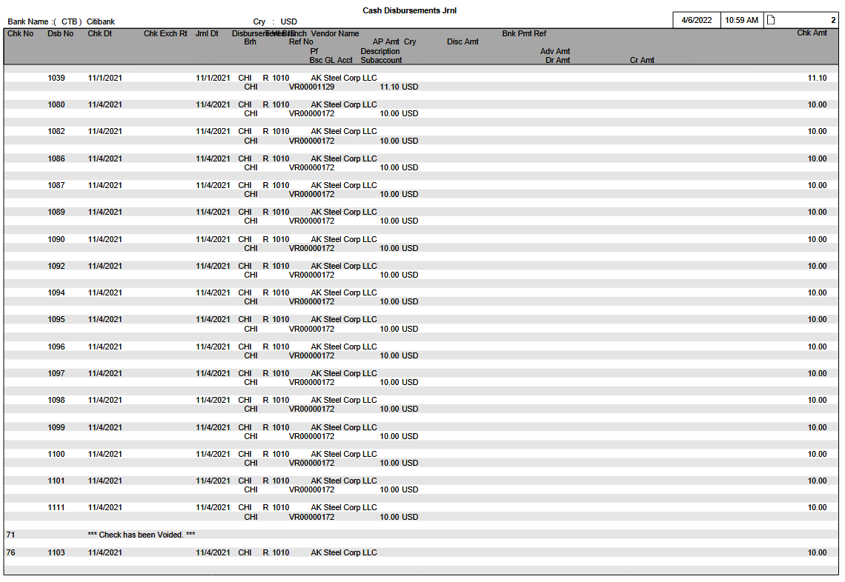
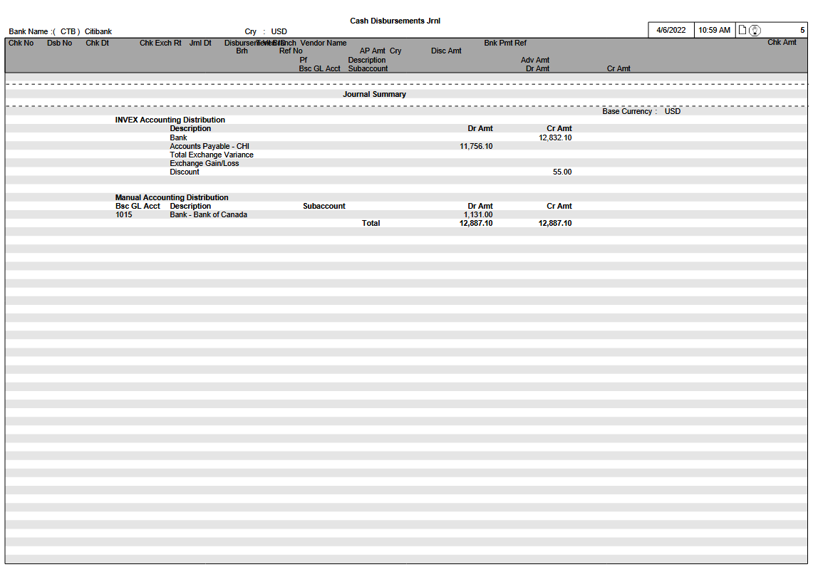

Report Structure

Report Field Description
Group | Report Field | Field Name | Business Rules | Formatting
 | Bank Name | DBJ-BNK  BNK-DESC30 |  | Bank code is printed in parentheses before Bank Name
 | Currency | DBJ-DSB-CRY
Header Line 1 | Check Number | DBJ-VEN-CHK-NO  or  DJV-VEN-CHK-NO | If Payment Type =‘T’, this field represents the Transfer Reference Number | The special notation:  *** Check has been Voided ***  is printed for the business case where the Check Number was Voided.
 | Disbursement Reference Number | DBJ-DSB-NO
 | Check Date | DBJ-VEN-CHK-DT
 | Check Exchange Rate | DBJ-DSB-EX-RT | Only shown if the Check Currency differs from the Base Currency
 | Journal Date | DBJ-JRNL-DT
 | Disbursing Branch | DBJ-DSB-BRH
 | Payment Type | DBJ-PMT-TYP
 | Vendor ID | DBJ-VEN-ID
 | Vendor Name | From the Name1 field in APJDNJ
 | Bank Payment Reference | DBJ-BNK-PMT-REF
 | Check Amount | DBJ-VEN-CHK-AMT
Header Line 2 | AP Branch | PYH-AP-BRH
 | Reference Number | DDJ-OPA-PFX  DDJ-OPA-NO |  | Reference Prefix and Number  ‘VR123’
 | AP Amount
 | Currency | DDJ-AP-CRY
 | Discount Amount | DDJ-DISC-TKN-AMT
Detail Line 1 | Advance Prefix | DUJ-ADV-DSB-PFX
 | Description | DUJ-DESC30
 | Advance Amount | DUJ-ADV-AMT |  | Denoted in Check Currency
Detail Line 2 | Basic GL Account | AGJ-BSC-GL-ACCT
 | Subaccount | AGJ-SACCT |  | Subaccount components use hyphen separators
 | Debit Amount | AGJ-DR-AMT |  | Denoted in Base Currency
 | Credit Amount | AGJ-CR-AMT |  | Denoted in Base Currency
Totals Line | Bank Total | Calculated | Total of Check Amounts
Journal Summary Recap
(System-assigned Accounting Distributions) | Bank | Calculated | - Total of Check Amounts.  - If the Total Check Amount is negative (due to a Disbursement Reversal), it is printed in the Debit Amount field.  - If the Total Check Amount is positive, it is printed in the Credit Amount field. | If the Total Check Amount is negative, then it is printed without the negative sign.
 | Debit Amount
 | Credit Amount
 | Accounts Payable  (by branch) | Business Case 1  Calculated by AP branch (PYH-AP-BRH).  Business Case 2  Calculated by Cash Disbursements branch (DBJ-DSB-BRH). | Business Case 1  Applications of existing AP Open Items:  ∑ [(DDJ-DSAMT) * (PYH-EX-RT)]  Business Case 2  Creation of new Advance Payments:  ∑ [(DUJ-ADV-AMT) * (DBJ-DSB-EX-RT)]  - If the ‘Accounts Payable’ is positive, then it is printed in the Debit Amount field.  - If the ‘Accounts Payable’ is negative, then it is printed in the Credit Amount field. | If the ‘Accounts Payable’ is negative, then it is printed without the negative sign.
 | Debit Amount
 | Credit Amount
 | Exchange Variance | ∑  Total Exchange Variance Amount (from the Cash Disb Journal Distribution Totals table) | - Only printed if the Bank Account is not in Base Currency.  - If the ‘Exchange Variance’ is positive, then it is printed in the Debit Amount field.  - If the ‘Exchange Variance’ is negative, then it is printed in the Credit Amount field. | If the ‘Exchange Variance’ is negative, then it is printed without the negative sign.
 | Debit Amount
 | Credit Amount
 | Exchange Gain/Loss | ∑  Total Exchange Gain/Loss (from the Cash Disb Journal Distribution Totals table) | - If the value is a gain, then the amount is positive and it is printed in the Credit Amount field.  - If the value is a loss, then the amount is negative and it is printed in the Debit Amount field. | If the ‘Exchange Gain/Loss’ is negative, then it is printed without the negative sign.
 | Debit Amount
 | Credit Amount
 | Discounts | ∑  Total Discount Taken Amount (from the Cash Disb Journal Distribution Totals table) | - If the Total Discount Taken Amount is negative (due to a Disbursement Reversal), then it is printed in the Debit Amount field.  - If the Total Discount Taken Amount is positive, then it is printed in the Credit Amount field. | If the Total Discount Taken Amount is negative, then it is printed without the negative sign.
 | Debit Amount
 | Credit Amount
Manually entered Accounting Distributions | Basic GL Account |  |  | Accounting Distributions are sub-totaled if they belong to the same GL Account/Subaccount combination
 | Subaccount |  |  | Subaccount components use hyphen separators
 | Debit Amount
 | Credit Amount
 | Debit Amount |  | Combined recap total of:  - System-assigned distributions  - Manually entered distributions
 | Credit Amount |  | Combined recap total of:  - System-assigned distributions  - Manually entered distributions

PURCHASE JOURNAL

Overview
The Purchase Journal is used to view invoiced purchases accrued within a given period.

Target Audience
Accounting staff can use the Purchase Journal for analysis purposes.

The Purchase Journal is also used as a verification report for the Period-End Balancing procedures. Please refer to the ‘INVEX Interface to General Ledger’ document for further details.

Frequency of Use
Monthly

Selection Options
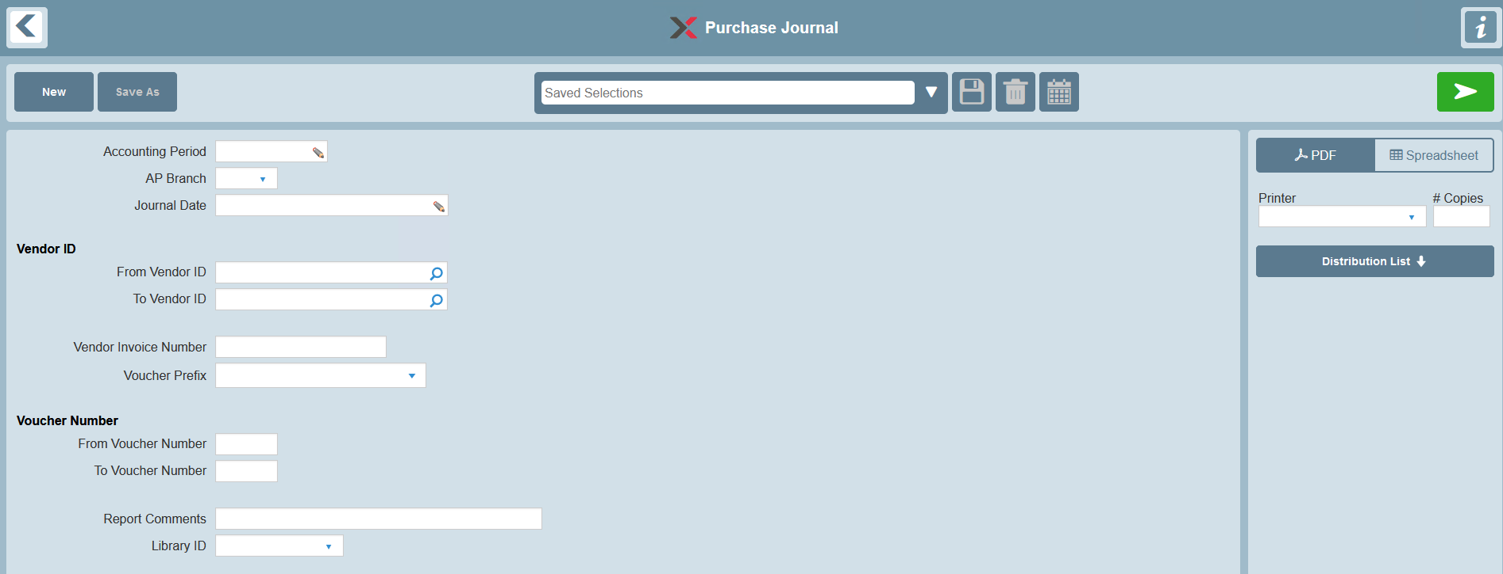

The report selections are listed below along with specific notes on their use in this report:
Selection | Valid Values | Default | Notes
Accounting Period | If selected, must be a specific Accounting Period. |  | Optional selection.  Lookup provided.  Please refer to the ‘Accounting Period Business Rules’ section for details on how this selection filter is used.
AP Branch | All or specific value | All
Journal Date | Specific date range |  | Optional selection.
Vendor ID | All or range | All
Vendor Invoice Number | All or specific value | All
Voucher Prefix | All or specific value | All
Voucher Number | All or range | All
Report Comments |  | None | Provides an option to print Report comments on the Selection page of the Report
Library ID | None or specific Library ID | None | Provides an option to select a Library ID for generic remarks to be printed on the Selection page of the Report

Accounting Period Business Rules
- When the Accounting Period selection is used, transaction filtering is determined based on the Accounting Period selection and the ‘Period Beginning Date’ and ‘Period Ending Date’ range in the Fiscal Calendar enterprise parameter.
- Purchase Journal transactions are included on the report if the Reference (Voucher Entry) Date is within the following range:
- greater than or equal to the corresponding Accounting Period’s 'Period Beginning Date', and
- less than or equal to the corresponding Accounting Period’s 'Period Ending Date'

Restrictions
By exception, if Accounting Period 13 is selected and the transaction's Reference Date was already defined within the Accounting Period 12 range of the Fiscal Calendar, then the transaction is not eligible and is excluded on the Accounting Period 13 report.

General Values

Values
Accounts Payable Invoices are printed in the currency of the Invoice

Data

Primary source of Data
- APJJVC – Purchase Journal

Detail Line Sequenced By
- Journal Date
- Reference Prefix and Number

Miscellaneous Accounting Distributions (manually entered) (supported for General Ledger licensees)
- Basic GL Account
- Subaccount

Page Breaks By
- Journal Summary Recap

Journal Summary Recap (New Page)
- Total Vouchers
- Total Debit Memos
- Total Credit Memos

System-assigned Accounting Distributions
- Unpaid Receipts
- Accounts Payable (by branch)
- There is one summary distribution line recap for Accounts Payable for each Voucher branch that has transactions. The branch recap is based on the following:
- the Voucher Branch
- the sum of the Voucher amounts in base currency equivalent
- Accrued Taxes
- Exchange Gain/Loss

Miscellaneous Accounting Distributions (manually entered)
- Basic GL Account
- Subaccount

Miscellaneous Accounting Distributions are sequenced according to the Basic GL Account and Subaccount.

A single grand totaling is provided for both the ‘INVEX Accounting Distributions’ and ‘Manual Accounting Distributions’ sections together.

Report Layout
Purchase Journal

Jrnl Dt Ven ID Vendor Name Ref Dt Inv No
Ref No Description Disc Dt Due Dt AP Amt Cry Disc Amt ExRt
GL Acct Subaccount Dr Amt Cr Amt
MM/DD/YY ZZZZZZZZ QQQQQQQQQQQQQQQQQQQQQQQQQQQQQQQQQQQ MM/DD/YY QQQQQQQQQQQQQQQQQQQQQQ
QQ99999999 QQQQQQQQQQQQQQQQQQQQQQQQQQQQQQ MM/DD/YY MM/DD/YY ZZZZ,ZZ9.99- QQQ ZZ,ZZZ.ZZ ZZ.999999
QQQQQQQQ QQQQQQQQQQQQQQQQQQQQQQQQQQQQQQ ZZZZ,ZZZ.ZZ- QQQ ZZZZ,ZZZ.ZZ- QQQ

MM/DD/YY ZZZZZZZZ QQQQQQQQQQQQQQQQQQQQQQQQQQQQQQQQQQQ MM/DD/YY QQQQQQQQQQQQQQQQQQQQQQ
QQ99999999 QQQQQQQQQQQQQQQQQQQQQQQQQQQQQQ MM/DD/YY MM/DD/YY ZZZZ,ZZ9.99- QQQ ZZ,ZZZ.ZZ ZZ.999999
QQQQQQQQ QQQQQQQQQQQQQQQQQQQQQQQQQQQQQQ ZZZZ,ZZZ.ZZ- QQQ ZZZZ,ZZZ.ZZ- QQQ

MM/DD/YY ZZZZZZZZ QQQQQQQQQQQQQQQQQQQQQQQQQQQQQQQQQQQ MM/DD/YY QQQQQQQQQQQQQQQQQQQQQQ
QQ99999999 QQQQQQQQQQQQQQQQQQQQQQQQQQQQQQ MM/DD/YY MM/DD/YY ZZZZ,ZZ9.99- QQQ ZZ.ZZZ.ZZ ZZ.999999
QQQQQQQQ QQQQQQQQQQQQQQQQQQQQQQQQQQQQQQ ZZZZ,ZZZ.ZZ- QQQ ZZZZ,ZZZ.ZZ- QQQ

----------------------------------------------------------------------------------------------------------------------------------------------------------------------------------------
Journal Summary (new page)
----------------------------------------------------------------------------------------------------------------------------------------------------------------------------------------
Base Cry: QQQ
Vouchers ZZZZ,ZZ9.99-
Debit Memos ZZZZ,ZZ9.99-
Credit Memos ZZZZ,ZZ9.99-

INVEX Accounting Distributions
Description Dr Amt Cr Amt
QQQQQQQQQQQQQQQQQQQQQQQQQQQQQQ ZZZZ,ZZZ.ZZ ZZZZ,ZZZ.ZZ
Unpaid Receipts ZZZZ,ZZZ.ZZ ZZZZ,ZZZ.ZZ
Accounts Payable – CHI ZZZZ,ZZZ.ZZ ZZZZ,ZZZ.ZZ
Accounts Payable – DET ZZZZ,ZZZ.ZZ ZZZZ,ZZZ.ZZ
Accrued Taxes ZZZZ,ZZZ.ZZ ZZZZ,ZZZ.ZZ
Exchange Gain/Loss ZZZZ,ZZZ.ZZ ZZZZ,ZZZ.ZZ

Manual Accounting Distributions
GL Acct Description Subaccount Dr Amt Cr Amt
QQQQQQQQ QQQQQQQQQQQQQQQQQQQQQQQQQQQQQQ QQQQQQQQQQQQQQQQQQQQQQQQQQQQQQ ZZZZ,ZZZ.ZZ ZZZZ,ZZZ.ZZ
QQQQQQQQ QQQQQQQQQQQQQQQQQQQQQQQQQQQQQQ QQQQQQQQQQQQQQQQQQQQQQQQQQQQQQ ZZZZ,ZZZ.ZZ ZZZZ,ZZZ.ZZ
QQQQQQQQ QQQQQQQQQQQQQQQQQQQQQQQQQQQQQQ QQQQQQQQQQQQQQQQQQQQQQQQQQQQQQ ZZZZ,ZZZ.ZZ ZZZZ,ZZZ.ZZ

Total ZZZZ,ZZZ.ZZ ZZZZ,ZZZ.ZZ

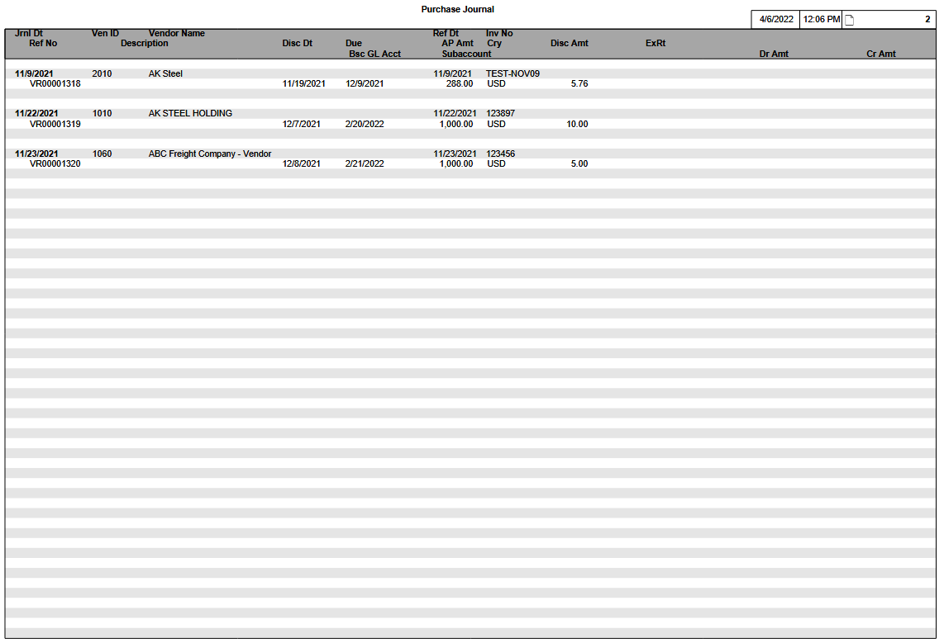
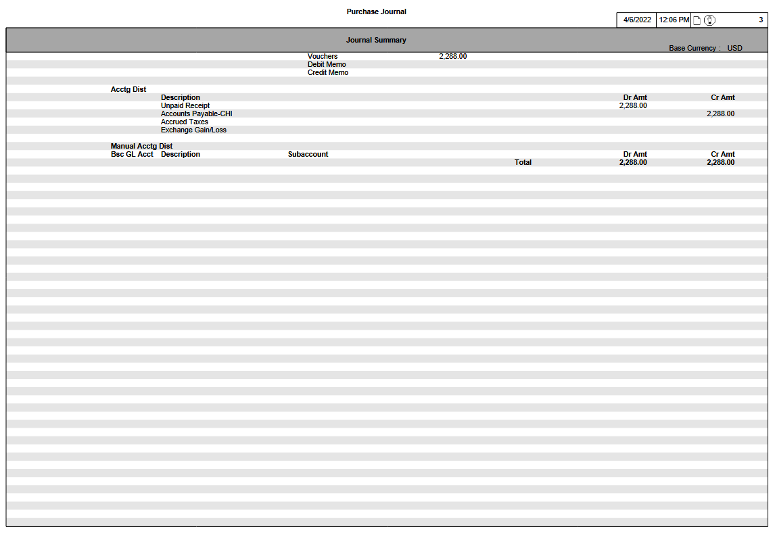

Report Structure

Report Field Description
Group | Report Field | Field Name | Business Rules | Formatting
Header Line 1 | Journal Date | JVC-ENT-DT
 | Vendor ID | JVC-VEN-ID
 | Vendor Long Name
 | Reference Date | JVC-VEN-INV-DT
 | Invoice Number | JVC-VEN-INV-NO
Header Line 2 | Reference Number | JVC-VCHR-PFX  JVC-VCHR-NO |  | Reference Prefix and Number  ‘VR123’
 | Description | JVC-DESC30
 | Discount Date | JVC-DISC-DT
 | Due Date | JVC-DUE-DT
 | AP Amount | JVC-VCHR-AMT
 | Currency | JVC-CRY
 | Discount Amount | JVC-DISC-AMT
 | Exchange Rate | JVC-EX-RT | Only printed if the AP Currency differs from the Base Currency
Detail Line 1 | Basic GL Account | GLJ-BSC-GL-ACCT
 | Subaccount | GLJ-SACCT |  | Subaccount components use hyphen separators
 | Debit Amount | GLJ-DR-AMT |  | Denoted in Base Currency
 | Credit Amount | GLJ-CR-AMT |  | Denoted in Base Currency
Journal Summary Recap | Vouchers | Calculated | Sum of Voucher amounts  ∑(AP Amount * ExRt) | Denoted in Base Currency
 | Debit Memos | Calculated | Sum of Debit Memo amounts  ∑(AP Amount * ExRt) | Denoted in Base Currency
 | Credit Memos | Calculated | Sum of Credit Memo amounts  ∑(AP Amount * ExRt) | Denoted in Base Currency
(System-assigned Accounting Distributions) | Unpaid Receipts | ‘Total Distributed Amount’ field (from the Purchase Journal Distribution Totals table APJPJT)  PJT-TDSAMT | If the ‘Unpaid Receipts’ amount is positive, then it is printed in the Debit Amount field.  If the ‘Unpaid Receipts’ amount is negative, then it is printed in the Credit Amount field. | If the ‘Unpaid Receipts’ amount is negative, then it is printed without the negative sign.
 | Debit Amount
 | Credit Amount
 | Accounts Payable | Calculated by branch | ∑(Voucher amounts + Credit Memo amounts) - ∑(Debit Memo amounts) by branch, expressed in base currency.  If the ‘Accounts Payable’ amount is positive, then it is printed in the Credit Amount field.  If the ‘Accounts Payable’ amount is negative, then it is printed in the Debit Amount field. | If the ‘Accounts Payable’ amount is negative, then it is printed without the negative sign.
 | Debit Amount
 | Credit Amount
 | Accrued Taxes | Tax Amount (from the Purchase Journal Tax Distribution table – APJPTX) | The Tax Amount is stored in the Voucher currency so it must be converted to Base currency for inclusion on the report.  In order to convert the Tax Amount to Base Currency, the following formula is used:  Tax Amount * Exchange Rate (Exchange Rate is from the Purchase Journal table – APJJVC)  If the ‘Accrued Taxes’ amount is positive, then it is printed in the Debit Amount field.  If the ‘Accrued Taxes’ amount is negative, then it is printed in the Credit Amount field. | If the ‘Accrued Taxes’ amount is negative, then it is printed without the negative sign.
 | Debit Amount
 | Credit Amount
 | Exchange Gain/Loss | ∑  [Total Exchange Gain/Loss (from the Purchase Journal Distribution Totals table)]  +  [‘Net Grand Total Accounting Distribution’ (Calculation)]⁽¹⁾ | - If the value is a gain, then the amount is negative and it is printed in the Credit Amount field.  - If the value is a loss, then the amount is positive and it is printed in the Debit Amount field. | If the ‘Exchange Gain/Loss’ is negative, then it is printed without the negative sign.
 | Debit Amount
 | Credit Amount
(Manually entered Accounting Distributions) | Basic GL Account |  |  | Accounting Distributions are to be sub-totaled if they belong to the same GL Account/Subaccount combination.
 | Subaccount |  |  | Subaccount components use hyphen separators.
 | Debit Amount
 | Credit Amount
 | Debit Amount |  | Combined recap total of:  - System-assigned distributions  - Manually entered distributions
 | Credit Amount |  | Combined recap total of:  - System-assigned distributions  - Manually entered distributions

⁽¹⁾In addition to the standard Exchange Gain/Loss portion that is already stored with the Purchase Journal transactions, determination of an additional Exchange Gain/Loss portion would be required due to minor rounding discrepancies that may occur as a result of translating all components of a foreign currency transaction into the equivalent Base Currency. Such discrepancies would otherwise cause the corresponding financial Accounting Distribution grand totals to be unbalanced.

The additional Exchange Gain/Loss calculation feature is only applicable where all the following conditions apply:

- At least one transaction on the report is denominated in a foreign currency
- the ‘Net Grand Total Accounting Distribution’ is not zero

The Net Grand Total Accounting Distribution is defined as follows:
- Net Grand Total Accounting Distribution = (Report Grand Total Credit Amounts) – (Report Grand Total Debit Amounts)

OUTSTANDING CHECKS LIST

Overview
The Outstanding Checks List prints the status of Checks issued through a specific bank account and up to a given Accounting Period, to facilitate reconciliation.

To obtain a listing that is as current as possible, the Accounting staff should ensure that all Cash Disbursements have been completed (and checks printed) before printing the list.

If the listing is printed prior to running the Outstanding Checks Cleanup utility, the List will provide reconciliation status information on all Checks. If the listing is printed afterwards, it will only show Outstanding Checks.

Target Audience
Accounting staff use this report to assist in the monthly bank reconciliation procedures.

Frequency of Use
Monthly or on-demand

Report Selections
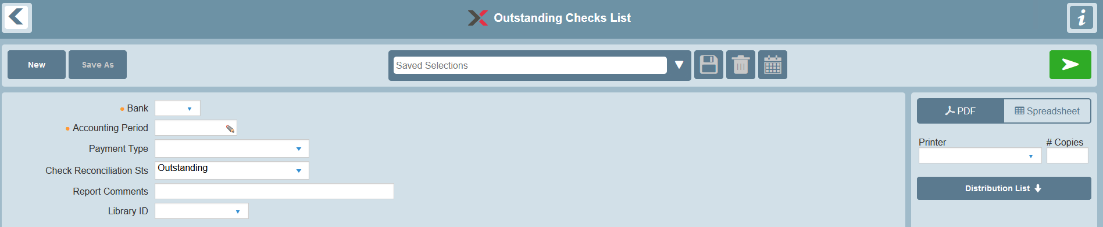

Selection Fields
Selection | Data Element | Valid Values | Default | Notes
Bank | BNK | Must be a valid Bank | None | Mandatory selection.  Look-up provided.
Accounting Period | ACCTG-PER | Must be a specific Accounting Period. |  | Mandatory selection.  Look-up provided.  Please refer to the ‘Accounting Period Business Rules’ section for details on how this selection filter is used.
Payment Type | PMT-TYP | M – Manual Check  R – Regular Check  T – Transfer | All
Reconciliation Status | CHK-RCN-STS | C – Cleared  O – Outstanding  S – Stop Payment | O – Outstanding
Report Comments | RPT-CMNT |  | None | Provides an option to print report comments on the Selection page of the report.
Library ID | LIB-ID | None or a specific Library ID | None | Provides an option to select a Library ID for generic remarks to be printed on the Selection page of the report.

Accounting Period Business Rules
- Transaction filtering is determined based on the Accounting Period selection and the ‘Period Ending Date’ in the Fiscal Calendar enterprise parameter.
- Transactions are assigned to an Accounting Period based on the Journal Date.
- Transactions are included on the report if the Journal Date is less than or equal to the corresponding Accounting Period’s Period Ending Date.

General Rules

Values
- Check Amounts are denominated according to the currency of the Bank.

Data

Primary Source of Data
- APTOSC – Outstanding Checks

Grouped By
- Accounting Period

Detail Line Sequenced By
- Check Number
- Payment Type

Page Breaks By
- Report Summary Recap (Bank Total)

Data Totaled By
- Accounting Period
- Bank (new page)

Report Sample (with no data)
Outstanding Checks List

Bank: (QQQ) QQQQQQQQQQQQQQQQQQQQQQQQQQQQQQ Cry: QQQ
Acctg Period -----------------------Amount------------------------
Chk No Typ Chk Dt Vendor No Payee Outstanding Cleared Stopped
YY/PP
ZZZZZZZ9 Q MM/DD/YYYY QQQQQQQQ QQQQQQQQQQQQQQQQQQQQQQQQQQQQQQQQQQQ ZZZ,ZZZ,ZZZ.ZZ- ZZZ,ZZZ,ZZZ.ZZ- ZZZ,ZZZ,ZZZ.ZZ-
ZZZZZZZ9 Q MM/DD/YYYY QQQQQQQQ QQQQQQQQQQQQQQQQQQQQQQQQQQQQQQQQQQQ ZZZ,ZZZ,ZZZ.ZZ- ZZZ,ZZZ,ZZZ.ZZ- ZZZ,ZZZ,ZZZ.ZZ-
ZZZZZZZ9 Q MM/DD/YYYY QQQQQQQQ QQQQQQQQQQQQQQQQQQQQQQQQQQQQQQQQQQQ ZZZ,ZZZ,ZZZ.ZZ- ZZZ,ZZZ,ZZZ.ZZ- ZZZ,ZZZ,ZZZ.ZZ-
ZZZZZZZ9 Q MM/DD/YYYY QQQQQQQQ QQQQQQQQQQQQQQQQQQQQQQQQQQQQQQQQQQQ ZZZ,ZZZ,ZZZ.ZZ- ZZZ,ZZZ,ZZZ.ZZ- ZZZ,ZZZ,ZZZ.ZZ-

YY/PP Total ZZZ,ZZZ,ZZ9.99- ZZZ,ZZZ,ZZ9.99- ZZZ,ZZZ,ZZ9.99-

Number of Checks Z,ZZZ Z,ZZZ Z,ZZZ

YY/PP
99999999 Q MM/DD/YYYY QQQQQQQQ QQQQQQQQQQQQQQQQQQQQQQQQQQQQQQQQQQQ ZZZ,ZZZ,ZZZ.ZZ- ZZZ,ZZZ,ZZZ.ZZ- ZZZ,ZZZ,ZZZ.ZZ-
99999999 Q MM/DD/YYYY QQQQQQQQ QQQQQQQQQQQQQQQQQQQQQQQQQQQQQQQQQQQ ZZZ,ZZZ,ZZZ.ZZ- ZZZ,ZZZ,ZZZ.ZZ- ZZZ,ZZZ,ZZZ.ZZ-
99999999 Q MM/DD/YYYY QQQQQQQQ QQQQQQQQQQQQQQQQQQQQQQQQQQQQQQQQQQQ ZZZ,ZZZ,ZZZ.ZZ- ZZZ,ZZZ,ZZZ.ZZ- ZZZ,ZZZ,ZZZ.ZZ-

YY/PP Total ZZZ,ZZZ,ZZ9.99- ZZZ,ZZZ,ZZ9.99- ZZZ,ZZZ,ZZ9.99-

Number of Checks Z,ZZZ Z,ZZZ Z,ZZZ

-----------------------------------------------------------------------------------------------------------------------------------------------------------------------------------------------------------------------------
(page break) Bank Total ZZZ,ZZZ,ZZ9.99- ZZZ,ZZZ,ZZ9.99- ZZZ,ZZZ,ZZ9.99-

Number of Checks Z,ZZZ Z,ZZZ Z,ZZZ

Report Sample (with data)
Outstanding Checks List

Bank: (CTY) City Bank Cry: USD
Acctg Period -----------------------Amount-------------------------
Chk No Typ Chk Dt Vendor No Payee Outstanding Cleared Stopped
06/11
255 R 15/10/06 1050 Kingston Steel 2,500.00
256 R 15/10/06 1025 Murray Steel Processors 4,793.26
257 R 15/10/06 2200 ABC Freight Company 5,805.35
258 R 21/10/06 1090 Fox Office Supplies 345.00

06/11 Total 5,805.35 7,638.26

Number of Checks 1 3

06/12
288 R 15/11/06 3000 Thornton Metals 9,852.20
289 R 15/11/06 1250 Douglas Steel 3,600.00
15200 T 1040 Firefly Processors 8,266.00

06/12 Total 18,118.20 3,600.00

Number of Checks 2 1

-----------------------------------------------------------------------------------------------------------------------------------------------------------------------------------------------------------------------------
(page break) Bank Total 5,805.35 25,756.46 3,600.00

Number of Checks 1 5 1

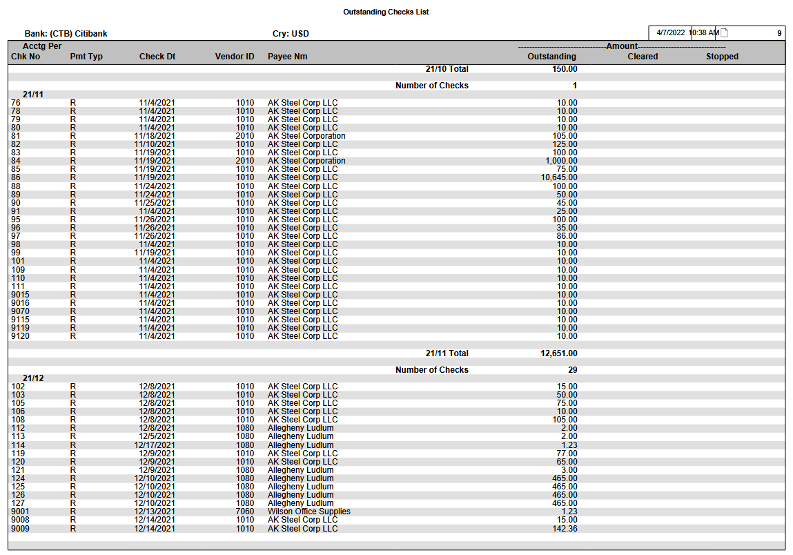

Report Structure

Report Field Description
Group | Report Field | Field Name | Business Rules | Formatting
 | Bank | BNK  BNK-DESC30 |  | Bank code is printed in parentheses before Bank Name  Printed in bold
 | Currency | BNK-CRY |  | Currency code is printed in bold  Currency defaults based on the Bank selected
Header Line | Accounting Period | ACCTG-PER |  | Printed in bold  Format is YY/PP
Detail Line | Check Number | CHK-NO | If the Payment Type=R or M, this field represents a Check Number.  If the Payment Type=T, this field represents a Transfer Reference Number.
 | Payment Type | PMT-TYP
 | Check Date | VEN-CHK-DT | If the Payment Type=T, then this field is blank (not applicable)
 | Vendor ID | VEN-ID
 | Payee Name | PAYEE-NM
 | Outstanding |  | If the Check Reconciliation Status=O, the Check Amount is printed in this column
 | Cleared |  | If the Check Reconciliation Status=C, the Check Amount is printed in this column
 | Stop Payment |  | If the Check Reconciliation Status=S, the Check Amount is printed in this column
Totals Line | Accounting Period | Calculated | Sum of Check Amounts in each of the Outstanding, Cleared & Stop Payment columns
 |  | Calculated | Number of Checks in each of the Outstanding, Cleared & Stop Payment columns
Report Summary Recap  (new page) | Bank | Calculated | Sum of Check Amounts in each of the Outstanding, Cleared & Stop Payment columns
 |  | Calculated | Number of Checks in each of the Outstanding, Cleared & Stop Payment columns

Technical Notes

Accessing Fiscal Calendar Information (Accounting Period Lookup Feature)
- Based on the ‘selected’ Company (scrcsc), the Fiscal Calendar (GLRFIS) EP is accessed.

PURCHASE TAX REPORT

Overview
The Purchase Tax Report provides accounting personnel with a tool to audit/report the taxes incurred for each tax region by voucher branch for a given month. The information provided includes the total pre-tax purchases & taxable purchase amount along with the amount of tax that was incurred via the Accounts Payable Voucher business application for each individual vendor invoice.

For foreign currency transactions, the total pre-tax purchase, taxable purchase & tax amounts are printed in the equivalent base currency.

Eligibility
Only those transactions which match all of the following conditions are eligible for reporting:
- A non-zero Pre-Tax Voucher Amount was provided
- A Tax Distribution was provided

Target Audience
Accounting staff.

Frequency of Use
Monthly or on-demand.

Report Selections
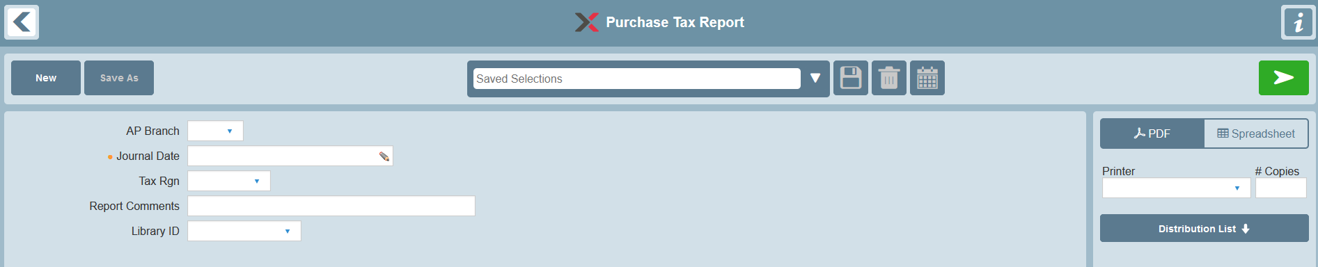

Selection Fields
Selection | Data Element | Valid Values | Default | Notes
AP Branch | JVC-VCHR-BRH | All or specific value | All
Journal Date | JVC-ENT-DT | Mandatory selection.  Specific date or date range. | None | - The standard Date selection is used.  - A Journal Date selection must be made in order to generate a report.
Tax Region | PTX-TX-RGN | All or specific value | All
Report Comments | RPT-CMNT |  | None | Provides an option to print report comments on the Selection page of the report.
Library ID | LIB-ID | None or a specific Library ID | None | Provides an option to select a Library ID for generic remarks to be printed on the Selection page of the report.

Data

Primary Source of Data
- APJJVC – Purchase Journal
- APJPTX – Purchase Journal Tax Distribution

Grouped By
- Voucher Branch
- Tax Region
- Detail transaction lines are grouped by Journal Date

Detail Line Sequenced By
- Journal Date
- Voucher Prefix-Number

Control Breaks
- Voucher Branch
- Tax Region

Page Breaks By
- Voucher Branch
- Tax Region

Data Totaled By
- Voucher Branch
- Tax Region

Display
- Values that exceed their designated space allocation are truncated, excluding numeric values.

Report Sample
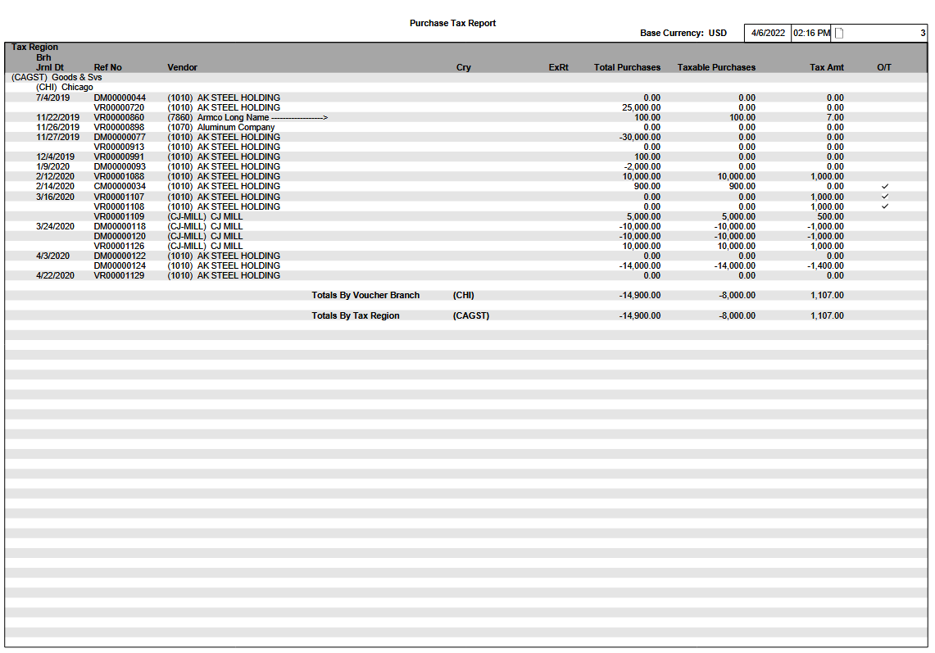

Report Layout
Purchase Tax Report Base Currency: XXX 04/03/07 16:50 PAGE: 1
Tax Region
Brh Total Taxable
Jrnl Date Ref No Vendor Cry ExRt Purchases Purchases Tax Amt O/T
(QQQQQQ) QQQQQQQQQQQQQQQ
(QQQ) QQQQQQQQQQQQQQQ
99/99/99 XX99999999 (QQQQQQQQ) QQQQQQQQQQQQQQQQQQQQQQQQQQQQQQQQQQQ XXX ZZZZ.ZZZZZZZZ ZZ,ZZZ,ZZ9.99- ZZ,ZZZ,ZZ9.99- ZZ,ZZZ,ZZ9.99- Q
12/15/11 VR00000681 (1010) Acme Fabrication Inc 1,000.00 1,000.00 62.50
VR00000685 (1010) Acme Fabrication Inc 1,000.00 1,000.00 63.50 √
12/31/11 VR00000692 (1010) Acme Fabrication Inc 1,000.00 0.00 0.00
VR00000697 (1010) Acme Fabrication Inc 1,000.00 0.00 0.00
99/99/99 XX99999999 (QQQQQQQQ) QQQQQQQQQQQQQQQQQQQQQQQQQQQQQQQQQQQ XXX ZZZZ.ZZZZZZZZ ZZ,ZZZ,ZZ9.99- ZZ,ZZZ,ZZ9.99- ZZ,ZZZ,ZZ9.99- Q
99/99/99 XX99999999 (QQQQQQQQ) QQQQQQQQQQQQQQQQQQQQQQQQQQQQQQQQQQQ XXX ZZZZ.ZZZZZZZZ ZZ,ZZZ,ZZ9.99- ZZ,ZZZ,ZZ9.99- ZZ,ZZZ,ZZ9.99- Q
99/99/99 XX99999999 (QQQQQQQQ) QQQQQQQQQQQQQQQQQQQQQQQQQQQQQQQQQQQ XXX ZZZZ.ZZZZZZZZ ZZ,ZZZ,ZZ9.99- ZZ,ZZZ,ZZ9.99- ZZ,ZZZ,ZZ9.99- Q

Totals By Voucher Branch (QQQ) ZZ,ZZZ,ZZ9.99- ZZ,ZZZ,ZZ9.99- ZZ,ZZZ,ZZ9.99-

Totals By Tax Region (QQQQQQ) ZZ,ZZZ,ZZ9.99- ZZ,ZZZ,ZZ9.99- ZZ,ZZZ,ZZ9.99-

Report Structure

Report Field Description
Group | Report Field | Field Name | Business Rules | Formatting
Heading
 | Base Currency | CSC-BAS-CRY
Region Name Line
1st Header Line | Tax Region | PTX-TX-RGN
 | Tax Region Name | TXR-DESC15
Branch Name Line
2nd Header Line | Branch | JVC-VCHR-BRH
 | Branch Name | BRH-BRH-NM
One Line per Purchase Journal Tax Distribution (APJPTX)
1st Detail Line | Journal Date | JVC-ENT-DT
 | Ref No | JVC-VCHR-PFX,  JVC-VCHR-NO |  | Voucher Prefix and Number
 | Vendor ID | JVC-VEN-ID
 | Vendor Name | VEN-VEN-LONG-NM
 | Currency | JVC-CRY | - Currency of voucher.  - Not printed if same as base currency.
 | Exchange Rate | JVC-EX-RT | - Exchange rate of voucher.  - Not printed if same as base currency.
 | Total Purchases | JVC-PTX-VCHR-AMT | If voucher currency is different than base currency, converted to base currency using JVC-EX-RT.
 | Taxable Purchases | PTX-TXBL-SLS-VAL | If voucher currency is different than base currency, converted to base currency using JVC-EX-RT.
 | Tax Amount | PTX-TX-VAL | If voucher currency is different than base currency, converted to base currency using JVC-EX-RT.
 | Override Tax | PTX-OVRD-TX |  | A check mark √ is printed on the report if the field is set to 1.  Nothing printed if the field is set to 0.
Report Total Lines
One for Branch total
One for Tax Region total
Sub-Totals | ‘Totals by Voucher Branch’ or ‘Totals by Tax Region’
 | Tax Region or Branch being totaled
 | Total Purchases | ∑ JVC-PTX-VCHR-AMT | Printed in base currency equivalent.
 | Taxable Purchases | ∑ PTX-TXBL-SLS-VAL | Printed in base currency equivalent.
 | Tax Amount | ∑ PTX-TX-VAL | Printed in base currency equivalent.

VOUCHER EDIT REPORT

Overview
The Voucher Edit Report displays a list of open Vouchers for supplier invoices that have been entered into INVEX but are not yet finalized.

Target Audience
Accounting staff can use this report to verify and approve the open Vouchers for accrual. Voucher entry transactions can be modified (if required), prior to the Voucher Update phase.

Frequency of Use
On demand

Report Selections
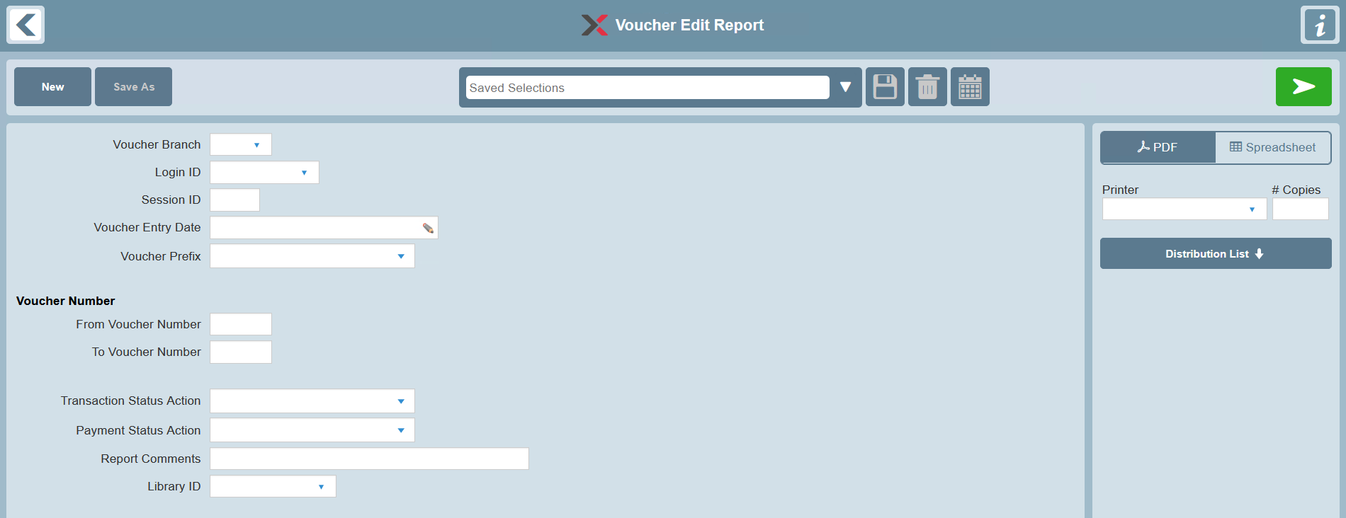

Selection Fields
Selection | Valid Values | Default | Notes
Voucher Branch | All or specific value
Login ID | All or specific value
Session ID | All or specific value | All
Voucher Entry Date | All or date range | All
Voucher Prefix | All or specific value | All
Voucher Number | All or range | All
Voucher Transaction Status Action | All or specific value | All | Selects Vouchers based on their Transaction Status Action  Options are:  - A – Approved  - H – Held
Voucher Payment Status Action | All or specific value | All | Selects Vouchers based on their Payment Status Action  Options are:  - A – Approved  - H – Held
Report Comments |  | None | Standard usage
Library ID | None or specific Library ID | None | Standard usage

General Business Rules
- The following are not eligible as they are beyond the scope of the business purpose of this report:
- Vouchers which have already been updated (i.e. Transaction Status Action C-Closed)
- Recurring Voucher templates (i.e. Recurrence Flag = 1)

Data

Primary source of Data
- APTVCH – Voucher

Secondary Related Data
- IRTCRH – Cost Reconciliation Header
- IRTCRI – Cost Reconciliation Distributions
- IRTACR – Advance Cost Reconciliation Distributions
- TCTGDS – GL Distributions (manual)
- IRTCRT – Cost Reconciliation Distribution Totals
- ORTOTX – Tax Distributions

Grouped By
- Session ID
- Vendor Name

Detail Line Sequenced By
- Reference Information:
- Voucher Prefix and Number

- Cost Reconciliation Distributions:
- Cost Reconciliation Number

- Advance Cost Reconciliation Distributions:
- Reference Item

- Miscellaneous Accounting Distributions (manually entered) (supported for General Ledger licensees):
  - Basic GL Account
  - Subaccount

Page Breaks By
- Session ID
- Session ID Summary Recap
- Report Summary Totals

Session ID Summary Recap (New Page)
- Total Vouchers Amount
- Total Debit Memos Amount
- Total Credit Memos Amount

INVEX System-assigned Accounting Distributions
- Sequenced by:
- Unpaid Receipts
- Accounts Payable
- Accrued Taxes
- Exchange Gain/Loss

Miscellaneous Accounting Distributions (manually entered)
- Sequenced by:
- Basic GL Account (with Account Description)
- Subaccount

A single grand totaling is provided for both the ‘INVEX Accounting Distributions’ and ‘Manual Accounting Distributions’ sections together.

Report Summary Recap (New Page)
- Same as for Session ID Summary Recap

Report Layout

Voucher Edit Report
Vendor
Reference Entered Brh PO Vendor Invoice Login Cry ExRt Due Disc Disc Amt Vchr Amt

GL Acct Subaccount Debit Credit
Session ZZZZZZ

QQQQQQQQQQQQQQQQQQQQQQQQQQQQQQQQQQQ (ZZZZZZZZ)

QQ-99999999 P,T MM/DD/YY QQQ 99999999-999 QQQQQQQQQQQQQQQQQQQQQQ-MM/DD/YY QQQQQQQQ QQQ ZZ.999999 MM/DD/YY MM/DD/YY E ZZZZ,ZZZ.ZZ ZZZZ,ZZ9.99-
QQQQQQQQQQQQQQQQQQQQQQQQQQQQQQ, QQQQQQQQQQQQQQQQQQQQQQQQQQQQQQQQQQQQQQQQQQQQQQQQQQ
IR-99999999 QQQ 99999999-999 QQ-99999999-999-9999 999-QQQQQQQQQQQQQQQQQQQQ ZZZ,ZZZ,ZZ9 QQQ ZZZZ,ZZ9.99-
QQ 99999999-999 999-QQQQQQQQQQQQQQQQQQQQ ZZZZ,ZZ9.99-
QQQQQQQQ QQQQQQQQQQQQQQQQQQQQQQQQQQQQQQ ZZZZ,ZZZ.ZZ- QQQ ZZZZ,ZZZ.ZZ- QQQ

Session ZZZZZZ

QQQQQQQQQQQQQQQQQQQQQQQQQQQQQQQQQQQ (ZZZZZZZZ)

QQ-99999999 P,T MM/DD/YY QQQ 99999999-999 QQQQQQQQQQQQQQQQQQQQQQ-MM/DD/YY QQQQQQQQ QQQ ZZ.999999 MM/DD/YY MM/DD/YY E ZZZZ,ZZZ.ZZ ZZZZ,ZZ9.99-
QQQQQQQQQQQQQQQQQQQQQQQQQQQQQQ, QQQQQQQQQQQQQQQQQQQQQQQQQQQQQQQQQQQQQQQQQQQQQQQQQQ
IR-99999999 QQQ 99999999-999 QQ-99999999-999-9999 999-QQQQQQQQQQQQQQQQQQQQ ZZZ,ZZZ,ZZ9 QQQ ZZZZ,ZZ9.99-
QQ 99999999-999 999-QQQQQQQQQQQQQQQQQQQQ ZZZZ,ZZ9.99-
QQQQQQQQ QQQQQQQQQQQQQQQQQQQQQQQQQQQQQQ ZZZZ,ZZZ.ZZ- QQQ ZZZZ,ZZZ.ZZ- QQQ

E=Discount Date Expired, P=Payment Hold, T=Transaction Hold

Session ZZZZZZ Summary Recap (new page)
----------------------------------------------------------------------------------------------------------------------------------------------------------------------------------------
Base Cry: QQQ
Vouchers ZZZZ,ZZZ.ZZ-
Debit Memos ZZZZ,ZZZ.ZZ-
Credit Memos ZZZZ,ZZZ.ZZ-

INVEX Accounting Distributions
Description Dr Amt Cr Amt
Unpaid Receipts ZZZZ,ZZZ.ZZ ZZZZ,ZZZ.ZZ
Accounts Payable ZZZZ,ZZZ.ZZ ZZZZ,ZZZ.ZZ
Accrued Taxes ZZZZ,ZZZ.ZZ ZZZZ,ZZZ.ZZ
Exchange Gain/Loss ZZZZ,ZZZ.ZZ ZZZZ,ZZZ.ZZ

Manual Accounting Distributions
GL Acct Description Subaccount Dr Amt Cr Amt
QQQQQQQQ QQQQQQQQQQQQQQQQQQQQQQQQQQQQQQ QQQQQQQQQQQQQQQQQQQQQQQQQQQQQQ ZZZZ,ZZZ.ZZ ZZZZ,ZZZ.ZZ
QQQQQQQQ QQQQQQQQQQQQQQQQQQQQQQQQQQQQQQ QQQQQQQQQQQQQQQQQQQQQQQQQQQQQQ ZZZZ,ZZZ.ZZ ZZZZ,ZZZ.ZZ
QQQQQQQQ QQQQQQQQQQQQQQQQQQQQQQQQQQQQQQ QQQQQQQQQQQQQQQQQQQQQQQQQQQQQQ ZZZZ,ZZZ.ZZ ZZZZ,ZZZ.ZZ

Total ZZZZ,ZZ9.99 ZZZZ,ZZ9.99

Report Summary Recap (new page)
----------------------------------------------------------------------------------------------------------------------------------------------------------------------------------------
Base Cry: QQQ
Vouchers ZZZZ,ZZZ.ZZ-
Debit Memos ZZZZ,ZZZ.ZZ-
Credit Memos ZZZZ,ZZZ.ZZ-

INVEX Accounting Distributions
Description Dr Amt Cr Amt
Unpaid Receipts ZZZZ,ZZZ.ZZ ZZZZ,ZZZ.ZZ
Accounts Payable ZZZZ,ZZZ.ZZ ZZZZ,ZZZ.ZZ
Accrued Taxes ZZZZ,ZZZ.ZZ ZZZZ,ZZZ.ZZ
Exchange Gain/Loss ZZZZ,ZZZ.ZZ ZZZZ,ZZZ.ZZ

Manual Accounting Distributions
GL Acct Description Subaccount Dr Amt Cr Amt
QQQQQQQQ QQQQQQQQQQQQQQQQQQQQQQQQQQQQQQ QQQQQQQQQQQQQQQQQQQQQQQQQQQQQQ ZZZZ,ZZZ.ZZ ZZZZ,ZZZ.ZZ
QQQQQQQQ QQQQQQQQQQQQQQQQQQQQQQQQQQQQQQ QQQQQQQQQQQQQQQQQQQQQQQQQQQQQQ ZZZZ,ZZZ.ZZ ZZZZ,ZZZ.ZZ
QQQQQQQQ QQQQQQQQQQQQQQQQQQQQQQQQQQQQQQ QQQQQQQQQQQQQQQQQQQQQQQQQQQQQQ ZZZZ,ZZZ.ZZ ZZZZ,ZZZ.ZZ

Total ZZZZ,ZZ9.99 ZZZZ,ZZ9.99

Report Sample
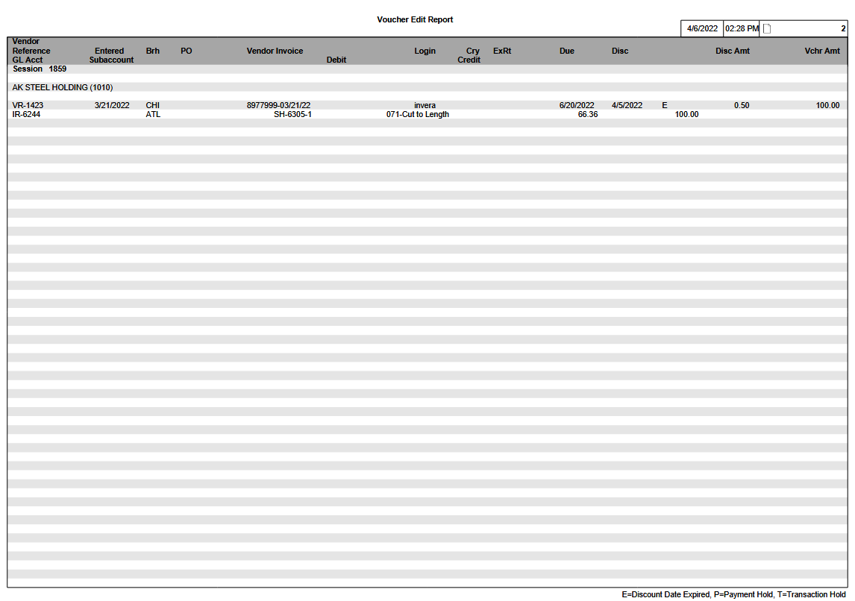

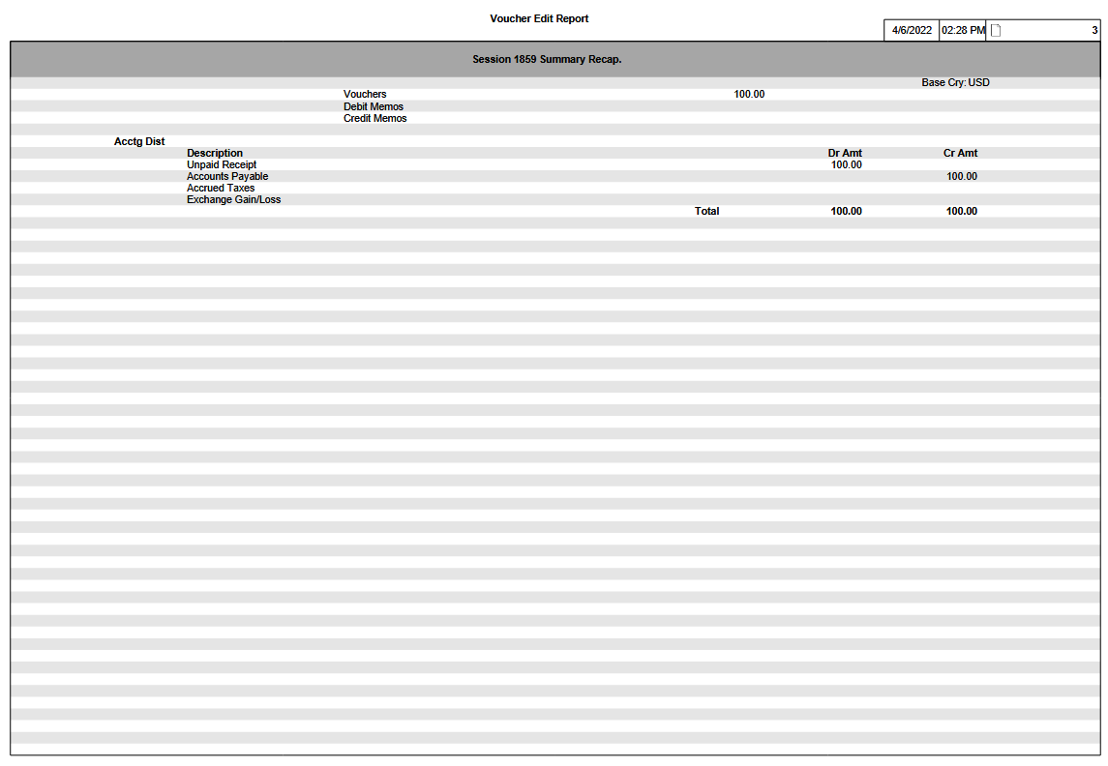
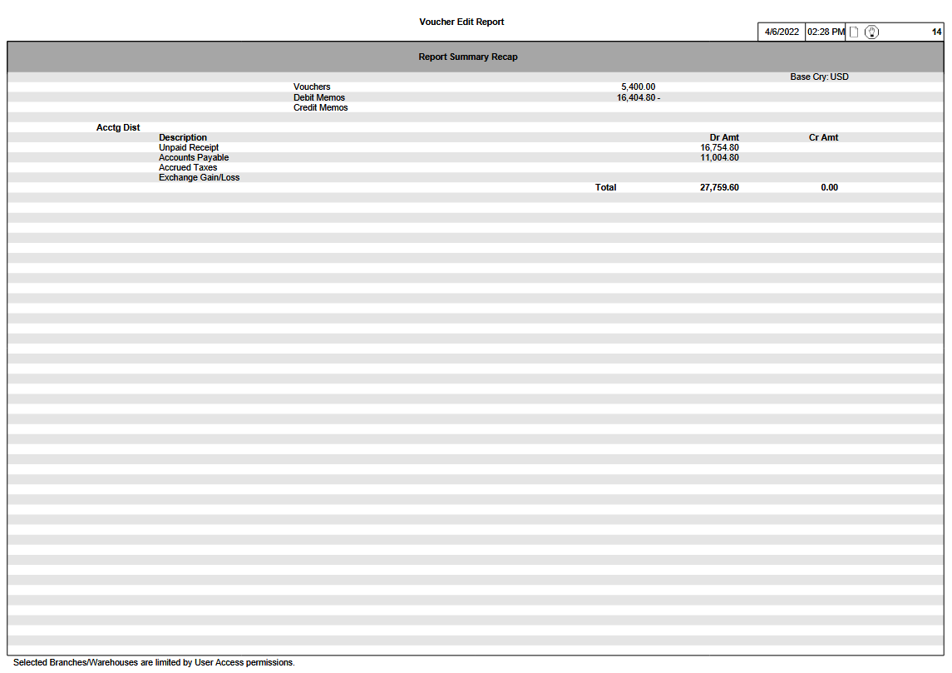

Report Structure

Report Field Description
Group | Report Field | Field Name | Business Rules | Formatting
Header Line 1 | Session ID | VCH-SSN-ID |  | The label ‘Session’ is printed in bold
Header Line 2 | Vendor Long Name | VEN-VEN-LONG-NM
 | Vendor ID | VCH-VEN-ID |  | Printed in parentheses
Detail Line 1  (Voucher) | Voucher Prefix and Number | VCH-VCHR-PFX,  VCH-VCHR-NO |  | Fields are separated by a hyphen
 | Payment Hold |  | An indicator is printed if the Voucher is on Payment Hold  This is determined by checking the Status table - TCTTSA  For a given Voucher, where TSA-STS-TYP = N, if TSA_STS_ACTN = H, then this indicates that the Voucher is on Payment Hold | If the Voucher is on Payment Hold, print ‘P’
 | Transaction Hold |  | An indicator is printed if the Voucher is on Transaction Hold  This is determined by checking the Status table - TCTTSA  For a given Voucher, where TSA-STS-TYP = T, if TSA_STS_ACTN = H, then this indicates that the Voucher is on Transaction Hold | If the Voucher is on Transaction Hold, print ‘T’
 | Entered | VCH-VCHR-ENT-DT
 | Voucher Branch | VCH-VCHR-BRH
 | PO Number, Item | VCH-PO-NO, VCH-PO-ITM |  | Fields are separated by a hyphen
 | Vendor Invoice | VCH-VEN-INV-NO,  VCH-VEN-INV-DT |  | Fields are separated by a hyphen
 | Login | VCH-LGN-ID
 | Currency | VCH-CRY | Only printed if the Voucher Currency differs from the Base Currency
 | Exchange Rate | VCH-EX-RT | Only printed if the Voucher Currency differs from the Base Currency
 | Due Date | VCH--DUE-DT
 | Discount Date | VCH-DISC-DT
 | Discount Date Expired |  | An indicator is printed if the Discount Date has expired  If the Discount Date < System Date at the time of Report generation, then this indicates that the Discount Date has expired | If the Discount Date has expired, print ‘E’
 | Discount Amount | VCH-DISC-AMT
 | Voucher Amount | VCH-VCHR-AMT
Detail Line 2 | This line is suppressed if the values for both of the following fields are blank
 | Description | VCH-DESC30
 | Check Item Remarks | VCH-CHK-ITM-RMK
Detail Line 3  (Cost Reconciliation Distributions) | No column headings appear for the following fields
 | Cost Reconciliation Number | CRI-CRCN-PFX,  CRI-CRCN-NO |  | Fields are separated by a hyphen
 | Cost Reconciliation Branch | CRH-CRCN-BRH
 | PO Number, Item | CRH-PO-NO,  CRH-PO-ITM |  | Fields are separated by a hyphen
 | Transaction Prefix, Number, Item, Sub-Item | CRH-TRS-PFX,  CRH-TRS-NO  CRH-TRS-ITM,  CRH-TRS-SBITM |  | Fields are separated by a hyphen
 | Charge and Cost Number,  Charge and Cost Description | CRH-CC-NO,  CCR-DESC20 |  | The CC Number is separated from the CC Description by a hyphen (e.g., 001- Metal)
 | Distributed Quantity | CRI-DSQTY
 | Distributed Quantity UM | CRI-DSQTY-UM
 | Distributed Amount | CRI-DSAMT
Detail Line 4 (Advance Cost Reconciliation Distributions) | No column headings appear for the following fields
 | Advance Prefix | ACR-ADV-PFX
 | PO Number, Item | ACR-PO-NO,  ACR-PO-ITM |  | Fields are separated by a hyphen
 | Charge & Cost Number | ACR-CC-NO,  CCR-DESC20 |  | The CC Number is separated from the CC Description by a hyphen (e.g., 001- Metal)
 | Advance Amount | ACR-ADV-AMT
Detail Line 5  (Misc Accounting Distributions) | Basic GL Account | GDS-BSC-GL-ACCT
 | Subaccount | GDS-SACCT |  | Subaccount components use hyphen separators
 | Debit Amount | GDS-DR-AMT |  | Denoted in Base Currency
 | Base Currency Code |  | Only printed if Debit Amount is printed.
 | Credit Amount | GDS-CR-AMT |  | Denoted in Base Currency
 | Base Currency Code |  | Only printed if Credit Amount is printed.
Session ID Summary Recap | Vouchers | Calculated | Sum of Voucher amounts  ∑(Voucher Amount * ExRt) | Denoted in Base Currency
 | Debit Memos | Calculated | Sum of Debit Memo amounts  ∑(Voucher Amount * ExRt) | Denoted in Base Currency
 | Credit Memos | Calculated | Sum of Credit Memo amounts  ∑(Voucher Amount * ExRt) | Denoted in Base Currency
(System-assigned Accounting Distributions) | Unpaid Receipts | CRT-TDSAMT  ‘Total Distributed Amount’ field from the Cost Reconciliation Distribution Totals table | If the ‘Unpaid Receipts’ amount is positive, then it is printed in the Debit Amount field.  If the ‘Unpaid Receipts’ amount is negative, then it is printed in the Credit Amount field. | If the ‘Unpaid Receipts’ amount is negative, then it is printed without the negative sign.
 | Debit Amount
 | Credit Amount
 | Accounts Payable |  | ∑(Voucher amounts + Credit Memo amounts) - ∑(Debit Memo amounts), expressed in base currency.  If the ‘Accounts Payable’ amount is positive, then it is printed in the Credit Amount field.  If the ‘Accounts Payable’ amount is negative, then it is printed in the Debit Amount field. | If the ‘Accounts Payable’ amount is negative, then it is printed without the negative sign.
 | Debit Amount
 | Credit Amount
 | Accrued Taxes | OTX-TX-VAL  Tax Value (from the Tax Distributions table) | The Tax Value is stored in the Voucher currency so it must be converted to Base currency for inclusion on the report.  In order to convert the Tax Amount to Base Currency, the following formula is used:  Tax Value * Exchange Rate (Exchange Rate is from the Voucher table – APTVCH)  If the ‘Accrued Taxes’ amount is positive, then it is printed in the Debit Amount field.  If the ‘Accrued Taxes’ amount is negative, then it is printed in the Credit Amount field. | If the ‘Accrued Taxes’ amount is negative, then it is printed without the negative sign.
 | Debit Amount
 | Credit Amount
 | Exchange Gain/Loss | CRT-TOT-EX-GN-LS  Total Exchange Gain/Loss (from the Cost Reconciliation Distribution Totals table) | - If the value is a gain, then the amount is negative and it is printed in the Credit Amount field.  - If the value is a loss, then the amount is positive and it is printed in the Debit Amount field. | If the ‘Exchange Gain/Loss’ is negative, then it is printed without the negative sign.
 | Debit Amount
 | Credit Amount
(Manually entered Accounting Distributions) | Basic GL Account |  |  | Accounting Distributions are to be sub-totaled if they belong to the same GL Account/Subaccount combination.
 | Account Description
 | Subaccount |  |  | Subaccount components use hyphen separators.
 | Debit Amount
 | Credit Amount
Totals | Debit Amount |  | Combined recap total of:  - System-assigned distributions  - Manually entered distribution
 | Credit Amount |  | Combined recap total of:  - System-assigned distributions  - Manually entered distribution
Report Summary Recap | Vouchers | Calculated | Sum of Voucher amounts  ∑(Voucher Amount * ExRt) | Denoted in Base Currency
 | Debit Memos | Calculated | Sum of Debit Memo amounts  ∑(Voucher Amount * ExRt) | Denoted in Base Currency
 | Credit Memos | Calculated | Sum of Credit Memo amounts  ∑(Voucher Amount * ExRt) | Denoted in Base Currency
(System-assigned Accounting Distributions) | Unpaid Receipts | CRT-TDSAMT  ‘Total Distributed Amount’ field from the Cost Reconciliation Distribution Totals table | If the ‘Unpaid Receipts’ amount is positive, then it is printed in the Debit Amount field.  If the ‘Unpaid Receipts’ amount is negative, then it is printed in the Credit Amount field. | If the ‘Unpaid Receipts’ amount is negative, then it is printed without the negative sign.
 | Debit Amount
 | Credit Amount
 | Accounts Payable |  | ∑(Voucher amounts + Credit Memo amounts) - ∑(Debit Memo amounts), expressed in base currency.  If the ‘Accounts Payable’ amount is positive, then it is printed in the Credit Amount field.  If the ‘Accounts Payable’ amount is negative, then it is printed in the Debit Amount field. | If the ‘Accounts Payable’ amount is negative, then it is printed without the negative sign.
 | Debit Amount
 | Credit Amount
 | Accrued Taxes | OTX-TX-VAL  Tax Value (from the Tax Distributions table) | The Tax Value is stored in the Voucher currency so it must be converted to Base currency for inclusion on the report.  In order to convert the Tax Amount to Base Currency, the following formula is used:  Tax Value * Exchange Rate (Exchange Rate is from the Voucher table – APTVCH)  If the ‘Accrued Taxes’ amount is positive, then it is printed in the Debit Amount field.  If the ‘Accrued Taxes’ amount is negative, then it is printed in the Credit Amount field. | If the ‘Accrued Taxes’ amount is negative, then it is printed without the negative sign.
 | Debit Amount
 | Credit Amount
 | Exchange Gain/Loss | CRT-TOT-EX-GN-LS  Total Exchange Gain/Loss (from the Cost Reconciliation Distribution Totals table) | - If the value is a gain, then the amount is negative and it is printed in the Credit Amount field.  - If the value is a loss, then the amount is positive and it is printed in the Debit Amount field. | If the ‘Exchange Gain/Loss’ is negative, then it is printed without the negative sign.
 | Debit Amount
 | Credit Amount
(Manually entered Accounting Distributions) | Basic GL Account |  |  | Accounting Distributions are to be sub-totaled if they belong to the same GL Account/Subaccount combination.
 | Account Description
 | Subaccount |  |  | Subaccount components use hyphen separators.
 | Debit Amount
 | Credit Amount
Totals | Debit Amount |  | Combined recap total of:  - System-assigned distributions  - Manually entered distribution
 | Credit Amount |  | Combined recap total of:  - System-assigned distributions  - Manually entered distributions

PRIOR PERIODS TRANSACTION POSTING REPORT

Overview
The Prior Periods Transaction Posting report provides an exception list of those INVEX financial transactions that indicate an Activity Date within a particular Accounting Period but which have been Updated in a different Accounting Period.

This scenario may occur when users backdate transactions via the following business applications:
- Vouchers
- Cash Receipts
- Cash Disbursements
- Invoicing

As a result, a transaction could be included in the General Ledger, but would not appear in the corresponding INVEX Source Journal reports printed during month-end.

The exception report provides a detailed list of the corresponding General Ledger financial transaction entries. The report lists, by Source Journal, the GL transaction information posted to a specific Ledger. The Journal Entry distribution details recorded against each Journal Entry are also included.

This exception report is useful for those situations where INVEX reports normally used for monthly balancing purposes have already been printed and therefore did not include the backdated transactions. Depending on the customer balancing procedures implemented, these transactions may also need to be taken into consideration as reconciling items in the balancing procedures.

Example:
- Assume that Accounting Period 06/01 reflects financial transaction activity from January 1, 2022 to January 31, 2022 inclusive.
- Month-end reports are normally run on the evening of January 31.
- On February 2, a supplier invoice is recorded and updated by the Accounting staff as an accounts payable Voucher with a backdated Activity Date of January 30, 2022.
- This results in the financial transaction being included in the General Ledger financial activity for Accounting Period 06/01 rather than Accounting Period 06/02.
- This also results in the Voucher transaction not appearing in the corresponding January Purchase Journal report printed on January 31.

Target Audience
The report is used by Accounting staff as an audit trace to highlight the exception financial transactions that were backdated for inclusion with a prior Accounting Period.

Accounting staff can then review and, if required, reprint the INVEX source journal that initiated the financial transaction in order to obtain further transaction details.

Frequency of Use
Monthly or on-demand.

Type of Report
Detail by Journal Entry reference.

Prerequisites

EXO Setup
This feature requires setup of the ‘Default Ledger ID’ Execution Option in the INVEX operational environment. The corresponding program name is ‘dspcrq’.

Report Selections

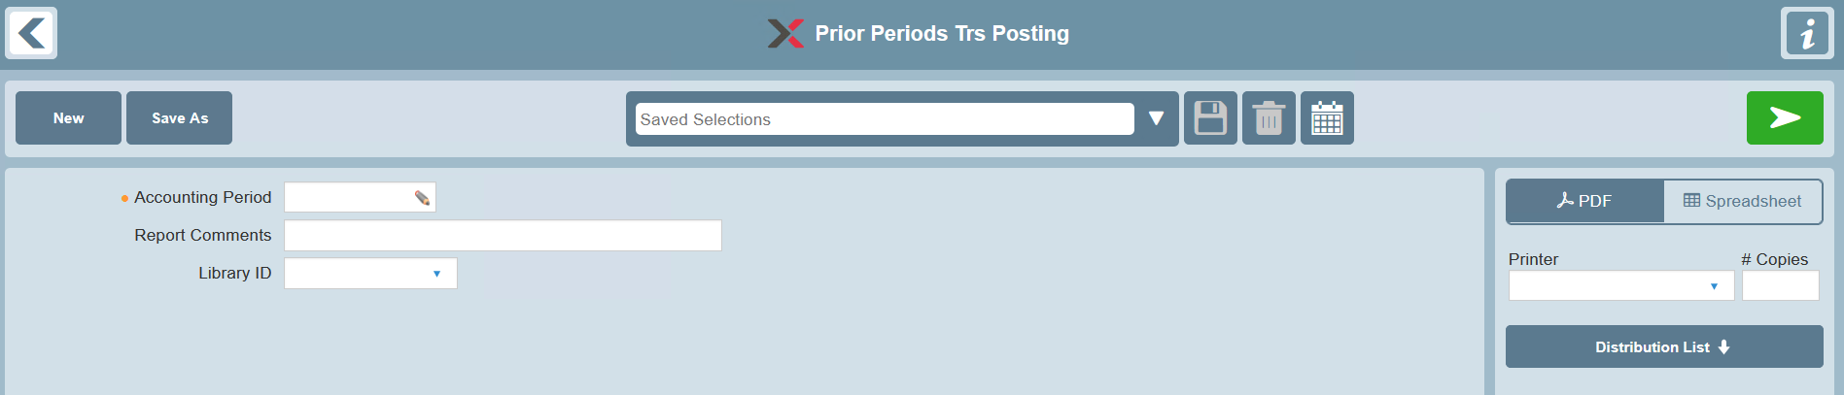

Sample Selection Entry window

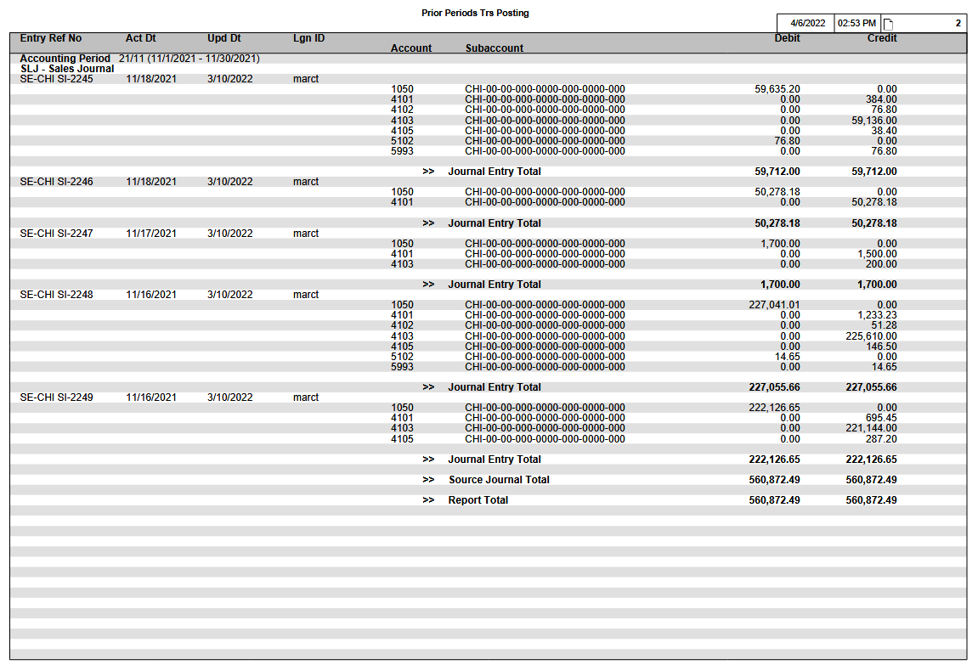

Selection Fields
Selection | Data Element | Valid Values | Default | Notes
Accounting Period | ACCTG-PER | Must be a specific Accounting Period. | None | Mandatory selection.  Look-up provided.  The beginning and ending date range for the report is determined based on the Accounting Period selection and the Fiscal Calendar enterprise parameter.
Report Comments | RPT-CMNT |  | None | Provides an option to print report comments on the Selection page of the report.
Library ID | LIB-ID | None or a specific Library ID | None | Provides an option to select a Library ID for generic remarks to be printed on the Selection page of the report.

General Rules
- The Prior Periods Transaction Posting report is initiated from the INVEX operational environment.
- Transactions are only included on the report subject to all of the following business rules:
- The transaction’s Activity Date falls within the date range of the Accounting Period selected
- The transaction’s Update Date falls outside the date range of the Accounting Period selected
- The transaction’s Source Journal is one of the following business applications:
- Cash Receipts Journal
- Cash Disbursements Journal
- Purchase Journal
- Sales Journal

Data

Primary Source of Data
- INVEX operational environment
- ARJJSH – Cash Receipts Journal
- Journal Date (JSH-JRNL-DT)
- Update Date (JSH-UPD-DT)
- APJDBJ – Cash Disbursements Journal
- Journal Date (DBJ-JRNL-DT)
- Update Date (DBJ-UPD-DT)
- APJJVC – Purchase Journal
- Entry Date (JVC-ENT-DT)
- Update Date (JVC-UPD-DT)
- IVJJVH – Sales and Cost Invoice Journal
- Invoice Date (JVH-INV-DT)
- Invoice Update Date (JVH-INV-UPD-DT)

- General Ledger (Technical Note: View is required on the INVEX operational database)
- GLHGLH – General Ledger History
- GLHGLD – General Ledger History Detail
- The corresponding General Ledger ID to be accessed is determined based on the ‘Default Ledger ID’ execution option.

Grouped By
- Journal Prefix-Number
- Source Journal

Detail Line Sequenced By
- General Ledger History:
- Source Journal
- Journal Entry Prefix
- Journal Entry Number

- General Ledger History Detail:
- Journal Entry Distribution Line Item Number

Page Breaks By
- For report summary recap only

Data Totaled By
- Journal Entry Number
- Source Journal
- Grand Total for entire report

Report Summary Recap (New Page)
A separate report summary recap is provided on the report for each Basic GL Account and Subaccount combination listed in the report details.

Accounting Distributions are sequenced according to the Basic GL Account and Subaccount.

The following information is provided:
- Basic GL Account
- Subaccount
- Account Description
- Debit Amount
- Credit Amount

Example
Prior Periods Transaction Posting 2/15/06 16:50 PAGE: 2

Entry Ref No Act Dt Upd Dt Lgn ID Debit Credit
Account Subaccount

Accounting Period YY/PP (MM/DD/YY – MM/DD/YY)
PUJ – Purchase Journal

XX-99999999 MM/DD/YY MM/DD/YY QQQQQQQQ
QQQQQQQQ QQQQQQQQQQQQQQQQQQQQQQQQQQQQQQ ZZZZ,ZZZ,ZZZ.ZZ ZZZZ,ZZZ,ZZZ.ZZ

VR-00031924 01/30/06 02/02/06 markp
7523 200-9500-MW 4,358.21
2000 4,358.21

>> Journal Entry Total ZZZZ,ZZZ,ZZ9.99 ZZZZ,ZZZ,ZZ9.99

>> Source Journal Total ZZZZ,ZZZ,ZZ9.99 ZZZZ,ZZZ,ZZ9.99

>> Report Total ZZZZ,ZZZ,ZZ9.99 ZZZZ,ZZZ,ZZ9.99

(Summary Recap Page – sample)
2/15/06 16:50 PAGE: 4
Prior Periods Transaction Posting
Account Subaccount Acct Description Debit Credit
QQQQQQQQ QQQQQQQQQQQQQQQQQQQQQQQQQQQQQQ QQQQQQQQQQQQQQQQQQQQQQQQQQQQQQ ZZZZ,ZZZ,ZZZ.ZZ ZZZZ,ZZZ,ZZZ.ZZ
2000 Accounts Payable Control 9,558.21
7523 200-9500-MW Slitter #1 Maintenance 4,358.21
8300 100-9500-SW Office Expenses 5,200.00

Report Structure

Report Field Description
Group | Report Field | Field Name | Business Rules | Formatting
1st Header Line | Accounting Period |  | Based on report selection. | YY/PP
 | Period Beginning and Ending Date range | FIS-BGN-PER-DT,  FIS-END-PER-DT | The Fiscal Calendar enterprise parameter table <GLRFIS> is accessed based on the Accounting Period selected.  The General Ledger Company ID to be accessed is determined based on the Ledger Control enterprise parameter. | (MM/DD/YY – MM/DD/YY)
2nd Header Line | Source Journal | GLH-SRC-JRNL | The Source Journal and equivalent Source Journal Description are printed.
1st Detail Line | Journal Entry Number  or  External Invoice Number | Source Journal not ‘SLJ’  GLD-JE-PFX, GLD-JE-NO  Source Journal ‘SLJ’  GLD-JE-PFX  GLH-EXTL1 |  | Source Journal not ‘SLJ’  PFX-NO  Source Journal not ‘SLJ’  PFX-EXTL1
 | Activity Date | GLH-ACTVY-DT
 | Update Date | DBJ-UPD-DT  JSH-UPD-DT  JVC-UPD-DT  JVH-INV-UPD-DT | Update Date to be printed is dependent on the specific INVEX Source Journal.
 | Login ID | GLH-LGN-ID
2nd Detail Line | Basic GL Account | GLD-BSC-GL-ACCT
 | Subaccount | GLD-SACCT |  | Subaccounts are printed via a special format that includes an optional Global Separator Character.
 | Debit Amount | GLD-DR-AMT
 | Credit Amount | GLD-CR-AMT
Totals | Debit Amount
 | Credit Amount
Report Summary Re-cap
 | Basic GL Account
 | Subaccount |  |  | Subaccounts are printed via a special format that includes an optional Global Separator Character.
 | Account Description | BGA-DESC30 | The Basic GL Account table <GLRBGA> is accessed based on the BSC-GL-ACCT of the General Ledger History Detail table <GLHGLD>.  The Description of the Basic GL Account is printed based on the language of the user running the report.
 | Debit Amount
 | Credit Amount

Technical Notes

Accessing Fiscal Calendar Information (Report Requester Screen)
- Based on the ‘selected’ Company (scrcsc), the Fiscal Calendar (GLRFIS) EP is accessed.

1099 REPORT

Overview
1099 Reporting Categories are established by the US government to ensure that Vendors report all payments received from their customers for goods delivered or services rendered. The 1099 report lists for each vendor, its associated legal name & address, tax-id, and 1099 reporting code, along with the details of the check information issued during the course of a selected time frame. Using this supporting report, which is also available via a standard Excel extraction, users may then fill out the 1099 forms provided by the Government.

Target Audience
Accounting staff.

Frequency of Use
Yearly or as required.

General Rules
The 1099 Report selects records from the Cash Disbursements Journal table for a given Check Date Range, Vendor, and 1099 reporting category. All transactions are printed in the currency of the disbursement. This means that for a given vendor, there may be multiple blocks of information, with each block showing details and total for a particular currency.

Prerequisite Data Retention Period
- The retention of underlying Cash Disbursements Journal information (used by the 1099 Report) is controlled by the ‘Number of Retention Months’ Execution Option setting for the Cash Disbursements Journal Cleanup utility.
- Please note that the default number of retention months is 16 (i.e., 12 + 4 months in following year) to ensure that there is sufficient data to be included for annual 1099 Reporting purposes.

Report Selections
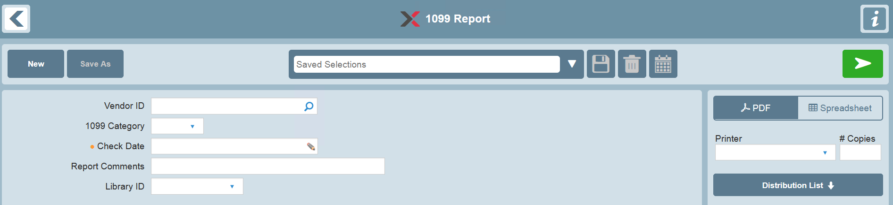

Selection Fields
The report selections are listed below with specific notes on their use in this report.

Selection | Data Element | Valid Values | Default | Notes
Vendor ID |  | Choice of one or all | All
1099 Category |  | Choice of one or all | All
Check Date |  | Specific Date or a Date Range | None | - The standard Date selection control is used.  - Mandatory  - A Check Date selection must be made in order to generate a report.  - The transaction Journal Date is used for report filtering if the Check Date is unavailable.
Report Comments |  |  | None | Provides an option to print report comments on the Selection page of the report.
Library ID |  | None or a specific Library ID | None | Provides an option to select a Library ID for generic remarks to be printed on the Selection page of the report.

General Rules

Vendors Excluded
- Vendors (and corresponding transactions) are not eligible for printing if the 1099 Category for the Vendor Account is blank.

Zero Check Amounts Excluded
- Transactions with Check Amounts of zero are not printed.

Data

Primary Source
- APRVEN – Vendor Account reference
- SCRCVA – Customer/Vendor Addresses
- APJDBJ – Cash Disbursements Journal

Grouped By
- Vendor & Currency

Records Sequenced By
- Vendor Name/Currency
- Check Date (Journal Date is used if Check Date is unavailable)

Control Breaks
- Vendor & Currency

Page Breaks By
- None

Data Totaled By
- Vendor/Currency combination

Example
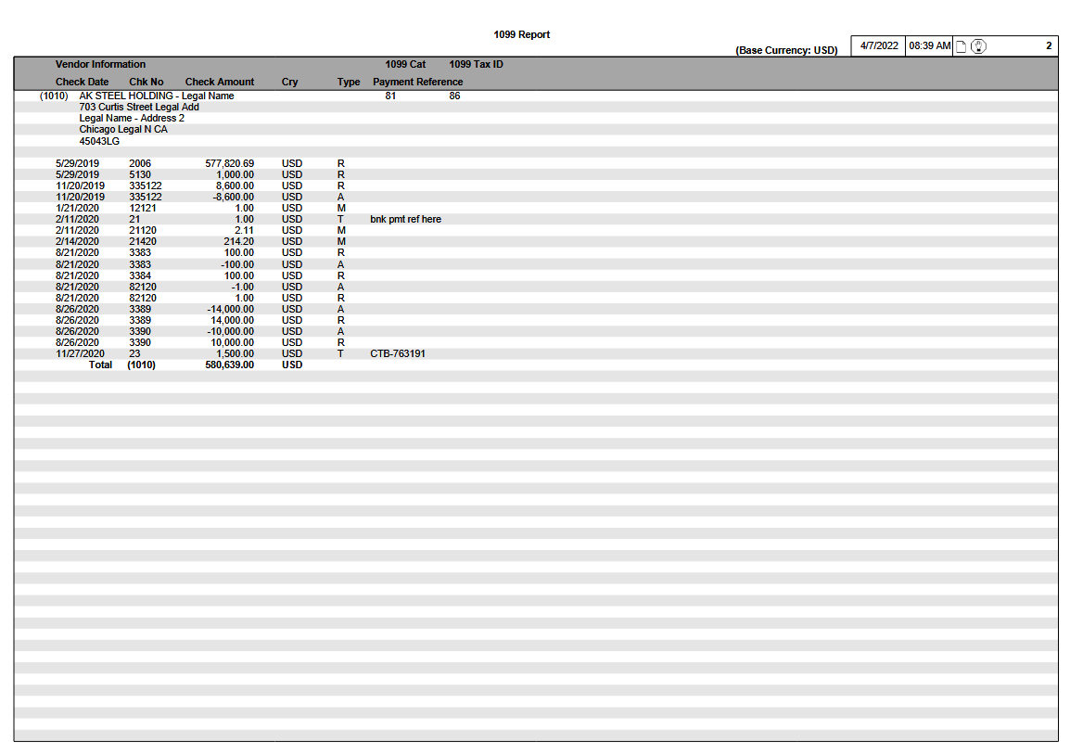
Report Layout
1099 Report (Base Currency: XXX) 04/03/07 16:50 PAGE: 1
Vendor Information 1099 Cat 1099 Tax ID
Check Date Check No. Check Amount Cry Type Payment Reference
(QQQQQQQQ) QQQQQQQQQQQQQQQQQQQQQQQQQQQQQQQQQQQ QQQQ QQQQQQQQQQQQQQQ
QQQQQQQQQQQQQQQQQQQQQQQQQQQQQQQQQQQ
QQQQQQQQQQQQQQQQQQQQQQQQQQQQQQQQQQQ
QQQQQQQQQQQQQQQQQQQQQQQQQQQQQQQQQQQ
QQQQQQQQQQQQQQQQQQQQQQQQQQQQQQQQQQQ
QQQQQQQQQQ QQ

99/99/99 ZZZZZZZZ ZZZ,ZZZ,ZZ9.99 QQQ Q QQQQQQQQQQQQQQQQQQQQQQ
99/99/99 ZZZZZZZZ ZZZ,ZZZ,ZZ9.99 QQQ Q QQQQQQQQQQQQQQQQQQQQQQ
99/99/99 ZZZZZZZZ ZZZ,ZZZ,ZZ9.99 QQQ Q QQQQQQQQQQQQQQQQQQQQQQ
99/99/99 ZZZZZZZZ ZZZ,ZZZ,ZZ9.99 QQQ Q QQQQQQQQQQQQQQQQQQQQQQ
99/99/99 ZZZZZZZZ ZZZ,ZZZ,ZZ9.99 QQQ Q QQQQQQQQQQQQQQQQQQQQQQ
Total (QQQQQQQQ) ZZZ,ZZZ,ZZ9.99 XXX

99/99/99 ZZZZZZZZ ZZZ,ZZZ,ZZ9.99 QQQ Q QQQQQQQQQQQQQQQQQQQQQQ
99/99/99 ZZZZZZZZ ZZZ,ZZZ,ZZ9.99 QQQ Q QQQQQQQQQQQQQQQQQQQQQQ
99/99/99 ZZZZZZZZ ZZZ,ZZZ,ZZ9.99 QQQ Q QQQQQQQQQQQQQQQQQQQQQQ
99/99/99 ZZZZZZZZ ZZZ,ZZZ,ZZ9.99 QQQ Q QQQQQQQQQQQQQQQQQQQQQQ
99/99/99 ZZZZZZZZ ZZZ,ZZZ,ZZ9.99 QQQ Q QQQQQQQQQQQQQQQQQQQQQQ
Total (QQQQQQQQ) ZZZ,ZZZ,ZZ9.99 YYY

(QQQQQQQQ) QQQQQQQQQQQQQQQQQQQQQQQQQQQQQQQQQQQ QQQQ QQQQQQQQQQQQQQQ
QQQQQQQQQQQQQQQQQQQQQQQQQQQQQQQQQQQ
QQQQQQQQQQQQQQQQQQQQQQQQQQQQQQQQQQQ
QQQQQQQQQQQQQQQQQQQQQQQQQQQQQQQQQQQ
QQQQQQQQQQQQQQQQQQQQQQQQQQQQQQQQQQQ
QQQQQQQQQQ QQ

99/99/99 ZZZZZZZZ ZZZ,ZZZ,ZZ9.99 QQQ Q QQQQQQQQQQQQQQQQQQQQQQ
99/99/99 ZZZZZZZZ ZZZ,ZZZ,ZZ9.99 QQQ Q QQQQQQQQQQQQQQQQQQQQQQ
99/99/99 ZZZZZZZZ ZZZ,ZZZ,ZZ9.99 QQQ Q QQQQQQQQQQQQQQQQQQQQQQ
99/99/99 ZZZZZZZZ ZZZ,ZZZ,ZZ9.99 QQQ Q QQQQQQQQQQQQQQQQQQQQQQ
99/99/99 ZZZZZZZZ ZZZ,ZZZ,ZZ9.99 QQQ Q QQQQQQQQQQQQQQQQQQQQQQ
Total (QQQQQQQQ) ZZZ,ZZZ,ZZ9.99 QQQ

Report Structure

Detail Page(s)

Report Field Description
Group | Report Field | Field Name | Business Rules | Formatting
Heading
 | Base Currency | OPT-BAS-CRY
Vendor Area
 | Vendor Number | VEN-VEN-ID
 | Vendor Information | CVA-NM1  CVA-ADDR1  CVA-ADDR2  CVA-ADDR3  CVA-CITY  CVA-ST-PROV  CVA-PCD | Name and Address information is printed based on the following business rules:  - The name/address information for Address Type ‘L’ (Legal) for the corresponding Vendor, is printed based on the Customer/Vendor Addresses table.
 | 1099 Cat | VEN-1099-CAT
 | 1099 Tax ID | VEN-1099-TX-ID
Cash Disbursement Area
 | Check Date | DBJ-VEN-CHK-DT  or  DBJ-JRNL-DT | - Journal Date is used only if the Check Date is unavailable.
 | Check Number | DBJ-VEN-CHK-NO | - Skip the print field when check number is blank
 | Check Amount | DBJ-VEN-CHK-AMT
 | Currency | DBJ-DSB-CRY | Since this is a regulatory report, the currency of the disbursement must be reported.  This means that for a given vendor, there may be multiple blocks of information, with each block showing details and total for a particular currency.
 | Payment Type | DBJ-PMT-TYP
 | Payment Reference | DBJ-BNK-PMT-REF
Vendor/Currency Total Line
 | ‘Total’ | ∑ DBJ-VEN-CHK-AMT | Vendor Total of all Checks printed per currency, print Vendor Number in (Vendor id).
 |  | DBJ-DSB-CRY | Disbursement Currency

REMITTANCE ADVICE DOCUMENT

Introduction
Bank Transfer payments (i.e. electronic funds transfer) are commonly used as an alternative payment method to traditional Check transactions.

Traditional Check transactions are issued via the Check Printing business application and create a standardized AP Check Document.

The Remittance Advice document presents cash disbursement information related to a Bank Transfer payment issued to a vendor. The document is sent/emailed to the vendor.

The Remittance Advice can only be generated after the Cash Disbursement Entry is updated. A Transfer Reference Number, system-assigned for each Bank code, is used to identify each Bank Transfer transaction instead of a Check Number.

Remittance Advice Templates
The Remittance Advice document supports the following templates:

North America Template
The North America Template has the following specifications:
- Envelope #10 is supported for this Template.
- The Mailing address is printed on the left of the document.
- The Return-to address is not printed.

Europe-1 Template
The Europe-1 Template has the following specifications:
- Envelope Format DL (110X220 mm) is supported for this Template.
- The Mailing address is printed on the left of the document.
- The Return-to address may be printed above the Mail-to Address.

Europe-2 Template
The Europe-2 Template has the following specifications:
- Envelope Format DL (110X220 mm) is supported for this Template.
- The Mailing address is printed on the right of the document.
- The Return-to address is not printed.

Initiating Document Generation/Printing
The Remittance Advice generation/printing is initiated from either the Cash Disbursement Browse, or the Cash Disbursement Form.

Number of Copies
The Remittance Advice can be printed with multiple copies, each with a Copy Designator printed at the bottom to indicate the distribution. Normally this document is printed in only one Vendor copy. The original is mailed or emailed to the Vendor.

Local audit or legal requirements may require an additional ‘File’ copy of every Remittance Advice to be printed, or company policy may require a copy to be printed for each supplier invoice that has been paid.

In either case, additional copies can be defined in the Default Document Printer table for Remittance Advice documents so that the same number of copies is always printed.

If a specific Vendor requires more than one copy, then the number of copies can be specified in the Vendor Profile under the Document Distribution function. This will automatically generate the required number of copies for that Vendor whenever Remittance Advices are printed.

Document Printing - General Rules and Restrictions
- All Instructions are printed subject to the setup of the Business Document Remarks Configuration table.
- Only the Instructions in the Vendor Language are printed.
- Section headings are shaded.
- Labels are printed in bold.
- Dates are printed using the Short Date format from the Language/Country table.
- Amounts are printed according to the formatting standards as per the ‘Standards – Generic Field Sizes’ document.
- Field lengths listed in the Field Descriptions table are approximate. The actual lengths printed on the document may vary.
- Only the Branch Print Messages in the Vendor Language are printed.
- One Remittance Advice may be for many paid AP Invoices.
- The Header and Item information is printed on contiguous sections with no page breaks between any sections.
- The Item information is broken down by Paid Invoices, and then by Advance Payments. Printing of manual General Ledger distributions entered for direct disbursements is not supported, as this information is intended for internal accounting purposes only.
- Only one Totals section is printed for the entire Remittance Advice.
- All fields alphanumeric or numeric overflow if they exceed their assigned space, unless otherwise stated for the specific field.

Document Formatting
Document Type | REM (Remittance Advice)
Font | Tahoma 8 point except where noted otherwise
Orientation | Portrait
Document Language | Vendor Language
Document Specific Formatting

Postal Address Printing Format
All addresses are printed using the Postal Address Printing format except where noted otherwise. For details on the format, please refer to the External Document Standards document.

Sample Data – Remittance Advice
The example below illustrates the Remittance Advice document printed with sample data.

Groups of fields have been categorized in sections and the different sections have been numbered. Please refer to the Field Descriptions Table for details about the fields, labels and messages printed on the document.

Remittance Advice – Example
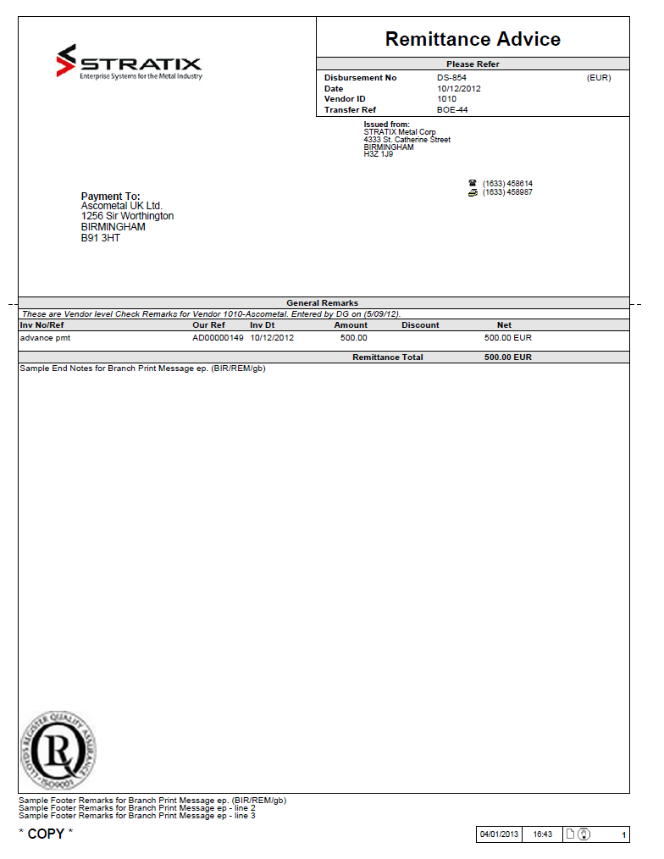

Remittance Advice Document Template
The following is the template of the Remittance Advice document. The space occupied by each field is illustrated by a string of one of the following values:

Q Represents the maximum space taken by a single alphanumeric character.
9 Represents the maximum space taken by a single numeric value.

Fields containing related information have been grouped together into sections. All sections have been numbered. Please refer to the Field Descriptions Table for details about each section and all the fields within each section.

The Remittance Advice template illustrates the largest possible area that a field can occupy. The actual space taken by a text or numeric string is typically smaller than what is indicated on the template due to the nature of non-proportional fonts.

North American Template

Europe-1 Template

Europe-2 Template

Remittance Advice Document – Fields Descriptions Table
 | Field Name | Description
Section 0 | Logo | - The Logo is printed based on the ‘Print Logo’ execution option  - The logo can be stored in an image file (e.g., a BITMAP or JPEG etc.).  - The logo image is scaled to size in order to fit it in the designated LOGO area.  - If printed, the logo is printed on all pages of the document.  - Refer to the External Document Standards specification for additional details.  - The Cash Disbursement Branch is used to print the logo
 | Logo Text | - The Logo Text is printed below the Logo based on the ‘Print Logo Text’ execution option and only if the ‘Print Logo’ execution option is set to No.  - It is printed based on the Branch Print Messages of type L-Logo Text of the Cash Disbursement Branch.  - A maximum of 35 characters in Tahoma with font size 12 in bold are printed. It is left aligned and printed as entered by the user.  - Refer to the External Document Standards specification for additional details.
Section 1  Title  This section is printed on all pages of the Remittance Advice document. | Form Title | - The title is ‘Remittance Advice’  - The font is Tahoma – 18 Point.
 | ‘Disbursement No’ | - Cash Disbursement Prefix and Number are printed. The fields are separated by a hyphen (e.g. DS-123)  - The Cash Disbursement currency is printed in parentheses at the end of the line. e.g. (EUR). There is no label printed for the currency.
 | ‘Date’ | The Journal Date is printed according to the Short Date setting in the Language/Country table.
 | ‘Vendor ID’ | The Vendor ID is printed.
 | ‘Transfer Ref’ | - The Bank and Check Number (i.e. Transfer Number) are printed.  - The fields are separated by a hyphen (e.g., CTB-123)
Section 2  Branch Return Address |  | - The Return Address is only printed if  - The ‘Europe-1’ template is used, and  - The ‘Print Return Address’ execution option is set to Yes.  - It is printed based on the rules outlined in External Document Standards document.  - The Return Address field is identical to the envelope window width, which is 3.4 inches. The font is Tahoma of point 5.
Section 3  Payment-to Address | ‘Payment To’ | - The Payment-to Address is printed using the Postal Address Printing Format. Refer to the External Document Standards specification for additional details.  - For the Europe-1 and Europe-2 Templates, the font size used is Arial (W1) – 8 Point.  - For the North American Template, the font size used is Arial (W1) – 9 Point.
Section 4 | ‘Issued From’ | - The Issued From Address is printed using the Postal Address Printing Format. Refer to the External Document Standards specification for additional details.  - For the Europe-1 and Europe-2 Templates, the font size used is Arial (W1) – 5 Point.  - For the North American Template, the font size used is Arial (W1) – 7 Point.
 | Telephone Number | - The Telephone number is not printed for the Europe-2 template. The label is suppressed.  - An icon is printed to represent a Telephone.  - The Telephone Number of the Issued From Address is printed.  - All trailing spaces are removed.  - The Telephone icon is suppressed if the Telephone Number is spaces.
 | Fax Number | - The Fax number is not printed for the Europe-2 template. The label is suppressed.  - An icon is printed to represent a Fax.  - The Fax Number of the Issued From Address is printed.  - All trailing spaces are removed.  - The Fax icon is suppressed if the Fax Number is spaces.
Section 7  General Remarks |  | - The Remarks are printed in the following sequence  - Check Printing (04) Instructions based on the setting of the Business Documents Remarks Configuration enterprise parameter  - This section has a variable size, which may differ from the size in the diagram.  - This entire section is suppressed if there are no remarks to be printed
Sections 10, 11  Paid Invoices,  Advance Payments |  | - This section lists both the Paid Invoices as well as any Advance Payments.  - Items are printed in the following sequence:  - Paid Invoices (see group 10 below)  - Sorted by Vendor Invoice Number  - Advance Payments (see group 11 below)
 | ‘Inv No/Ref’  10a | - The Vendor Invoice Number or Memo/Adjustment Description is printed.
 | 11a | - The Advance Payment Description is printed.
 | ‘Our Ref’  10b | - The Open Payable Prefix and Open Payable Number are printed (e.g., VR00000353).
 | 11b | - The Advance Payment Reference Prefix and Advance Payment Reference Number are printed (e.g., AD00000464).
 | ‘Inv Dt’  10c | - The Vendor Invoice Date is printed.
 | 11c | - The Cash Disbursement Journal Date is printed.
 | ‘Amount’  10d | - The AP Distribution Amount is printed.  - Denoted in Supplier Invoice currency.
 | 11d | - The Advance Payment Amount is printed.  - Denoted in the Cash Disbursement currency.
 | ‘Discount’  10e | - The Discount Taken Amount is printed.  - Denoted in Supplier Invoice currency.
 | 11e | - Discounts are not applicable to Advance Payments.
 | ‘Net’  10f | - The Net Payment Amount is printed.  - Denominated in Supplier Invoice currency.
 | 11f | - The Net Payment Amount is printed.  - Denoted in the Cash Disbursement currency.
 | 10g | - The Supplier Invoice currency is printed.  - There is no column heading.
 | 11g | - The Cash Disbursement currency is printed.  - There is no column heading.
 | ‘Paid In’  10h | - Indicates the Net Payment Amount denoted in the Cash Disbursement currency equivalent.  - Column is suppressed if all of the paid Supplier Invoices are denoted in the Cash Disbursement currency.
 | 11h | - Indicates the Net Payment Amount denoted in the Cash Disbursement currency equivalent.  - Same as Net Payment Amount for the Advance Payment (11f).  - Column is suppressed if all of the paid Supplier Invoices are denoted in the Cash Disbursement currency.
 | 10i | - The Cash Disbursement currency is printed.  - There is no column heading.  - Column is suppressed if all of the paid Supplier Invoices are denoted in the Cash Disbursement currency.
 | 11i | - The Cash Disbursement currency is printed.  - There is no column heading.  - Column is suppressed if all of the paid Supplier Invoices are denoted in the Cash Disbursement currency.
 | 10j | - The Check Item Remarks specific to the Supplier Invoice are printed.  - There is no column heading.  - The entire line is suppressed if the Check Item Remarks is SPACES.
 | 11j | - Check Item Remarks are not applicable to Advance Payments.
Section 12  Remittance Total | ‘Remittance Total’  12a | - One blank line is skipped before the section is printed.  - The section is separated from the preceding Paid Invoices section by a solid line that runs through the entire width of the document.  - The section is separated from the following section by a solid line that runs through the entire width of the document.  - This section is shaded.  - The label and Remittance Total amount are printed in bold.  - The Remittance Total is printed based on the total of either the ‘Net’ or ‘Paid In’ amounts.  - If all of the paid Supplier Invoices are denoted in the Cash Disbursement currency:  - A Net total is printed (aligned with the ‘Net’ column)  - A Paid In total is suppressed  - If any of the paid Supplier Invoices are not denoted in the Cash Disbursement currency:  - A Net total is suppressed  - A Paid In total is printed (aligned with the ‘Paid In’ column)
 | 12b | The Cash Disbursement currency is printed in bold.
Section 21 | End Notes | - Remittance Advice Print Messages of type E-End Notes are printed based on the Branch Print Messages table.  - Each End Note is printed separately, in which trailing blanks are removed.  - This section has a variable size that may differ from the size in the diagram.  - This section is printed only once, at the end of the document.
Section 22  Secondary Document Logo Area | Legal Notes Footer | - The printing of the Legal Notes Footer is controlled by the ‘REM Footer’ execution option. The entire section is suppressed if the execution option is off.  - Legal Notes or additional secondary logos that are required on the document are stored in an image file (e.g., a bitmap image).  - A pre-defined area on the document as shown on the sample diagram as ‘Legal Notes Footer’ is reserved for the printing of this image.  - The space required is approximately 1” in height and is bottom-justified. The space allocated is Fixed.  - Technical Note: the sample dotted line shown is for illustrative purposes only to indicate the space allocated and is not to be printed.  - The image is scaled to size in order to fit it in the designated area.  - This section is printed only once, on the last page of the document.
Section 23 | Footer Remarks | - Remittance Advice Print Messages of type F-Footer are printed based on the Branch Print Messages table.  - A maximum of three lines (90 Characters per line) is printed.  - A full width solid line is printed above the Footer Branch Print Messages.

Data Extraction – General Rules
- The Cash Disbursement Branch is always used to read the Branch Print Messages enterprise parameter. If a record is not found, the Corporate Branch from the Company enterprise parameter is used.

Remittance Advice Document – Fields Descriptions Table
 | Field Name | Description | Data Element | Table
Section 0 | Logo |  | DSB-BRH | APJDBJ
 | Logo Text | - The Branch Print Messages table <SCRBPM> is read using the following:  - BRH = DBJ-DSB-BRH  - BUS-DOC-TYP = REM  - LNG = Vendor Language  - MSG-TYP = L | TXT | SCRBPM
Section 1  Title  This section is printed on all pages of the Remittance Advice document. | Form Title | ‘Remittance Advice’
 | ‘Disbursement No’ |  | DSB-PFX  DSB-NO  DSB-CRY | APJDBJ
 | ‘Date’ |  | JRNL-DT | APJDBJ
 | ‘Vendor ID’ |  | VEN-ID | APJDBJ
 | ‘Transfer Ref’ |  | BNK  VEN-CHK-NO | APJDBJ
Section 2  Branch Return Address |  | - The Branch table <SCRBRH> is read using the Cash Disbursement Branch (DSB-BRH) from the Cash Disbursement Journal Header <APJDBJ>. | NM1  ADDR1, PCD, CITY | SCRBRH
Section 3  Payment-to Address |  | - The Cash Disbursement Journal Name and Address table <APJDNJ> is read using the following:  - DSB-PFX = DBJ-DSB-PFX  - DSB-NO = DBJ-DSB-NO  - ADDR-TYP = ‘P’ – Payment-to | NM1, NM2  ADDR1, ADDR2,  ADDR3,  CITY, PCD, CTY, ST-PROV | APJDNJ
Section 4 | ‘Issued From’ | Extracting the Issued From Address  - The address is printed based on the Forms Company Name execution option.  Using the Forms Company Name execution option to print the Issued From address:  - C – Company Legal Name & Address  - T – Name & Address for the Branch on the Cash Disbursement Journal Header.  - W or R – Not applicable. In this case the same Address is printed as for option ‘T’. | NM1, NM2  ADDR1,  ADDR2,  ADDR3,  CITY,PCD,CTY | SCRCSC  SCRBRH
 | Telephone Number | - The Telephone Number is retrieved based on the Issued From address. | TEL-AREA-CD  TEL-NO  TEL-EXT | SCRCSC  SCRBRH
 | Fax Number | - The Fax Number is retrieved based on the Issued From address. | FAX-AREA-CD  FAX-NO  FAX-EXT | SCRCSC  SCRBRH
Section 7  General Remarks |  | Extracting the Check Printing Instructions  - The Customer/Vendor Remarks table <SCRCVR> is read using the following:  - REF-PFX = VN  - CUS-VEN-TYP = V  - CUS-VEN-ID = DBJ-VEN-ID  - CUS-VEN-SHP = 0  - RMK-CL = 5  - RMK-TYP = 04  - LNG = VEN-LNG  - The LIB-ID field is verified:  - If LIB-ID = spaces the TXT from the Customer/Vendor Remarks table is printed.  - If LIB-ID <> spaces the TXT from the Library table <SCRLIB> is printed. The Library table is read using the Vendor Language. | TXT  TXT | SCRCVR  SCRLIB
Sections 10, 11  Paid Invoices,  Advance Payments |  | Items in this section are printed in the following sequence:  - Paid Invoices (APJDDJ)  - Advance Payments (APJDUJ)
 | ‘Inv No/Ref’  10a | - The AP-PFX and AP-NO from APJDDJ is used to read the AP Open Item table <APTPYH> to retrieve the Vendor Invoice Number.  - If there is no Vendor Invoice Number available, the Invoice or Memo/Adjustment Description is printed. | VEN-INV-NO  or  DESC30 | APTPYH
 | 11a |  | DESC30 | APJDUJ
 | ‘Our Ref’  10b |  | OPA-PFX  OPA-NO | APJDDJ
 | 11b |  | ADV-DSB-PFX  ADV-DSB-NO | APJDUJ
 | ‘Inv Dt’  10c | The AP-PFX and AP-NO from APJDDJ is used to read the AP Open Item table <APTPYH> to retrieve the Vendor Invoice Date. | VEN-INV-DT | APTPYH
 | 11c | The DSB-PFX and DSB-NO from APJDUJ is used to read the Cash Disbursement Journal header table <APJDBJ> to retrieve the Journal Date. | JRNL-DT | APJDBJ
 | ‘Amount’  10d |  | DSAMT | APJDDJ
 | 11d |  | ADV-AMT | APJDUJ
 | ‘Discount’  10e |  | DISC-TKN-AMT | APJDDJ
 | 11e | Discounts are not applicable to Advance Payments.
 | ‘Net’  10f | - The Net Payment Amount is calculated as follows:  - (DSAMT) – (DISC-TKN-AMT) | Calculated | APJDDJ
 | 11f |  | ADV-AMT | APJDUJ
 | 10g |  | AP-CRY | APJDDJ
 | 11g | The DSB-PFX and DSB-NO from APJDUJ is used to read the Cash Disbursement Journal header table <APJDBJ> to retrieve the Cash Disbursement currency. | DSB-CRY | APJDBJ
 | ‘Paid In’  10h | - The Paid In Amount is calculated as follows:  - (DSB-AMT) – (DISC-TKN-AMT * AP-XEX-RT) | Calculated | APJDDJ
 | 11h |  | ADV-AMT | APJDUJ
 | 10i | The DSB-PFX and DSB-NO from APJDDJ is used to read the Cash Disbursement Journal header table <APJDBJ> to retrieve the Cash Disbursement currency. | DSB-CRY | APJDBJ
 | 11i | The DSB-PFX and DSB-NO from APJDUJ is used to read the Cash Disbursement Journal header table <APJDBJ> to retrieve the Cash Disbursement currency. | DSB-CRY | APJDBJ
 | 10j | The AP-PFX and AP-NO from APJDDJ is used to read the AP Open Item table <APTPYH> to retrieve the Check Item Remarks. | CHK-ITM-RMK | APTPYH
 | 11j | Check Item Remarks are not applicable to Advance Payments.
Section 12  Remittance Total | ‘Remittance Total’  12a |  | VEN-CHK-AMT | APJDBJ
 | 12b |  | DSB-CRY | APJDBJ
Section 21  End Notes |  | - The Branch Print Message table <SCRBPM> is read using the following:  - Branch = DSB-BRH  - Document Type = REM  - Language = Vendor Language  - Message Type = E-End Notes | TXT | SCRBPM
Section 22  Secondary Document Logo area | Legal Notes Footer | Procedure when ‘REM Footer’ execution option = 1:  - The system verifies the Cash Disbursement Branch  - In the $HOME/logo directory, the system searches for the bitmap image which has the branch code found in the previous step. If no image can be found with that branch code, then the default image (i.e. REMFOOTER.bmp) is used. | LOGO-NM
Section 23  Footer Remarks |  | - The Branch Print Message table <SCRBPM> is read using the following:  - Branch = DSB-BRH  - Document Type = REM  - Language = Vendor Language  - Message Type = F-Footer Remarks | TXT | SCRBPM

Remittance Advice – Summary of Execution Options
The following table summarizes the Execution Options referenced by the Remittance Advice document. For further details, refer to the ‘Execution Options Data Dictionary’.

Execution Option | Description
PRT-LOGO | Print Logo
PRT-LOGO-TXT | Print Logo Text
PRT-RTN-ADDR | Print Return Address
RPT-DOC-PG-FMT | Report Document Page Format
REM-FTR | REM Footer
FRM-CO | Forms Company Name
RPTG-RETN-DY | Reporting Retention Days
PRTY-LVL | Priority Level

RECONCILIATION POSITION REPORT BY PO

Overview
This report shows the status of the Cost Reconciliation transactions that meet the selection criteria, sequenced according to Purchase Order and Item numbers.

Selection Options are available to limit the scope of Cost Reconciliation transactions shown.

Target Audience
Accounting staff can use this report to reconcile open Cost Reconciliation transactions based on Purchase Order information.

The report is also used as a verification report for the Period-End Balancing procedures. Please refer to the ‘INVEX Interface to General Ledger’ document for further details.

Prerequisites

Period-End Inventory Data Capture
This is a prerequisite procedure only if the Accounting Period selection is used.

Please refer to the ‘Inventory Data Capture’ documentation for further details.

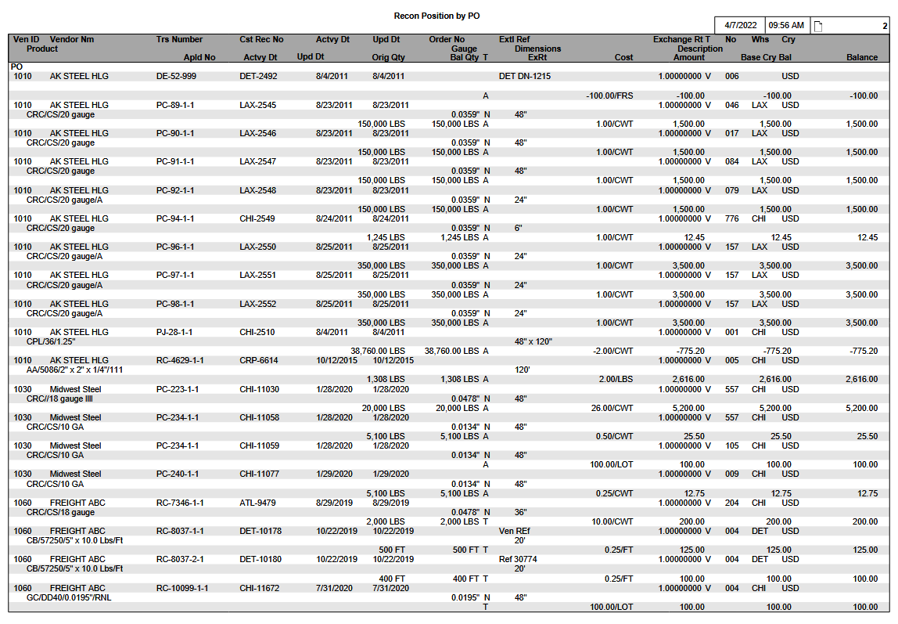

Report Selections
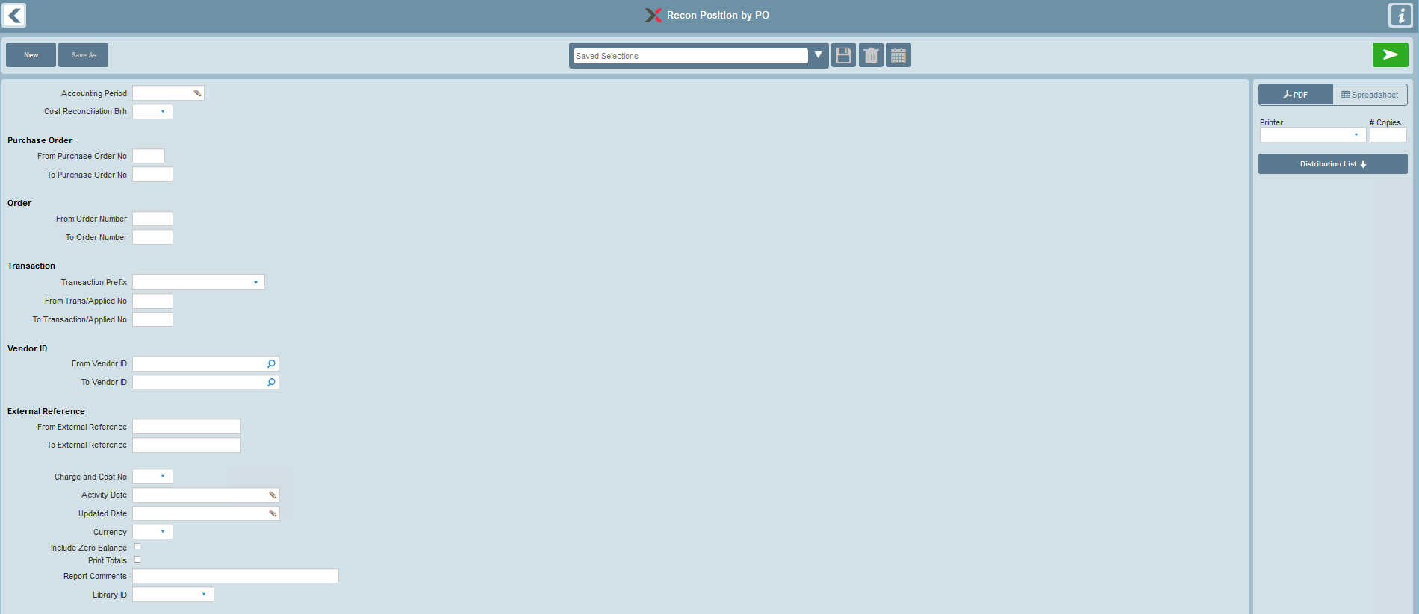

Selections | Options | Data Elements | Default | Notes
Accounting Period | If selected, must be a specific Accounting Period. |  |  | Optional selection.  Look-up provided.  Please refer to the ‘Accounting Period Business Rules’ section for details on how this selection filter is used.
Cost Reconciliation Branch |  | CRH-CRCN-BRH | All
Purchase Order
 | From PO No | CRH-PO-NO | All
 | To PO No | CRH-PO-NO | All
Order
 | From Order No | CRH-ORD-NO | All
 | To Order No | CRH-ORD-NO | All
Transaction
 | Transaction Prefix | CRH-TRS-PFX | All
 | From Trans No | CRH-TRS-NO | All
 | To Trans No | CRH-TRS-NO | All
Vendor ID
 | From Vendor ID | CRH-VEN-ID | All
 | To Vendor ID | CRH-VEN-ID | All
External Reference
 | From External Ref | CRH-EXTL-REF | All
 | To External Ref | CRH-EXTL-REF | All
Charge & Cost No |  | CRH-CC-NO | All
Activity Date |  |  |  | If a record from IRTCRH is retrieved, then INVEX also performs a scan of IRTCRP to see if any associated applications exist, subject to the Activity Date.
 | From Activity Date | CRH-ACTVY-DT,  CRP-ACTVY-DT | All
 | To Activity Date | CRH-ACTVY-DT,  CRP-ACTVY-DT | All
Update Date |  |  |  | If a record from IRTCRH is retrieved, then INVEX also performs a scan of IRTCRP to see if any associated applications exist, subject to the Update Date.
 | From Update Date | CRH-UPD-DT,  CRP-UPD-DT | All
 | To Update Date | CRH-UPD-DT,  CRP-UPD-DT | All
Currency |  | CRH-CRY | All
Include Zero Balance | Unchecked-excluded  Checked-included | SS-INCZ-BAL | Unchecked | If checked, includes printing of transactions where there is no calculated Cost Reconciliation balance remaining.
Print Totals Only |  |  | Unchecked | If checked, print the Totals section only.
Report Comments |  |  | None | Provides an option to print report comments on the Selection page of the report.
Library ID | None or a specific Library ID |  | None | Provides an option to select a Library ID for generic remarks to be printed on the Selection page of the report.

Accounting Period Business Rules
- If an Accounting Period selection is provided, transaction eligibility is case-dependent and is determined based on the Accounting Period selection, as well as the Cost Reconciliation Transaction Prefix, and either the ‘Data Capture Date/Time’ in the Inventory Data Capture Summary or the ‘Period Ending Date’ in the Fiscal Calendar enterprise parameter:

Case A
- If the Cost Reconciliation Accrual (Header) Transaction Prefix is not ‘SE/DE/CE/TE/TD/TN/VR/CM/DM’, then Cost Reconciliation Accrual transactions are eligible for possible inclusion on the report if the Transaction Update Date/Time (IRTCRH-UPD-DTTS) is less than or equal to the corresponding Data Capture Date/Time (INTIDE-IDC-DTTS) for the selected Accounting Period:
- An error is issued for the business case where the Accounting Period selection is used but the corresponding Inventory Data Capture Summary is absent.

Case B
- If the Cost Reconciliation Accrual (Header) Transaction Prefix is ‘SE/DE/CE/TE/TD/TN/VR/CM/DM’, then Cost Reconciliation Accrual transactions are eligible for possible inclusion on the report if the Transaction Activity Date (IRTCRH-ACTVY-DT) is less than or equal to the corresponding Accounting Period’s Period Ending Date.

Case C
- Cost Reconciliation Application transactions are eligible for possible inclusion on the report if the Activity Date (IRTCRP-ACTVY-DT) is less than or equal to the corresponding Accounting Period’s Period Ending Date. Please note that Cost Reconciliation Applications can be included even if the corresponding Cost Reconciliation Accrual is not eligible.

Case D
- If the Cost Reconciliation Accrual transaction is eligible, but the Cost Reconciliation Application transactions are not eligible for possible inclusion on the report, the Original Amount of the Cost Reconciliation Accrual is printed.

Case E
- If neither the Cost Reconciliation Accrual nor the Cost Reconciliation Application transactions are eligible for possible inclusion on the report, the Cost Reconciliation transaction is excluded from the report.

In all cases, the Cost Reconciliation Balance for reporting is calculated dynamically as per the following examples:
Case | Accrual Eligible | Applications Eligible | Expected Balance Calculation
A | Yes  $100 | Yes  $20 | Accrual Original Amount minus Application Applied Amounts  100 – 20 = 80
B | Yes  $200 | Yes  $30 | Accrual Original Amount minus Application Applied Amounts  200 – 30 = 170
C | No | Yes  $40 | Zero minus Application Applied Amounts  0 – 40 = negative 40
D | Yes  $60 | No | Accrual Original Amount only  60
E | No | No | Cost Reconciliation transaction bypassed.

Refer to the following sections for further details:
- 'Transaction Eligibility – Cost Reconciliation Transactions Included/Excluded'
- 'Report Field Descriptions'

General Rules

Report Sequencing
This report is sequenced by Purchase Order information. The sequence starts with PO Prefix, PO Number, and then PO Item.

Total Summary Recap
The Total summary is started from a new page. This section includes the following totals:
- Cost Reconciliation Transaction Base Currency Value
- Cost Reconciliation Applications Base Currency Value
- Net Base Currency Value
- Base Currency Charge & Cost
- A recap of the total Cost Reconciliation for each Cost Reconciliation branch that is listed in the report details. The branch recap is based on the following:
- the Cost Reconciliation Branch
- the printed ‘Base Currency Balance’ that was calculated
- The recap is sequenced by Cost Reconciliation Branch.
- A grand total for all the Cost Reconciliation branches is included.

Report Currency Base
The Totals are provided in the company’s base currency for better readability.

Transaction Eligibility – Cost Reconciliation Transactions Included/Excluded

Transactions are printed/not printed based on the resulting "calculated" balance. Refer to the 'Report Field Descriptions' section for further details.

Data

Primary Source of Data
- IRTCRH – Cost Reconciliation Accrual (Header)
- IRTCRP – Cost Reconciliation Application

Grouped By
- PO Prefix/Number/Item
- Cost Reconciliation Branch/Number

Detail Line Sequenced By
- Applied Ref Prefix/Number

Control Breaks By
- Cost Reconciliation Branch/Number
- PO Prefix/Number/Item

Page Break By
- PO Prefix

Data Totaled By

Purchase Order Info
- PO Item
- PO Number

Total Summary Recap (New Page)
- Cost Reconciliation Transaction Base Currency Value
- Cost Reconciliation Applications Base Currency Value
- Net Base Currency Value
- Base Currency Charge & Cost Recap
- Base Currency Branch Recap

Sample Report: Transactions in Base Currency
10/07/99 16:50 PAGE: 2
Recon Position By PO
Ven ID Ven Nm Trs Number Cst Rec No Actvy Dt Upd Dt Order No Extl Ref Exchange Rt T No Whs Cry
Product Gauge T Dimensions Description
Apld No Actvy Dt Upd Dt Orig Qty Bal Qty T Cost Amt Base Cry Bal Bal
PO-2046-1
1010 Ross Metals RC-337-1-1 PHI-428 10/19/1999 10/19/1999 SO-663-1 2088-4799-001 1.00000000 F 001 PPR USD
HRC/430/3372/D 0.45000 N 48.0000 APACHE TRUCKING
30,000 LBS 30,000 T 25.00/CWT 7,500.00 7,500.00 7,500.00

1010 Ross Metals RC-337-1-1 PHI-429 10/19/1999 10/19/1999 SO-663-1 2088-4799-002 1.00000000 F 002 PPR USD
HRC/430/3372/D 0.45000 N 48.0000
30,000 LBS 30,000 T 1.00/CWT 300.00 300.00 300.00
>> PO Item 7,800.00

>> Purchase Order 7,800.00

PO-2047-1
1010 Ross Metals RC-338-1-1 PHI-430 10/20/1999 10/20/1999 SO-664--1 2088-4800-001 1.00000000 F 001 PPR USD
HRC/430/3372/D 0.45000 N 48.0000 APACHE TRUCKING
30,000 LBS 30,000 T 25.00/CWT 7,500.00 7,500.00 7,500.00

1010 Ross Metals RC-339-1-1 PHI-431 10/21/1999 10/21/1999 SO-664-1 2088-4800-002 1.00000000 F 001 PPR USD
HRC/430/3372/D 0.45000 N 48.0000 APACHE TRUCKING
50,000 LBS 4,900 T 22.00/CWT 11,000.00
VR-34 10/28/1999 10/28/1999 20,000 LBS 1.00000000 4,400.00 6,600.00 6,600.00
VR-35 10/29/1999 10/29/1999 25,100 LBS 1.00000000 5,500.00 1,100.00 1,100.00
>> PO Item 8,600.00

>> Purchase Order 8,600.00

10/07/99 16:50 PAGE: 3
Recon Position By PO
No Description Base Cry Amt Base Cry Applied Base Cry Bal
001 Metal Charge & Cost 26,000.00 9,900.00 16,100.00
002 Freight Charge & Cost 300.00 0.00 300.00

>> Base Cry Charge & Cost 26,300.00 9,900 16,400.00

Branch Recap
QQQ QQQQQQQQQQQQQQQ ZZZZ,ZZZ,ZZ9.99-

CHI Chicago 10,000.00
DET Detroit 6,400.00

Total 16,400.00

Sample Report: Transactions in Foreign Currency
10/07/99 16:50 PAGE: 2
Recon Position By PO
Ven ID Ven Nm Trs Number Cst Rec No Actvy Dt Upd Dt Order No Extl Ref Exchange Rt T No Whs Cry
Product Gauge T Dimensions Description
Apld No Actvy Dt Upd Dt Orig Qty Bal Qty T Cost Amt Base Cry Bal Bal
PO-2046-1
1010 Ross Metals RC-337-1-1 PHI-428 10/19/1999 10/19/1999 SO-663-1 2088-4799-001 0.67000000 V 001 PPR CAD
HRC/430/3372/D 0.45000 N 48.0000 APACHE TRUCKING
30,000 LBS 30,000 T 25.00/CWT 7,500.00 5,025.00 7,500.00

1010 Ross Metals RC-337-1-1 PHI-429 10/19/1999 10/19/1999 SO-663-1 0.67000000 V 002 PPR CAD
HRC/430/3372/D 0.45000 N 48.0000
30,000 LBS 30,000 T 1.00/CWT 300.00 201.00 300.00
>> PO Item 5,226.00
>> Purchase Order 5,226.00

PO-2047-1
1010 Ross Metals RC-338-1-1 PHI-430 10/20/1999 10/20/1999 SO-664-001 2088-4800-001 0.65000000 V 001 PPR CAD
HRC/430/3372/D 0.45000 N 48.0000 APACHE TRUCKING
30,000 LBS 30,000 T 25.00/CWT 7,500.00 4,875.00 7,500.00

1010 Ross Metals RC-339-1-1 PHI-431 10/21/1999 10/21/1999 SO-664-1 2088-4800-002 0.65000000 V 001 PPR CAD
HRC/430/3372/D 0.45000 N 48.0000 APACHE TRUCKING
50,000 LBS 4,900 T 22.00/CWT 11,000.00
VR-34 10/28/1999 10/28/1999 20,000 LBS 0.66000000 4,400.00 4,290.00 6,600.00
VR-35 10/29/1999 10/29/1999 25,100 LBS 0.66000000 5,500.00 715.00 1,100.00
>> PO Item 4,990.00

>> Purchase Order 4,990.00

10/07/99 16:50 PAGE: 3
Recon Position By PO
No Description Base Cry Amt Base Cry Applied Base Cry Bal
001 Metal Charge & Cost 17,050.00 6,435.00 10,615.00
002 Freight Charge & Cost 201.00 0.00 201.00

>> Base Cry Charge & Cost 17,251.00 6,435.00 10,816.00

Report Layout
10/07/99 16:50 PAGE: 2
Recon Position By PO
Vendor ID Trs Number Cst Rec No Actvy Dt Upd Dt Order No Extl Ref Exchange Rt T No Whs Cry
Product Gauge T Dimensions Description
Apld No Actvy Dt Upd Dt Orig Qty Bal Qty T Cost Amt Base Cry Bal Bal
WW-999999-999
QQQQQQQQ WW-99999999-999-9999 WWW-999999 MM/DD/YYYY MM/DD/YYYY WW-99999999-999 QQQQQQQQQQQQQQQQQQQQQQ ZZZ9.99999999 W 999 WWW WWW
QQQQQQ/QQQQQQQQ/QQQQQQQQQQQQQQQ/QQQQQQQQ ZZ9.99999 W ZZZZ9.9999 ZZZZ9.9999 QQQQQQQQQQQQQQQQQQQQQQQQQQQQQQ
ZZZ,ZZZ,ZZ9 WWW ZZZ,ZZZ.ZZ9 W ZZZ,ZZZ,ZZ9.99/WWW Z,ZZZ,ZZZ,ZZ9.99 Z,ZZZ,ZZZ,ZZ99.99 ZZZ,ZZZ,ZZ9.99
WW-999999 MM/DD/YYYY MM/DD/YYYY ZZZ,ZZZ,ZZ9 WWW ZZZ9.99999999 Z,ZZZ,ZZZ,ZZ9.99 Z,ZZZ,ZZZ,ZZ99.99 ZZZ,ZZZ,ZZ9.99
WW-999999 MM/DD/YYYY MM/DD/YYYY ZZZ,ZZZ,ZZ9 WWW ZZZ9.99999999 Z,ZZZ,ZZZ,ZZ9.99 Z,ZZZ,ZZZ,ZZ99.99 ZZZ,ZZZ,ZZ9.99
WW-999999 MM/DD/YYYY MM/DD/YYYY ZZZ,ZZZ,ZZ9 WWW ZZZ9.99999999 Z,ZZZ,ZZZ,ZZ9.99 Z,ZZZ,ZZZ,ZZ99.99 Z,ZZZ,ZZZ,ZZ9.99
WW-999999 MM/DD/YYYY MM/DD/YYYY ZZZ,ZZZ,ZZ9 WWW ZZZ9.99999999 Z,ZZZ,ZZZ,ZZ9.99 Z,ZZZ,ZZZ,ZZ99.99 Z,ZZZ,ZZZ,ZZ9.99
>> PO Item Z,ZZZ,ZZZ,ZZZ,ZZ9.99

>> Purchase Order Z,ZZZ,ZZZ,ZZZ,ZZ9.99

10/07/99 16:50 PAGE: 3
Recon Position By PO
No Description Base Cry Amt Base Cry Applied Base Cry Bal
999 WWWWWWWWWWWWWWWWWWWW Z,ZZZ,ZZZ,ZZZ,ZZ9.99 Z,ZZZ,ZZZ,ZZZ,ZZ9.99 Z,ZZZ,ZZZ,ZZZ,ZZ9.99
999 WWWWWWWWWWWWWWWWWWWW Z,ZZZ,ZZZ,ZZZ,ZZ9.99 Z,ZZZ,ZZZ,ZZZ,ZZ9.99 Z,ZZZ,ZZZ,ZZZ,ZZ9.99
999 WWWWWWWWWWWWWWWWWWWW Z,ZZZ,ZZZ,ZZZ,ZZ9.99 Z,ZZZ,ZZZ,ZZZ,ZZ9.99 Z,ZZZ,ZZZ,ZZZ,ZZ9.99

>> Base Cry Charge & Cost Z,ZZZ,ZZZ,ZZZ,ZZ9.99 Z,ZZZ,ZZZ,ZZZ,ZZ9.99 Z,ZZZ,ZZZ,ZZZ,ZZ9.99

Report Structure

Report Field Description
Group | Report Field | Field Name | Business Rules | Formatting
1st Group (PO)
 | PO Prefix | CRH-PO-PFX | PO Brh/Prefix/PO Num/PO Item
 | PO Number | CRH-PO-NO | PO Brh/Prefix/PO Num/PO Item
 | PO Item | CRH-PO-ITM | PO Brh/Prefix/PO Num/PO Item
2nd Group Heading
 | Vendor ID | CRH-VEN-ID
 | Transaction Prefix | CRH-TRS-PRX
 | Transaction Number | CRH-TRS-NO
 | Transaction Item | CRH-TRS-ITM
 | Transaction Sub-item | CRH-TRS-SBITM
 | Cost Reconciliation Branch | CRH-CRCN-BRH
 | Cost Reconciliation Number | CRH-CRCN-NO
 | Activity Date | CRH-ACTVY-DT |  | Depends on the short date style found in the Language/Country Enterprise Parameter.
 | Update Date | CRH-UPD-DT
 | Order Prefix | CRH-ORD-PFX
 | Order Number | CRH-ORD-NO
 | Order Item | CRH-ORD-ITM
 | External Reference | CRH-EXTL-REF
 | Exchange Rate | CRH-EX-RT
 | Exchange Rate Type | CRH-EX-RT-TYP
 | Charge & Cost Number | CRH-CC-NO
 | Warehouse | CRH-WHS
 | Currency | CRH-CRY
 | Product | CRH-FRM  CRH-GRD  CRH-SIZE  CRH-FNSH
 | Gauge Size | CRH-GA-SIZE
 | Gauge Type | CRH-GA-TYP
 | Dimension | CRH-WDTH  CRH-LGTH
 | Description | CRH-DESC30
 | Original Quantity | CRH-CST-QTY |  | Quantity Format 3
 | Balance Quantity | CRH-BAL-QTY |  | Quantity Format 3
 | Cost Quantity UM | CRH-CST-QTY-UM
 | Cost Quantity Type | CRH-CST-QTY-TYP
 | Cost | CRH-CST
 | Cost UM | CRH-CST-UM
 | Original Amount | CRH-ORIG-AMT
 | Base Currency Balance | Calculated | - Printed on this line only if no Cost Reconciliation Application transactions are printed for this Cost Reconciliation Header.  (Calculated ‘Balance’) * (CRH-EX-RT)
 | Balance | Calculated | - Printed on this line only if no Cost Reconciliation Application transactions are printed for this Cost Reconciliation Header.  Case A  - Accounting Period selected, and  - Cost Reconciliation Header is eligible, and  - Cost Reconciliation Applications are eligible  (IRTCRH_ORIG_AMT)  + (∑ IRTCRP Applications included/excluded, subject to Accounting Period filtering)  Transaction excluded from report if the 'Include Zero Balance' selection is off and the resulting Calculated Balance is zero.  Case B  - Accounting Period selected, and  - Cost Reconciliation Header is not eligible, and  - Cost Reconciliation Applications are eligible  (IRTCRH_ORIG_AMT calculated as zero)  + (∑ IRTCRP Applications included/excluded, subject to Accounting Period filtering)  Transaction excluded from report if the 'Include Zero Balance' selection is off and the resulting Calculated Balance is zero.  Case C  - Accounting Period selected, and  - Cost Reconciliation Header is not eligible, and  - Cost Reconciliation Applications are not eligible  Transaction excluded from report.  Case D  - Accounting Period not selected  (IRTCRH_ORIG_AMT)  + (∑ All IRTCRP Applications)  Transaction excluded from report if the 'Include Zero Balance' selection is off and the resulting Calculated Balance is zero.
1st Detail Line
 | Applied Prefix | CRP-APLD-PFX
 | Applied Number | CRP-APLD-NO
 | Activity Date | CRP-ACTVY-DT |  | Depends on the short date style found in the Language/Country Enterprise Parameter.
 | Update Date | CRP-UPD-DT
 | Applied Quantity | CRP-APLD-QTY |  | Quantity Format 3
 | Applied Quantity UM | CRP-APLD-QTY-UM
 | Applied Exchange Rate | CRP-EX-RT | Reference only. Not used in report calculations.
 | Applied Amount | CRP-APLD-AMT
 | Applied Base Currency Balance | Calculated | (Calculated ‘Applied Balance’) *  (CRH-EX-RT)
 | Applied Balance | Calculated | (CRH-ORIG-AMT)  + All previously printed Application Amounts for this Cost Reconciliation transaction (if any)  + current Application Amount
PO Item Total
 | PO Item Total | Calculated | Sums total Base Currency Balance for the same PO Item.
PO Total
 | Purchase Order Total | Calculated | Sums total Base Currency Balance for all PO Items of the Purchase Order.
Charge & Cost Summary Recap |  |  | Recap info for different Charge & Cost Number.  Lists all Charge & Cost Items appearing on the report.
 | Charge & Cost No | CRH-CC-NO | The Charge & Cost No appears on the report.
 | Charge & Cost Description | CCR-DESC20 | The description for this Charge & Cost No from the Charge & Cost Reference table.
 | Base Currency Amount (A) | Calculated | Sums total Header Original Amt, in base currency, by specific Charge & Cost Number.
 | Base Currency Applied Amt (B) | Calculated | Sums total Applied Amt, in base currency, by specific Charge & Cost Number.
 | Base Currency Balance | Calculated | Base Cry Amount – Base Cry Applied Amount  (i.e., A – B)
Charge & Cost Recap Totals
 | Total Base Currency Amt (C) | Calculated | ∑ (Base Currency Amount) for all Charge & Cost Numbers.
 | Total Base Currency Applied Amt (D) | Calculated | ∑ (Base Currency Applied Amt) for all Charge & Cost Numbers.
 | Total Base Currency Balance | Calculated | Total Base Cry Amount – Total Base Cry Applied Amt for all Charge & Cost Numbers.  (i.e., C – D)
Branch Summary Recap
 | Cost Reconciliation Branch
 | Branch Name
 | Base Currency Balance

Accounting Period Selection Window
If the Accounting Period selection is accessed via the Report Requester screen, the following window is provided:


Radio Button Selections

Radio Button Selection Label | Valid Values | Default | Notes
Accounting Period | Specific value | checked | A valid Accounting Period must be provided if this radio button is selected.  Drop-down look-up is provided via Fiscal Calendar EP (glrfis table)  Example:  
Current Period |  | unchecked | Allows user to select transactions for the entire 'current' Accounting Period.  Note that this is a variable context report selection that is determined dynamically relative to the date of report execution.  Please refer to “Report Execution - Business Rules” section for details on this feature.
Previous Period |  | unchecked | Allows user to select transactions for the entire 'previous' Accounting Period.  Note that this is a variable context report selection that is determined dynamically relative to the date of report execution.  This uses the most recent financial Inventory Data Capture information available at time of report execution to determine whether transactions are selected for reporting purposes.  Prerequisites  It is assumed that procedurally the Inventory Data Capture for "End of Month – Inventory Closing" has been completed.

Business Rules
If the user navigates back from the Accounting Period Selection window via the OK or EXIT buttons, and has selected the “Accounting Period” radio button but has not provided a specific Accounting Period value, then this is equivalent to not having requested an Accounting Period selection filter for the report.

Navigating Back to the Report Requester Screen
Depending on the business case, one of the following values is returned from the Accounting Period Selection window and displayed directly on the main Report Requester screen:

- A specific Accounting Period value eg. “202203”
- The label “Cur Period”
- The label “Prev Period”
- blank (ie. indicates no filtering was requested via the window)

Business Case 1 - Example:


Business Case 2 - Example:


Business Case 3 - Example:


Business Case 4 - Example:


Report Execution – Business Rules

Accounting Period Radio Button
- If the “Accounting Period” radio button was selected, then the specific Accounting Period value that was provided directly is used at report execution time.

Current Period Radio Button
- If the ‘Current Period’ radio button was selected, then the Accounting Period to be used at report execution time is determined dynamically as follows:
- Accounting Period value is not resolvable.
- The Inventory Data Capture header (intide) table is bypassed.
- All transactions are eligible for inclusion.
- The front selection page of the generated report indicates the words ‘Current Period’ (since there is no resolvable Accounting Period value).

Previous Period Radio Button
- If the “Previous Period” radio button was selected, then the Accounting Period to be used at report execution time is determined dynamically as follows:
- The Inventory Data Capture header (intide) table is accessed
- The financial (Purpose Code = “F”) Inventory Data Capture record which contains the most recent Accounting Period is accessed
- The front selection page of the generated report indicates the actual equivalent Accounting Period, not the words “Previous Period”
- If there is no corresponding Inventory Data Capture record available, the report cannot be generated correctly and an error is issued via the View Log button in the Document Manager:
“Inventory Data Capture information unavailable”

RECONCILIATION POSITION BY VENDOR

Overview
This report shows the status of the Cost Reconciliation transactions that meet the selection criteria, sequenced according to Vendor ID and External Reference.

Target Audience
Accounting staff can use this report to reconcile open Cost Reconciliation transactions based on Vendor ID and External Reference.

The report is also used as a verification report for the Period-End Balancing procedures. Please refer to the ‘INVEX Interface to General Ledger’ document for further details.

Prerequisites

Period-End Inventory Data Capture
This is a prerequisite procedure only if the Accounting Period selection is used.

Please refer to the ‘Inventory Data Capture’ documentation for further details.

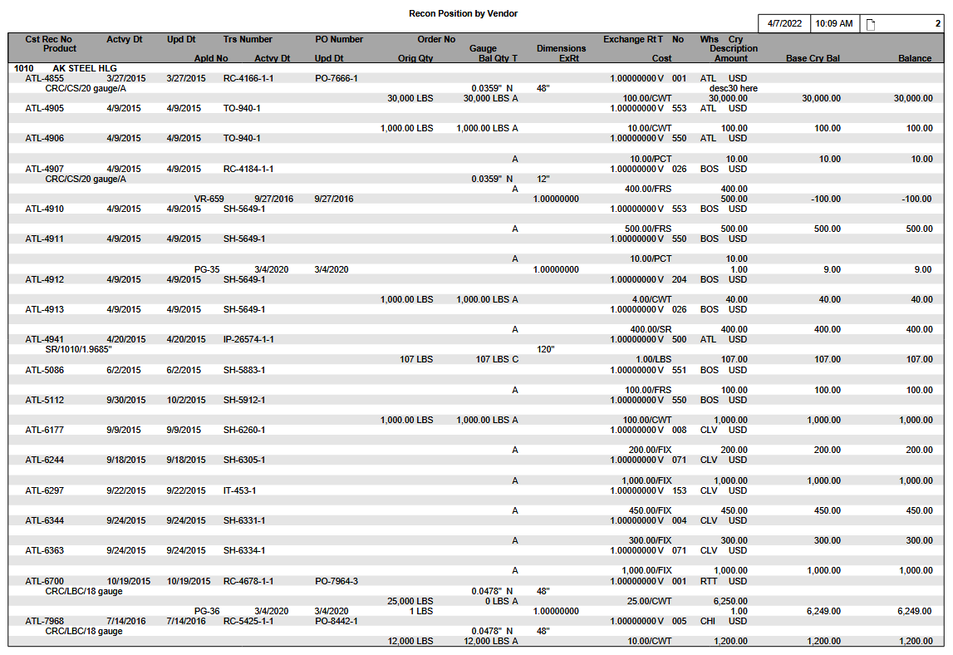

Report Selections
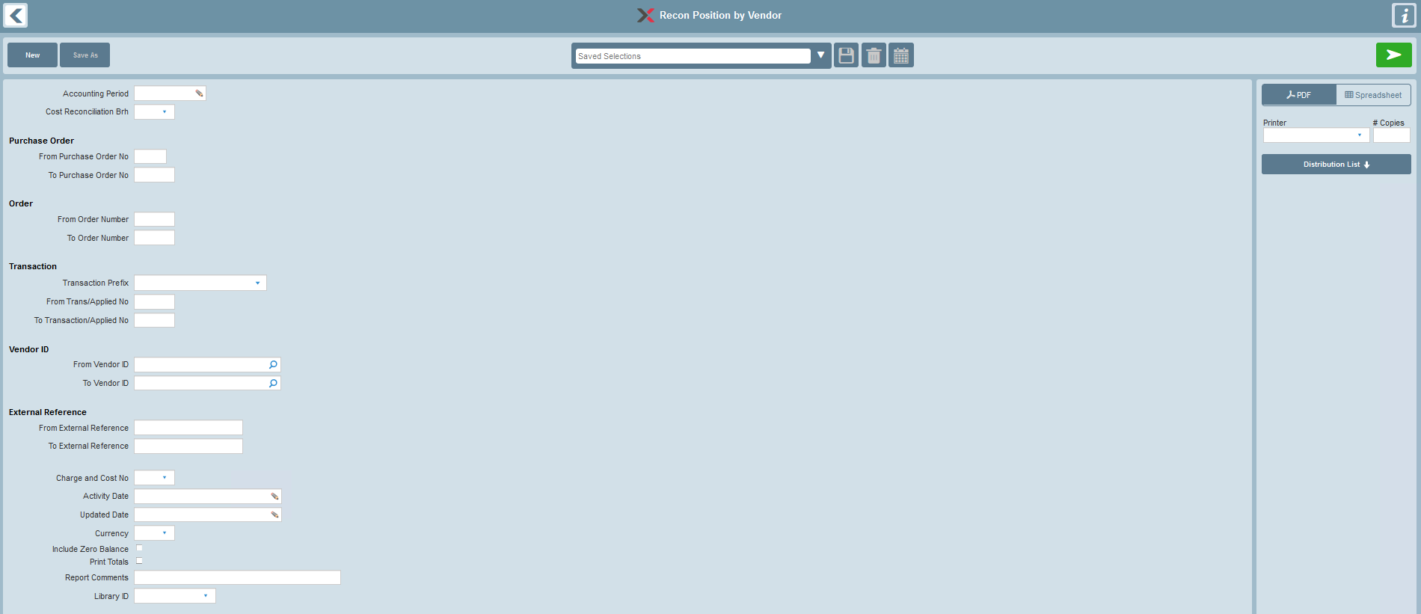

Selections | Options | Data Elements | Default | Notes
Accounting Period | If selected, must be a specific Accounting Period. |  |  | Optional selection.  Look-up provided.  Please refer to the ‘Accounting Period Business Rules’ section for details on how this selection filter is used.
Cost Reconciliation Branch |  | CRH-CRCN-BRH | All
Purchase Order
 | From PO No | CRH-PO-NO | All
 | To PO No | CRH-PO-NO | All
Order
 | From Order No | CRH-ORD-NO | All
 | To Order No | CRH-ORD-NO | All
Transaction
 | Transaction Prefix | CRH-TRS-PFX | All
 | From Trans No | CRH-TRS-NO | All
 | To Trans No | CRH-TRS-NO | All
Vendor ID
 | From Vendor ID | CRH-VEN-ID | All
 | To Vendor ID | CRH-VEN-ID | All
External Reference
 | From External Ref | CRH-EXTL-REF | All
 | To External Ref | CRH-EXTL-REF | All
Charge & Cost No |  | CRH-CC-NO | All
Activity Date |  |  |  | If a record from IRTCRH is retrieved, then INVEX also performs a scan of IRTCRP to see if any associated applications exist, subject to the Activity Date.
 | From Activity Date | CRH-ACTVY-DT,  CRP-ACTVY-DT | All
 | To Activity Date | CRH-ACTVY-DT,  CRP-ACTVY-DT | All
Update Date |  |  |  | If a record from IRTCRH is retrieved, then INVEX also performs a scan of IRTCRP to see if any associated applications exist, subject to the Update Date.
 | From Update Date | CRH-UPD-DT,  CRP-UPD-DT | All
 | To Update Date | CRH-UPD-DT  CRP-UPD-DT | All
Currency |  | CRH-CRY | All
Include Zero Balance | Unchecked-excluded  Checked-included | SS-INCZ-BAL | Unchecked | If checked, includes printing of transactions where there is no calculated Cost Reconciliation balance remaining.
Print Totals Only |  |  | Unchecked | If checked, print the Totals section only.
Report Comments |  |  | None | Provides an option to print report comments on the Selection page of the report.
Library ID | None or a specific Library ID |  | None | Provides an option to select a Library ID for generic remarks to be printed on the Selection page of the report.

Accounting Period Business Rules
- If an Accounting Period selection is provided, transaction eligibility is case-dependent and is determined based on the Accounting Period selection, as well as the Cost Reconciliation Transaction Prefix, and either the ‘Data Capture Date/Time’ in the Inventory Data Capture Summary or the ‘Period Ending Date’ in the Fiscal Calendar enterprise parameter:

Case A
- If the Cost Reconciliation Accrual (Header) Transaction Prefix is not ‘SE/DE/CE/TE/TD/TN/VR/CM/DM’, then Cost Reconciliation Accrual transactions are eligible for possible inclusion on the report if the Transaction Update Date/Time (IRTCRH-UPD-DTTS) is less than or equal to the corresponding Data Capture Date/Time (INTIDE-IDC-DTTS) for the selected Accounting Period:
- An error is issued for the business case where the Accounting Period selection is used but the corresponding Inventory Data Capture Summary is absent.

Case B
- If the Cost Reconciliation Accrual (Header) Transaction Prefix is ‘SE/DE/CE/TE/TD/TN/VR/CM/DM’, then Cost Reconciliation Accrual transactions are eligible for possible inclusion on the report if the Transaction Activity Date (IRTCRH-ACTVY-DT) is less than or equal to the corresponding Accounting Period’s Period Ending Date.

Case C
- Cost Reconciliation Application transactions are eligible for possible inclusion on the report if the Activity Date (IRTCRP-ACTVY-DT) is less than or equal to the corresponding Accounting Period’s Period Ending Date. Please note that Cost Reconciliation Applications can be included even if the corresponding Cost Reconciliation Accrual is not eligible.

Case D
- If the Cost Reconciliation Accrual transaction is eligible, but the Cost Reconciliation Application transactions are not eligible for possible inclusion on the report, the Original Amount of the Cost Reconciliation Accrual is printed.

Case E
- If neither the Cost Reconciliation Accrual nor the Cost Reconciliation Application transactions are eligible for possible inclusion on the report, the Cost Reconciliation transaction is excluded from the report.

In all cases, the Cost Reconciliation Balance for reporting purposes is calculated dynamically as per the following examples:
Case | Accrual Eligible | Applications Eligible | Expected Balance Calculation
A | Yes  $100 | Yes  $20 | Accrual Original Amount minus Application Applied Amounts  100 – 20 = 80
B | Yes  $200 | Yes  $30 | Accrual Original Amount minus Application Applied Amounts  200 – 30 = 170
C | No | Yes  $40 | Zero minus Application Applied Amounts  0 – 40 = negative 40
D | Yes  $60 | No | Accrual Original Amount only  60
E | No | No | Cost Reconciliation transaction bypassed.

Refer to the following sections for further details:
- 'Transaction Eligibility – Cost Reconciliation Transactions Included/Excluded'
- 'Report Field Descriptions'

General Rules

Report Sequencing
This report is sequenced by Vendor and External Reference information. The sequence starts with Vendor ID then External Reference.

Total Summary Recap
The Total summary is started from a new page. This section includes the following totals:

- Cost Reconciliation Transaction Base Currency Value
- Cost Reconciliation Applications Base Currency Value
- Net Base Currency Value
- Base Currency Charge & Cost Recap

- A recap of the total Cost Reconciliation for each Cost Reconciliation branch that is listed in the report details. The branch recap is based on the following:
- the Cost Reconciliation Branch
- the printed ‘Base Currency Balance’ that was calculated

- The recap is sequenced by Cost Reconciliation Branch.

- A grand total for all the Cost Reconciliation branches is included.

Report Currency Base
The Totals are provided in the company’s base currency for better readability.

Transaction Eligibility – Cost Reconciliation Transactions Included/Excluded

Transactions are printed/not printed based on the resulting "calculated" balance. Refer to the 'Report Field Descriptions' section for further details.

Data

Primary Source of Data
- IRTCRH – Cost Reconciliation Header
- IRTCRP – Cost Reconciliation Application

Grouped By
- Vendor ID/External Reference
- Cost Reconciliation Branch/Number

Detail Line Sequenced By
- Applied Ref Prefix/Number

Control Breaks By
- Cost Reconciliation Branch/Number
- Vendor ID/External Reference

Page Break By
- Vendor ID

Data Totaled By

Vendor/External Reference Info
- Vendor ID
- External Reference

Total Summary Recap (New Page)
- Cost Reconciliation Transaction Base Currency Value
- Cost Reconciliation Applications Base Currency Value
- Net Base Currency Value
- Base Currency Charge & Cost Recap
- Base Currency Branch Recap

Sample Report: Transactions in Base currency
10/07/99 16:50 PAGE: 2
Recon Position By Vendor
Cst Rec No Actvy Dt Upd Dt Trs Number PO Number Order No Exchange Rt T No Whs Cry
Product Gauge T Dimensions Description
Apld No Actvy Dt Upd Dt Orig Qty Bal Qty T Cost Amt Base Cry Bal Bal
1010 Ross Metals 2088-4799-001
PHI-428 10/19/1999 10/19/1999 RC-337-1-1 PO-2046-1 SO-663-1 1.00000000 F 001 PPR USD
HRC/430/3372/D 0.45000 N 48.0000 APACHE TRUCKING
30,000 lb 30,000 T 25.00/CWT 7,500.00 7,500.00 7,500.00
>> External Reference 7,500.00
1010 Ross Metals 2088-4799-002
PHI-430 10/19/1999 10/19/1999 RC-338-1-1 PO-2046-2 SO-663-2 1.00000000 F 001 PPR USD
HRC/430/3372/D 0.45000 N 96.0000
30,000 lb 30,000 T 35.00/CWT 10,500.00 10,500.00 10,500.00
>> External Reference 10,500.00

>> Vendor 18,000.00

10/07/99 16:50 PAGE: 3
Recon Position By Vendor
Cst Rec No Actvy Dt Upd Dt Trs Number PO Number Order No Exchange Rt T No Whs Cry
Product Gauge T Dimensions Description
Apld No Actvy Dt Upd Dt Orig Qty Bal Qty T Cost Amt Base Cry Bal Bal
1060 Franklin Steel 4896-221
PHI-431 10/19/1999 10/19/1999 RC-338-1-1 PO-2046-2 SO-663-002 1.00000000 F 002 PPR USD
HRC/430/3372/D 0.45000 N 96.0000
60,000 lb 15,000 T 2.00/CWT 1,200.00
VR-34 10/28/1999 10/28/1999 20,000 lb 1.00000000 400.00 800.00 800.00
VR-35 10/29/1999 10/29/1999 25,000 lb 1.00000000 500.00 300.00 300.00
>> External Reference 300.00

>> Vendor 300.00

10/07/99 16:50 PAGE: 4
Recon Position By Vendor
No Description Base Cry Amt Base Cry Applied Base Cry Bal
001 Metal Charge & Cost 18,000.00 0.00 18,000.00
002 Freight Charge & Cost 1,200.00 900.00 300.00

>> Base Cry Charge & Cost 19,200.00 900.00 18,300.00

Branch Recap
QQQ QQQQQQQQQQQQQQQ ZZZZ,ZZZ,ZZ9.99-

CHI Chicago 10,000.00
DET Detroit 8,300.00

Total 18,300.00

Sample Report: Transactions in Foreign Currency
10/07/99 16:50 PAGE: 2
Recon Position By Vendor
Cst Rec No Actvy Dt Upd Dt Trs Number PO Number Order No Exchange Rt T No Whs Cry
Product Gauge T Dimensions Description
Apld No Actvy Dt Upd Dt Orig Qty Bal Qty T Cost Amt Base Cry Bal Bal
1010 Ross Metals 2088-4799-001
PHI-428 10/19/1999 10/19/1999 RC-337-1-1 PO-2046-1 SO-663-1 1.00000000 F 001 PPR USD
HRC/430/3372/D 0.45000 N 48.0000 APACHE TRUCKING
30,000 lb 30,000 T 25.00/CWT 7,500.00 7,500.00 7,500.00
>> External Reference 7,500.00

1010 Ross Metals 2088-4799-002
PHI-430 10/19/1999 10/19/1999 RC-338-1-1 PO-2046-2 SO-663-2 1.00000000 F 001 PPR USD
HRC/430/3372/D 0.45000 N 96.0000
30,000 lb 30,000 T 35.00/CWT 10,500.00 10,500.00 10,500.00
>> External Reference 10,500.00

>> Vendor 18,000.00

10/07/99 16:50 PAGE: 3
Recon Position By Vendor
Cst Rec No Actvy Dt Upd Dt Trs Number PO Number Order No Exchange Rt T No Whs Cry
Product Gauge T Dimensions Description
Apld No Actvy Dt Upd Dt Orig Qty Bal Qty T Cost Amt Base Cry Bal Bal
1060 Franklin Steel 4896-221
PHI-431 10/19/1999 10/19/1999 RC-338-1-1 PO-2046-2 SO-663-2 0.650000000 F 002 PPR CAD
HRC/430/3372/D 0.45000 N 96.0000
60,000 lb 15,000 T 2.00/CWT 1,200.00
VR000034 10/28/1999 10/28/1999 20,000 lb 0.66500000 400.00 520.00 800.00
VR000035 10/29/1999 10/29/1999 25,000 lb 0.67000000 500.00 195.00 300.00
>> External Reference 195.00

>> Vendor 195.00

10/07/99 16:50 PAGE: 4
Recon Position By Vendor
No Description Base Cry Amt Base Cry Applied Base Cry Bal
001 Metal Charge & Cost 18,000.00 0.00 18,000.00
002 Freight Charge & Cost 780.00 585.00 195.00

>> Base Cry Charge & Cost 19,200.00 900 18,195.00

Report Layout
10/07/99 16:50 PAGE: 2
Recon Position By Vendor
Cst Rec No Actvy Dt Upd Dt Trs Number PO Number Order No Exchange Rt T No Whs Cry
Product Gauge T Dimensions Description
Apld No Actvy Dt Upd Dt Orig Qty Bal Qty T Cost Amt Base Cry Bal Bal
QQQQQQQQ QQQQQQQQQQQQQQQQQQQQQQ
WWW-99999999 MM/DD/YYYY MM/DD/YYYY WW-99999999-999-9999 WW-99999999-999 WW-99999999-999 ZZZ9.99999999 W 999 WWW WWW
QQQQQQ/QQQQQQQQ/QQQQQQQQQQQQQQQ/QQQQQQQQ ZZ9.99999 W ZZZZ9.9999 ZZZZ9.9999 QQQQQQQQQQQQQQQQQQQQQQQQQQQQQQ
ZZZ,ZZZ,ZZ9 WWW ZZZ,ZZZ,ZZ9 W ZZZ,ZZZ,ZZ9.99/WWW Z,ZZZ,ZZZ,ZZ9.99 Z,ZZZ,ZZZ,ZZ99.99 ZZZ,ZZZ,ZZ9.99
WW-999999 MM/DD/YYYY MM/DD/YY ZZZ,ZZZ,ZZ9 WWW ZZZ9.99999999 Z,ZZZ,ZZZ,ZZ9.99 Z,ZZZ,ZZZ,ZZ99.99 ZZZ,ZZZ,ZZ9.99
WW-999999 MM/DD/YYYY MM/DD/YY ZZZ,ZZZ,ZZ9 WWW ZZZ9.99999999 Z,ZZZ,ZZZ,ZZ9.99 Z,ZZZ,ZZZ,ZZ99.99 ZZZ,ZZZ,ZZ9.99
WW-999999 MM/DD/YYYY MM/DD/YY ZZZ,ZZZ,ZZ9 WWW ZZZ9.99999999 Z,ZZZ,ZZZ,ZZ9.99 Z,ZZZ,ZZZ,ZZ99.99 ZZZ,ZZZ,ZZ9.99
WW-999999 MM/DD/YYYY MM/DD/YY ZZZ,ZZZ,ZZ9 WWW ZZZ9.99999999 Z,ZZZ,ZZZ,ZZ9.99 Z,ZZZ,ZZZ,ZZ99.99 ZZZ,ZZZ,ZZ9.99
>> External Reference Z,ZZZ,ZZZ,ZZZ,ZZ9.99

>> Vendor Z,ZZZ,ZZZ,ZZZ,ZZ9.99

10/07/99 16:50 PAGE: 3
Recon Position By Vendor
No Description Base Cry Amt Base Cry Applied Base Cry Bal
999 WWWWWWWWWWWWWWWWWWWW Z,ZZZ,ZZZ,ZZZ,ZZ9.99 Z,ZZZ,ZZZ,ZZZ,ZZ9.99 Z,ZZZ,ZZZ,ZZZ,ZZ9.99
999 WWWWWWWWWWWWWWWWWWWW Z,ZZZ,ZZZ,ZZZ,ZZ9.99 Z,ZZZ,ZZZ,ZZZ,ZZ9.99 Z,ZZZ,ZZZ,ZZZ,ZZ9.99
999 WWWWWWWWWWWWWWWWWWWW Z,ZZZ,ZZZ,ZZZ,ZZ9.99 Z,ZZZ,ZZZ,ZZZ,ZZ9.99 Z,ZZZ,ZZZ,ZZZ,ZZ9.99

>> Base Cry Charge & Cost Z,ZZZ,ZZZ,ZZZ,ZZ9.99 Z,ZZZ,ZZZ,ZZZ,ZZ9.99 Z,ZZZ,ZZZ,ZZZ,ZZ9.99

Report Structure

Report Field Description
Group | Report Field | Field Name | Business Rules | Formatting
1st Group (Vendor/
External Ref)
 | Vendor ID | CRH-VEN-ID | Vendor ID/External Ref
 | External Reference | CRH-EXTL-REF | Vendor ID/External Ref
2nd Group Heading
 | Cost Reconciliation Branch | CRH-CRCN-BRH
 | Cost Reconciliation Number | CRH-CRCN-NO
 | Activity Date | CRH-ACTVY-DT |  | Depends on the short date style found in the Language/Country Enterprise Parameter.
 | Update Date | CRH-UPD-DT
 | Transaction Prefix | CRH-TRS-PRX
 | Transaction Number | CRH-TRS-NO
 | Transaction Item | CRH-TRS-ITM
 | Transaction Sub-item | crh-trs-sbitm
 | PO Prefix | CRH-PO-PFX
 | PO Number | CRH-PO-NO
 | PO Item | CRH-PO-ITM
 | Order Prefix | CRH-ORD-PFX
 | Order Number | CRH-ORD-NO
 | Order Item | CRH-ORD-ITM
 | Exchange Rate | CRH-EX-RT
 | Exchange Rate Type | CRH-EX-RT-TYP
 | Charge & Cost Number | CRH-CC-NO
 | Warehouse | CRH-WHS
 | Currency | CRH-CRY
 | Product | CRH-FRM  CRH-GRD  CRH-SIZE  CRH-FNSH
 | Gauge Size | CRH-GA-SIZE
 | Gauge Type | CRH-GA-TYP
 | Dimension | CRH-WDTH  CRH-LGTH
 | Description | CRH-DESC30
 | Original Quantity | CRH-CST-QTY |  | Quantity Format 3
 | Balance Quantity | CRH-BAL-QTY |  | Quantity Format 3
 | Cost Quantity UM | CRH-CST-QTY-UM
 | Cost Quantity Type | CRH-CST-QTY-TYP
 | Cost | CRH-CST
 | Cost UM | CRH-CST-UM
 | Original Amount | CRH-ORIG-AMT
 | Base Currency Balance | Calculated | - Printed on this line only if no Cost Reconciliation Application transactions are printed for this Cost Reconciliation Header.  (Calculated ‘Balance’) * (CRH-EX-RT)
 | Balance | Calculated | - Printed on this line only if no Cost Reconciliation Application transactions are printed for this Cost Reconciliation Header.  Case A  - Accounting Period selected, and  - Cost Reconciliation Header is eligible, and  - Cost Reconciliation Applications are eligible  (IRTCRH_ORIG_AMT)  + (∑ IRTCRP Applications included/excluded, subject to Accounting Period filtering)  Transaction excluded from report if the 'Include Zero Balance' selection is off and the resulting Calculated Balance is zero.  Case B  - Accounting Period selected, and  - Cost Reconciliation Header is not eligible, and  - Cost Reconciliation Applications are eligible  (IRTCRH_ORIG_AMT calculated as zero)  + (∑ IRTCRP Applications included/excluded, subject to Accounting Period filtering)  Transaction excluded from report if the 'Include Zero Balance' selection is off and the resulting Calculated Balance is zero.  Case C  - Accounting Period selected, and  - Cost Reconciliation Header is not eligible, and  - Cost Reconciliation Applications are not eligible  Transaction excluded from report.  Case D  - Accounting Period not selected  (IRTCRH_ORIG_AMT)  + (∑ All IRTCRP Applications)  Transaction excluded from report if the 'Include Zero Balance' selection is off and the resulting Calculated Balance is zero.
1st Detail Line
 | Applied Prefix | CRP-APLD-PFX
 | Applied Number | CRP-APLD-NO
 | Activity Date | CRP-ACTVY-DT |  | Depends on the short date style found in the Language/Country Enterprise Parameter.
 | Update Date | CRP-UPD-DT
 | Applied Quantity | CRP-APLD-QTY |  | Quantity Format 3
 | Applied Quantity UM | CRP-APLD-QTY-UM
 | Applied Exchange Rate | CRP-EX-RT | Reference only. Not used in report calculations.
 | Applied Amount | CRP-APLD-AMT
 | Applied Base Currency Balance | Calculated | (Calculated ‘Applied Balance’) *  (CRH-EX-RT)
 | Applied Balance | Calculated | (CRH-ORIG-AMT)  + All previously printed Application Amounts for this Cost Reconciliation transaction (if any)  + current Application Amount
Ext Ref Total
 | External Ref Total | Calculated | Sums total Base Currency Balance for the same External Ref.
Vendor Total
 | Vendor Total | Calculated | Sums total Base Currency Balance for the Vendor.
Charge & Cost Summary Recap |  |  | Recap info for different Charge & Cost Number.  Lists all Charge & Cost Items appearing on the report.
 | Charge & Cost No | CRH-CC-NO | The Charge & Cost No appears on the report.
 | Charge & Cost Description | CCR-DESC20 | The description for this Charge & Cost No from the Charge & Cost Reference table.
 | Base Currency Original Amount (A) | Calculated | Sums total Header Original Amount, converted to base currency, by specific Charge & Cost Number.
 | Base Currency Applied Amount (B) | Calculated | Sums total Applied Amount, converted to base currency, by specific Charge & Cost Number.
 | Base Currency Balance | Calculated | Base Currency Original Amount – Base Currency Applied Amount  (i.e., A – B)
Charge & Cost Recap Totals
 | Total Base Currency Original Amount (C) | Calculated | ∑ (Base Currency Original Amount) for all Charge & Cost Numbers.
 | Total Base Currency Applied Amount (D) | Calculated | ∑ (Base Currency Applied Amount) for all Charge & Cost Numbers.
 | Total Base Currency Balance | Calculated | Total Base Currency Original Amount – Total Base Currency Applied Amount  (i.e., C – D)
Branch Summary Recap
 | Cost Reconciliation Branch
 | Branch Name
 | Base Currency Balance

Accounting Period Selection Window
If the Accounting Period selection is accessed via the Report Requester screen, the following window is provided:


Radio Button Selections

Radio Button Selection Label | Valid Values | Default | Notes
Accounting Period | Specific value | checked | A valid Accounting Period must be provided if this radio button is selected.  Drop-down look-up is provided via Fiscal Calendar EP (glrfis table)  Example:  
Current Period |  | unchecked | Allows user to select transactions for the entire 'current' Accounting Period.  Note that this is a variable context report selection that is determined dynamically relative to the date of report execution.  Please refer to “Report Execution - Business Rules” section for details on this feature.
Previous Period |  | unchecked | Allows user to select transactions for the entire 'previous' Accounting Period.  Note that this is a variable context report selection that is determined dynamically relative to the date of report execution.  This uses the most recent financial Inventory Data Capture information available at time of report execution to determine whether transactions are selected for reporting purposes.  Prerequisites  It is assumed that procedurally the Inventory Data Capture for "End of Month – Inventory Closing" has been completed.

Business Rules
If the user navigates back from the Accounting Period Selection window via the OK or EXIT buttons, and has selected the “Accounting Period” radio button but has not provided a specific Accounting Period value, then this is equivalent to not having requested an Accounting Period selection filter for the report.

Navigating Back to the Report Requester Screen
Depending on the business case, one of the following values is returned from the Accounting Period Selection window and displayed directly on the main Report Requester screen:

- A specific Accounting Period value eg. “202203”
- The label “Cur Period”
- The label “Prev Period”
- blank (ie. indicates no filtering was requested via the window)

Business Case 1 - Example:


Business Case 2 - Example:


Business Case 3 - Example:


Business Case 4 - Example:


Report Execution – Business Rules

Accounting Period Radio Button
- If the “Accounting Period” radio button was selected, then the specific Accounting Period value that was provided directly is used at report execution time.

Current Period Radio Button
- If the ‘Current Period’ radio button was selected, then the Accounting Period to be used at report execution time is determined dynamically as follows:
- Accounting Period value is not resolvable.
- The Inventory Data Capture header (intide) table is bypassed.
- All transactions are eligible for inclusion.
- The front selection page of the generated report indicates the words ‘Current Period’ (since there is no resolvable Accounting Period value).

Previous Period Radio Button
- If the “Previous Period” radio button was selected, then the Accounting Period to be used at report execution time is determined dynamically as follows:
- The Inventory Data Capture header (intide) table is accessed
- The financial (Purpose Code = “F”) Inventory Data Capture record which contains the most recent Accounting Period is accessed
- The front selection page of the generated report indicates the actual equivalent Accounting Period, not the words “Previous Period”
- If there is no corresponding Inventory Data Capture record available, the report cannot be generated correctly and an error is issued via the View Log button in the Document Manager:
“Inventory Data Capture information unavailable”

COST RECONCILIATION ACTIVITY JOURNAL

Overview
This report prints a list of Cost Reconciliation transaction activity for each Cost Reconciliation transaction meeting the selection criteria.

Cost Reconciliation transactions can be listed for either of the following business cases:
- External cost activity accruals based on the Receiving, Production and Shipping business applications.
- Applications against accrued external costs, based on the Voucher business application.

Target Audience
Accounting staff can use this report to review the Cost Reconciliation or Cost Reconciliation Application transaction activity.

The report is also used as a verification report for the Period-End Balancing procedures. Please refer to the ‘INVEX Interface to General Ledger’ document for further details.

Prerequisites

Period-End Inventory Data Capture
This is a prerequisite procedure only if the Accounting Period selection is used in conjunction with Transaction Source ‘C’ (refer to Accounting Period Business Rules section).

Please refer to the ‘Inventory Data Capture’ documentation for further details.

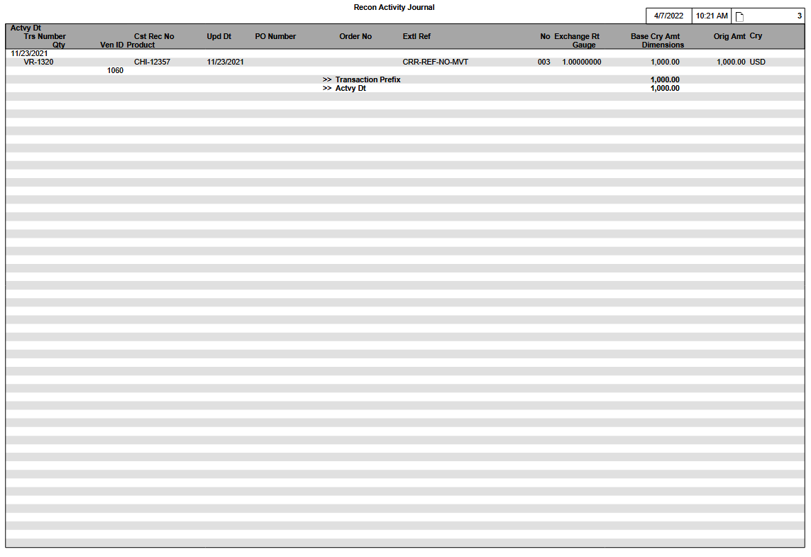
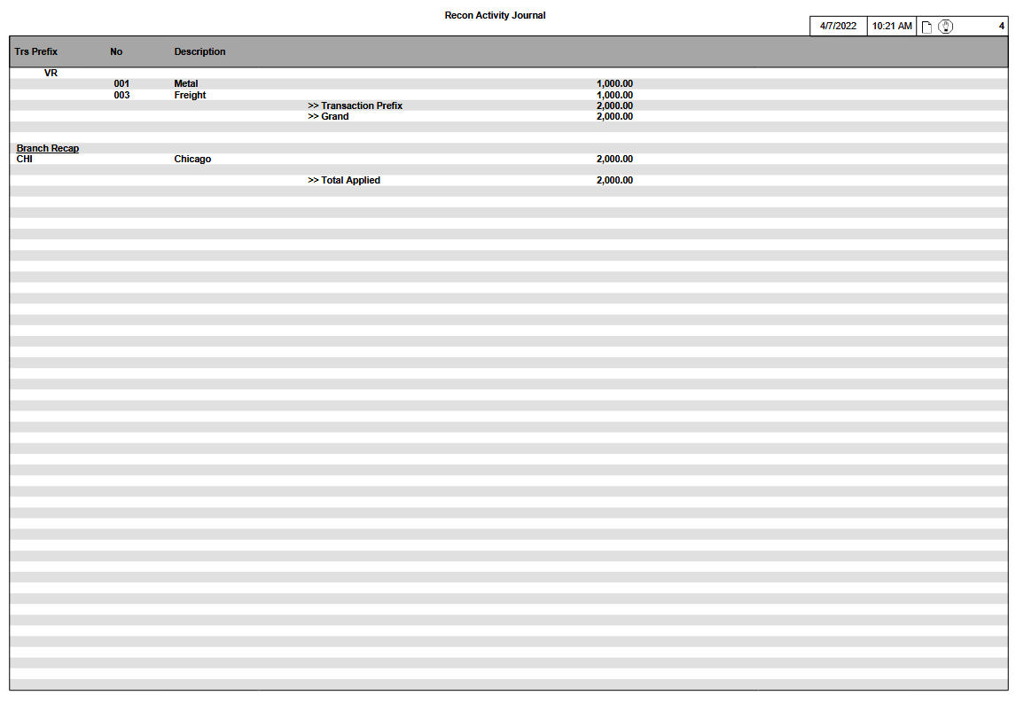

Report Selections
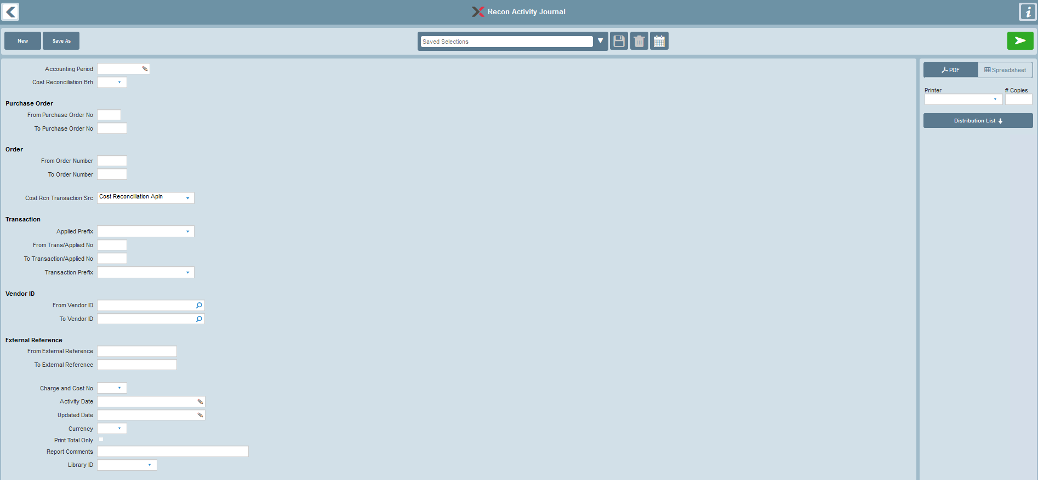

Selection | Options | Data Element | Default | Notes
Accounting Period | If selected, must be a specific Accounting Period. |  |  | Optional selection.  Look-up provided.  Please refer to the ‘Accounting Period Business Rules’ section for details on how this selection filter is used.
Cost Reconciliation Branch |  | CRH-CRCN-BRH | All | Selection filter is used when the Transaction Source is either ‘C’ or ‘A’.
Purchase Order
 | From PO No | CRH-PO-NO |  | Selection filter is used when the Transaction Source is ‘C’.
 | To PO No | CRH-PO-NO |  | Selection filter is used when the Transaction Source is ‘C’.
Order
 | From Order No | CRH-ORD-NO |  | Selection filter is used when the Transaction Source is ‘C’.
 | To Order No | CRH-ORD-NO |  | Selection filter is used when the Transaction Source is ‘C’.
Transaction Source | C – Cost Reconciliation Header  A – Cost Reconciliation Application | IRC-TRS-SRC | C | C – lists accrued transaction activity from the Cost Reconciliation Header table.  A – lists applied transaction activity from the Cost Reconciliation Application table.  Mandatory selection.
Transaction Group
 | Transaction Prefix | CRH-TRS-PFX |  | Selection filter is used when the selected Transaction Source is ‘C’.
 | Applied Prefix | CRP-APLD-PFX |  | Selection filter is used when the selected Transaction Source is ‘A’.
 | From Trans No | CRH-TRS-NO  CRP-APLD-NO |  | The Transaction Reference Number from the Cost Reconciliation Accrual (Header) table is used as the selection filter when the selected Transaction Source is ‘C’.  The Applied Reference Number from the Cost Reconciliation Application table is used as the selection filter when the selected Transaction Source is ‘A’.
 | To Trans No | CRH-TRS-NO  CRP-APLD-NO |  | The Transaction Reference Number from the Cost Reconciliation Accrual (Header) table is used as the selection filter when the selected Transaction Source is ‘C’.  The Applied Reference Number from the Cost Reconciliation Application table is used as the selection filter when the selected Transaction Source is ‘A’.
Vendor ID
 | From Vendor ID | CRH-VEN-ID |  | Selection filter is used when the Transaction Source is either ‘C’ or ‘A’.
 | To Vendor ID | CRH-VEN-ID |  | Selection filter is used when the Transaction Source is either ‘C’ or ‘A’.
External Reference
 | From External Ref | CRH-EXTL-REF |  | Selection filter is used when the Transaction Source is ‘C’.
 | To External Ref | CRH-EXTL-REF |  | Selection filter is used when the Transaction Source is ‘C’.
Charge & Cost No |  | CRH-CC-NO | All | Selection filter is used when the Transaction Source is ‘C’.
Activity Date
 | From Activity Date | CRH-ACTVY-DT  CRP-ACTVY-DT |  | The Activity Date from the Cost Reconciliation Accrual (Header) table is used as the selection filter when the selected Transaction Source is ‘C’.  The Activity Date from the Cost Reconciliation Application table is used as the selection filter when the selected Transaction Source is ‘A’.
 | To Activity Date | CRH-ACTVY-DT  CRP-ACTVY-DT |  | The Activity Date from the Cost Reconciliation Accrual (Header) table is used as the selection filter when the selected Transaction Source is ‘C’.  The Activity Date from the Cost Reconciliation Application table is used as the selection filter when the selected Transaction Source is ‘A’.
Update Date
 | From Update Date | CRH-UPD-DT  CRP-UPD-DT |  | The Update Date from the Cost Reconciliation Accrual (Header) table is used as the selection filter when the selected Transaction Source is ‘C’.  The Update Date from the Cost Reconciliation Application table is used as the selection filter when the selected Transaction Source is ‘A’.
 | To Update Date | CRH-UPD-DT  CRP-UPD-DT |  | The Update Date from the Cost Reconciliation Accrual (Header) table is used as the selection filter when the selected Transaction Source is ‘C’.  The Update Date from the Cost Reconciliation Application table is used as the selection filter when the selected Transaction Source is ‘A’.
Currency Code |  | CRH-CRY | All | Selection filter is used when the Transaction Source is either ‘C’ or ‘A’.
Print Totals Only |  |  | Unchecked | If Checked, print the Totals section only.
Report Comments |  |  | None | Provides an option to print report comments on the Selection page of the report.
Library ID | None or a specific Library ID |  | None | Provides an option to select a Library ID for generic remarks to be printed on the Selection page of the report.

Accounting Period Business Rules
- When the Accounting Period selection is used, transaction filtering is case-dependent based on the selected Transaction Source, as well as the Cost Reconciliation Transaction Prefix, and is determined based on the Accounting Period selection and either the ‘Data Capture Date/Time’ in the Inventory Data Capture Summary or the ‘Period Beginning Date’ and ‘Period Ending Date’ range in the Fiscal Calendar enterprise parameter as follows:

Selected Transaction Source is 'C' – Cost Reconciliation Header
Case 1
- If the Cost Reconciliation Accrual (Header) Transaction Prefix is not ‘SE/DE/CE/TE/TD/TN/VR/CM/DM’, then Cost Reconciliation Accrual transactions (selected Transaction Source – ‘C’) are included on the report if the Transaction Update Date/Time is:
- greater than the corresponding Data Capture Date/Time for the previous Accounting Period (compared only if it is available), and
- less than or equal to the corresponding Data Capture Date/Time for the selected Accounting Period.
- An error is issued for the business case where the Accounting Period selection is used but the corresponding Inventory Data Capture Summary is absent.

Case 2
- If the Cost Reconciliation Accrual (Header) Transaction Prefix is ‘SE/DE/CE/TE/TD/TN/VR/CM/DM’, then Cost Reconciliation Accrual transactions (selected Transaction Source – ‘C’) are included on the report if the Transaction Activity Date is:
- greater than or equal to the corresponding Fiscal Calendar Accounting Period’s Period Beginning Date, and
- less than or equal to the corresponding Fiscal Calendar Accounting Period’s Period Ending Date.

Selected Transaction Source is 'A' – Cost Reconciliation Application
Case 3
- Cost Reconciliation Application transactions (selected Transaction Source – ‘A’) are included on the report if the transaction Activity Date is:
- greater than or equal to the corresponding Fiscal Calendar Accounting Period’s Period Beginning Date, and
- less than or equal to the corresponding Fiscal Calendar Accounting Period’s Period Ending Date.

"Current Period" Radio Button Selection
Case 4
- Please refer to the 'Accessing Fiscal Calendar Information' Technical Notes section for details.

"Previous Period" Radio Button Selection
Case 5
- Please refer to the 'Accessing Fiscal Calendar Information' Technical Notes section for details.

General Rules

Report Sequencing
This report is sequenced as follows:

When the selected Transaction Source is ‘C’:
- By Transaction Activity Date, then Transaction Reference Prefix/Number. The sequence starts with Transaction Activity Date, then Transaction Reference Prefix/Number.

When the selected Transaction Source is ‘A’:
- By Applied Activity Date, then Applied Reference Prefix/Number information. The sequence starts with Applied Activity Date, then Applied Reference Prefix/Number.

Report Currency Base
The company’s base currency is provided for all Items and Totals for better readability.

Data

Primary Source of Data
- IRTCRH – Cost Reconciliation Header
- IRTCRP – Cost Reconciliation Application

Grouped By
- Transaction Activity Date (when the Transaction Source is ‘C’ )
or
- Applied Activity Date (when the Transaction Source is ‘A’ )

Detail Line Sequenced By
- Transaction Reference Prefix/Number (when the Transaction Source is ‘C’ )
or
- Applied Reference Prefix/Number (when the Transaction Source is ‘A’ )

Control Breaks By
- Transaction Activity Date (when the Transaction Source is ‘C’ )
or
- Applied Activity Date (when the Transaction Source is ‘A’ )

Page Break By
- Transaction Activity Date (when the Transaction Source is ‘C’ )
or
- Applied Activity Date (when the Transaction Source is ‘A’ )

Data Totaled By
When the Transaction Source is ‘C’:
- Transaction Reference Prefix
- Transaction Activity Date

When the Transaction Source is ‘A’:
- Applied Reference Prefix
- Applied Activity Date

Total Summary Recap (New Page)
When the Transaction Source is ‘C’:
- Transaction Reference Prefix
- Total by Transaction Reference Prefix
- Grand Total (All Prefixes)
- Base Currency Branch Recap

When the Transaction Source is ‘A’:
- Applied Reference Prefix
- Total by Applied Reference Prefix
- Grand Total (All Prefixes)
- Base Currency Branch Recap

Sample Report
11/10/99 11:50 PAGE: 2
Recon Activity Journal
Actvy Dt
Trs Number Cst Rec No Upd Dt PO Number Order No Extl Ref No Exchange Rt Base Cry Amt Orig Amt Cry
Cost Qty Vendor ID Product Gauge T Dimensions
10/19/1999
RC-336-1-1 PHI-001392 10/25/1999 PO-2046-1 SO-663-1 2088-4799-001 001 0.66000000 4,950.00 7,500.00 CAD
30,000 LBS 1060 HRC/430/3372/D 0.45000 N 48.0000 96.0000
RC-336-1-1 PHI-001393 10/29/1999 PO-2046-1 SO-663-1 F87724800-001 002 0.66000000 561.00 850.00 CAD
30,000 LBS 1010 HRC/430/3372/D 0.45000 N 48.0000 96.0000
>> Transaction Prefix 5,511.00

>> Activity Date 5,511.00

11/10/99 11:50 PAGE: 3
Recon Activity Journal
Actvy Dt
Trs Number Cst Rec No Upd Dt PO Number Order No Extl Ref No Exchange Rt Base Cry Amt Orig Amt Cry
Cost Qty Vendor ID Product Gauge T Dimensions
10/20/1999
RC-337-1-1 CHI-001394 10/25/1999 PO-2047-1 SO-664-1 2088-4801-001 001 1.00000000 7,500.00 7,500.00 USD
30,000 LBS 1060 HRC/430/3372/D 0.45000 N 48.0000 96.0000
>> Transaction Prefix 7,500.00

IV-147-1-1 PHI-001395 10/27/1999 PO-2047-1 SO-664-1 F87724802-001 002 1.00000000 850.00 850.00 USD
30,000 LBS 1010 HRC/430/3372/D 0.45000 N 48.0000 96.0000
>> Transaction Prefix 850.00

>> Activity Date 8,350.00

11/10/99 11:50 PAGE: 3
Recon Activity Journal
Trs Prefix No Description
IV 002 Freight Charge & Cost 850.00
>> Transaction Prefix 850.00

RC 001 Metal Charge & Cost 12,450.00
002 Freight Charge & Cost 561.00
>> Transaction Prefix 13,011.00

>> Grand Total 13,861.00

Branch Recap
CHI Chicago 7,500.00
PHI Philadelphia 6,361.00

>> Total Accrued 13,861.00

Report Layout
11/10/99 11:50 PAGE: 2
Recon Activity Journal
Actvy Dt
Trs Number Cst Rec No Upd Dt PO Number Order No Extl Ref No Exchange Rt Base Cry Amt Orig Amt Cry
Cost Qty Vendor ID Product Gauge T Dimensions
MM/DD/YYYY
WW-99999999-999-9999 WWW-99999999 MM/DD/YY WW-99999999-999 WW-99999999-999 QQQQQQQQQQQQQQQQQQQQQQ 999 ZZZ9.99999999 Z,ZZZ,ZZZ,ZZ9.99- Z,ZZZ,ZZZ,ZZ9.99- WWW
ZZZ,ZZZ,ZZ9 WWW QQQQQQQQ QQQQQQ/QQQQQQQQ/QQQQQQQQQQQQQQQ/QQQQQQQQ ZZ9.99999 W ZZZZ9.9999 ZZZZ9.9999
WW-99999999-999-9999 WWW-99999999 MM/DD/YY WW-99999999-999 WW-99999999-999 QQQQQQQQQQQQQQQQQQQQQQ 999 ZZZ9.99999999 Z,ZZZ,ZZZ,ZZ9.99- Z,ZZZ,ZZZ,ZZ9.99- WWW ZZZ,ZZZ,ZZ9 WWW QQQQQQQQ QQQQQQ/QQQQQQQQ/QQQQQQQQQQQQQQQ/QQQQQQQQ ZZ9.99999 W ZZZZ9.9999 ZZZZ9.9999
>> Transaction Prefix Z,ZZZ,ZZZ,ZZ9.99-

>> Activity Date Z,ZZZ,ZZZ,ZZ9.99-

11/10/99 11:50 PAGE: 3
Recon Activity Journal
Actvy Dt
Trs Number Cst Rec No Upd Dt PO Number Order No Extl Ref No Exchange Rt Base Cry Amt Orig Amt Cry
Cost Qty Vendor ID Product Gauge T Dimensions
MM/DD/YYYY
WW-99999999-999-9999 WWW-99999999 MM/DD/YY WW-99999999-999 WW-99999999-999 QQQQQQQQQQQQQQQQQQQQQQ 999 ZZZ9.99999999 Z,ZZZ,ZZZ,ZZ9.99- Z,ZZZ,ZZZ,ZZ9.99- WWW
ZZZ,ZZZ,ZZ9 WWW QQQQQQQQ QQQQQQ/QQQQQQQQ/QQQQQQQQQQQQQQQ/QQQQQQQQ ZZ9.99999 W ZZZZ9.9999 ZZZZ9.9999

>> Transaction Prefix Z,ZZZ,ZZZ,ZZ9.99-

WW-99999999-999-9999 WWW-99999999 MM/DD/YY WW-99999999-999 WW-99999999-999 QQQQQQQQQQQQQQQQQQQQQQ 999 ZZZ9.99999999 Z,ZZZ,ZZZ,ZZ9.99- Z,ZZZ,ZZZ,ZZ9.99- WWW
ZZZ,ZZZ,ZZ9 WWW QQQQQQQQ QQQQQQ/QQQQQQQQ/QQQQQQQQQQQQQQQ/QQQQQQQQ ZZ9.99999 W ZZZZ9.9999 ZZZZ9.9999

>> Transaction Prefix Z,ZZZ,ZZZ,ZZ9.99-

>> Activity Date Z,ZZZ,ZZZ,ZZ9.99-

11/10/99 11:50 PAGE: 4
Recon Activity Journal
Trs Prefix No Description
WW 999 WWWWWWWWWWWWWWWWWWWW Z,ZZZ,ZZZ,ZZ9.99-
999 WWWWWWWWWWWWWWWWWWWW Z,ZZZ,ZZZ,ZZ9.99-
999 WWWWWWWWWWWWWWWWWWWW Z,ZZZ,ZZZ,ZZ9.99-
999 WWWWWWWWWWWWWWWWWWWW Z,ZZZ,ZZZ,ZZ9.99-
>> Transaction Prefix Z,ZZZ,ZZZ,ZZ9.99-

WW 999 WWWWWWWWWWWWWWWWWWWW Z,ZZZ,ZZZ,ZZ9.99-
999 WWWWWWWWWWWWWWWWWWWW Z,ZZZ,ZZZ,ZZ9.99-
>> Transaction Prefix Z,ZZZ,ZZZ,ZZ9.99-

>> Grand Total Z,ZZZ,ZZZ,ZZ9.99-

Branch Recap
QQQ QQQQQQQQQQQQQQQ Z,ZZZ,ZZZ,ZZ9.99-
QQQ QQQQQQQQQQQQQQQ Z,ZZZ,ZZZ,ZZ9.99-

>> Total Applied Z,ZZZ,ZZZ,ZZ9.99-

Report Structure

Report Field Description
Group | Report Field | Field Name | Business Rules | Formatting
1st Group
(Actvy Dt)
 | Activity Date | CRH-ACTVY-DT  or  CRP-ACTVY-DT |  | Depends on the short date style found in the Language/Country Enterprise Parameter.
Detail Line 1 (Cost Rec Pfx) |  |  | This section is only printed if the selected Transaction Source is:  C-Cost Reconciliation Header
 | Transaction Ref Prefix | CRH-TRS-PFX
 | Transaction Ref Number | CRH-TRS-NO
 | Transaction Ref Item | CRH-TRS-ITM
 | Transaction Sub-item | crh-trs-sbitm
 | Cost Reconciliation Branch | CRH-CRCN-BRH
 | Cost Reconciliation Number | CRH-CRCN-NO
 | Update Date | CRH-UPD-DT
 | PO Prefix | CRH-PO-PFX | PO Prefix/Number/Item
 | PO Number | CRH-PO-NO | PO Prefix/Number/Item
 | PO Item | CRH-PO-ITM | PO Prefix/Number/Item
 | Order Prefix | CRH-ORD-PFX
 | Order Number | CRH-ORD-NO
 | Order Item | CRH-ORD-ITM
 | External Ref No | CRH-EXTL-REF
 | Charge & Cost Number | CRH-CC-NO
 | Exchange Rate | CRH-EX-RT
 | Original Base Currency Amount | Calculated | ‘Original Amount’ x Cost Rec Header Exchange Rate
 | Original Amount | CRH-ORIG-AMT
 | Currency Code | CRH-CRY
 | Cost Quantity | CRH-CST-QTY |  | Quantity Format 3
 | Cost Quantity UM | CRH-CST-QTY-UM
 | Vendor ID | CRH-VEN-ID
 | Product | CRH-FRM  CRH-GRD  CRH-SIZE  CRH-FNSH
 | Gauge Size | CRH-GA-SIZE
 | Gauge Type | CRH-GA-TYP
 | Dimension | CRH-WDTH  CRH-LGTH
Cost Rec Prefix Total |  |  | This section is only printed if the selected Transaction Source is:  C-Cost Reconciliation Header
 | Cost Rec Transaction Prefix | Calculated | ∑ ‘Original Base Currency Amount’ for the same Cost Rec Transaction Prefix.
Cost Rec Actvy Date Total |  |  | This section is only printed if the selected Transaction Source is:  C-Cost Reconciliation Header
 | Cost Rec Activity Date | Calculated | ∑ ‘Original Base Currency Amount’ for all Cost Rec Transaction Prefix Totals.
Detail Line 2 (Cost Rec Appl Pfx) |  |  | This section is only printed if the selected Transaction Source is:  A-Cost Reconciliation Application
 | Applied Ref Prefix | CRP-APLD-PFX
 | Applied Ref Number | CRP-APLD-NO
 | Cost Reconciliation Branch | CRH-CRCN-BRH
 | Cost Reconciliation Number | CRP-CRCN-NO
 | Update Date | CRP-UPD-DT
 | PO Prefix | CRH-PO-PFX | PO Prefix/Number/Item
 | PO Number | CRH-PO-NO | PO Branch/Number/Item
 | PO Item | CRH-PO-ITM | PO Branch/Number/Item
 | Order Prefix | CRH-ORD-PFX
 | Order Number | CRH-ORD-NO
 | Order Item | CRH-ORD-ITM
 | External Ref No | CRH-EXTL-REF
 | Charge & Cost Number | CRH-CC-NO
 | Applied Exchange Rate | CRP-EX-RT | For reference purposes only. Not used in report calculations.
 | Application Base Currency Amount | Calculated | ‘Application Amount’ x Cost Rec Header Exchange Rate
 | Application Amount | CRP-APLD-AMT
 | Currency Code | CRH-CRY
 | Applied Quantity | CRP-APLD-QTY |  | Quantity Format 3
 | Applied Quantity UM | CRP-APLD-QTY-UM
 | Vendor ID | CRH-VEN-ID
 | Product | CRH-FRM  CRH-GRD  CRH-SIZE  CRH-FNSH
 | Gauge Size | CRH-GA-SIZE
 | Gauge Type | CRH-GA-TYP
 | Dimension | CRH-WDTH  CRH-LGTH
Appl Prefix Total |  |  | This section is only printed if the selected Transaction Source is:  A-Cost Reconciliation Application
 | Cost Rec Appl Prefix | Calculated | ∑ ‘Application Base Currency Amount’ for the same Cost Rec Appl Prefix.
Appl Actvy Date Total |  |  | This section is only printed if the selected Transaction Source is:  A-Cost Reconciliation Application
 | Appl Activity Date | Calculated | ∑ ‘Application Base Currency Amount’ for all Cost Rec Applied Prefix Totals.
Summary Recap Page |  |  | This page is always printed.
Totals by Ref Prefix |  |  | Recap info for each Charge & Cost Number, by Prefix.  Lists all Charge & Cost Items appearing on the report.
 | Prefix |  | The Prefix appears on the report.
 | Charge & Cost No |  | The Charge & Cost No appears on the report.
 | Charge & Cost Description | CCR-DESC20 | The description for this Charge & Cost No based on the Charge & Cost enterprise parameter.
 | Charge & Cost Total (Break) | Calculated | The total Amount for each specific Charge & Cost No on the report,  (in Base Currency).
Ref Prefix Total
 | Transaction Prefix (Break) | Calculated | Transaction Source ‘C’  ∑ ‘Original Base Currency Amount’ for the same Ref Prefix.  or  Transaction Source ‘A’  ∑ ‘Application Base Currency Amount’ for the same Applied Prefix.
Grand Totals
 | Grand Total | Calculated | The total Amount for all Charge & Cost Numbers of all Ref Prefixes on the report, (expressed in Base Currency).
Branch Summary Recap
 | Cost Reconciliation Branch
 | Branch Name
 | Base Currency Amount |  | Transaction Source ‘C’  ∑ ‘Original Base Currency Amount’ for the same Branch.  or  Transaction Source ‘A’  ∑ ‘Application Base Currency Amount’ for the same Branch.
 | ‘Total Accrued’  or  ‘Total Applied’ |  | Total for all Branches. | Label printing format is based on the selected Transaction Source.

Technical Notes

Accessing Fiscal Calendar Information (Accounting Period Look-Up Feature)
Based on the ‘selected’ Company (scrcsc), the Fiscal Calendar (glrfis) EP is accessed.

Current Period Radio Button Selection

Transaction Source – ‘C’
- If the ‘Current Period’ radio button is selected, the corresponding selection filter to be used at report execution time is determined dynamically as follows:
- The Accounting Period value is not resolvable.
- The Inventory Data Capture header (intide) table is accessed.
- The financial (Purpose Code = ‘F’) Inventory Data Capture record which contains the most recent Inventory Data Capture Date/Time is accessed.
- Transactions are eligible for inclusion if the Transaction Update Date/Time is:
- greater than the Inventory Data Capture Date/Time
- less than the System Date/Time.
- If there is no corresponding Inventory Data Capture record available, e.g., 1st month INVEX is live, all transactions are eligible for inclusion.
- The front selection page of the generated report indicates the words ‘Current Period’ (since there is no resolvable Accounting Period value).

Transaction Source – ‘A’
- If the ‘Current Period’ radio button is selected, the corresponding selection filter to be used at report execution time is determined dynamically as follows:
- The Accounting Period value is resolvable.
- The System Date is determined dynamically at report execution time.
- The Fiscal Calendar enterprise parameter (glrfis) is accessed.
- The Accounting Period whose Period Beginning Date/Ending Date range corresponds to the System Date is accessed.
- Transactions are eligible for inclusion if the Transaction Activity Date is:
  - greater than or equal to the Period Beginning Date
  - less than or equal to the Period Ending Date
- The front selection page of the generated report indicates the actual equivalent Accounting Period, not the words ‘Current Period’.
- If there is no matching Fiscal Calendar enterprise parameter record available, the report cannot be generated correctly and an error is issued via the View Log button in the Document Manager:
- “Current Accounting Period unavailable – please review Fiscal Calendar ep”.

Previous Period Radio Button Selection

Transaction Source – ‘C’
- If the ‘Previous Period’ radio button is selected, the corresponding selection filter to be used at report execution time is determined dynamically as follows:
- The Accounting Period value is not resolvable.
- The Inventory Data Capture header (intide) table is accessed.
- The financial (Purpose Code = ‘F’) Inventory Data Capture record (F2) which contains the most recent ending Inventory Data Capture Date/Time is accessed.
- In addition, the immediately preceding financial (Purpose Code = ‘F’) Inventory Data Capture beginning record (F1) is also accessed.
- Transactions are eligible for inclusion if the Transaction Update Date/Time is:
- greater than the Inventory Data Capture Date/Time of the beginning Inventory Data Capture record (F1)
- less than or equal to the Inventory Data Capture Date/Time of the ending Inventory Data Capture record (F2)
- The front selection page of the generated report indicates the actual equivalent Accounting Period, not the words “Previous Period”.
- If there is no corresponding Inventory Data Capture record available, the report cannot be generated correctly and an error is issued via the View Log button in the Document Manager:
“Inventory Data Capture information unavailable”

Transaction Source – ‘A’
- If the ‘Previous Period’ radio button is selected, the corresponding selection filter to be used at report execution time is determined dynamically as follows:
- The Accounting Period value is resolvable.
- The System Date is determined dynamically at report execution time.
- The Fiscal Calendar enterprise parameter (glrfis) is accessed, and the Accounting Period whose Period Beginning Date/Ending Date range corresponds to the System Date is determined.
- The immediately preceding Accounting Period is accessed. If the immediately preceding Accounting Period is determined to be period 13, then period 12 is used instead for reporting purposes.
- Transactions are eligible for inclusion if the Transaction Activity Date is:
  - greater than or equal to the Period Beginning Date
  - less than or equal to the Period Ending Date
- The front selection page of the generated report indicates the actual equivalent Accounting Period, not the words ‘Previous Period’.
- If there is no immediately preceding Fiscal Calendar enterprise parameter record available, the report cannot be generated correctly and an error is issued via the View Log button in the Document Manager:
“Previous Accounting Period unavailable – please review Fiscal Calendar ep“

